EI/ECSE Standard 7
Component 7.2

Overview and Speaker Notes

Intended Audience:

Overview for Facilitators:
ECPC has developed an anchor presentation for each of the Initial Practice-Based Professional Preparation Standards for Early Interventionists/Early Childhood Special Educators (EI/ECSE). The components under each Standard are presented separately. The materials are designed for an in-service professional development (PD) program but can be used in a pre-service teacher preparation course. This resource will increase professionals’ ability to address each of the EI/ECSE Standards and components. Additional materials for each Standard can be found on the ECPC Website: Curriculum Module | The Early Childhood Personnel Center (ecpcta.org)

Speaker Notes
The speaker notes provide a narrative and activities for each slide. You will see speaker notes for most of the slides within the slide deck. The notes provide additional details about the information on a particular slide, including the context for the information and key points. The notes are a guide, and speakers should feel free to modify these as needed. Please note the following:
- The narrative is a sample script for the presenter. Although you may read it verbatim, speaker notes are intended as a guide for the presenter, and you may modify them as needed.

Materials required for face to face
- Share the outline with timelines for the training (build in breaks)
- Conduct an opening activity (introductions/ice breaker)
- Computers or tablets with internet access for participants (if possible)
- Handouts
- Projector with audio capable for playing video with speakers
- Presentation slides with speaker notes
- Develop an evaluation tool for all attendees (e.g., continuous improvement activity)

Materials required for virtual
- Distribute the link to the online platform in advance
- Share the outline with timelines for the training (build in breaks)
- Conduct an opening activity (introductions/ice breaker)
- Determine how participants will receive handouts and materials, on the cloud, using a storage platform (e.g., Dropbox, google, etc.)
- Platform to share presentation (e.g., zoom, teams, etc.) with polling questions prepared in advance and breakout room capability
- Upload or send handouts in advance or through platform (insert through chat)
- Download videos ahead of time to prepare for low bandwidth from slide deck
- Share screen capability (be sure to enable sound for videos)
- Develop an evaluation tool for all attendees (e.g., continuous improvement activity)

Objectives for Standard 7, Component 7.2:
After participating in this professional learning opportunity, participants will be able to:
- Describe how to access evidenced based information to improve EI/ECSE practice.
- Describe the role of reflective practice to promote professional growth and improvement of EI/ECSE knowledge and skills.
- Engage learners in developing a professional growth plan.

Outline of Session Activities
Topic | Slides | Activity
Introduction/Objectives | 1-4
Evidence-Based Practices  Activity: Applying the RPs | 5-16 | Activity (Slide 16)
Reflective practice  Video: Using Video as a Foundation for Reflective Supervision | 17-25 | Video (Slide 25)
Professional Growth Plan  Activity: PGP Goals | 26-29 | Activity (Slide 29)
References | 30-31
Disclaimer | 32

Speaker Notes with Slides

Slide 1 |  | Today we will discuss component 7.2 of the EI/ECSE Standard 7, Professionalism and Ethical Practice.
Slide 2 | 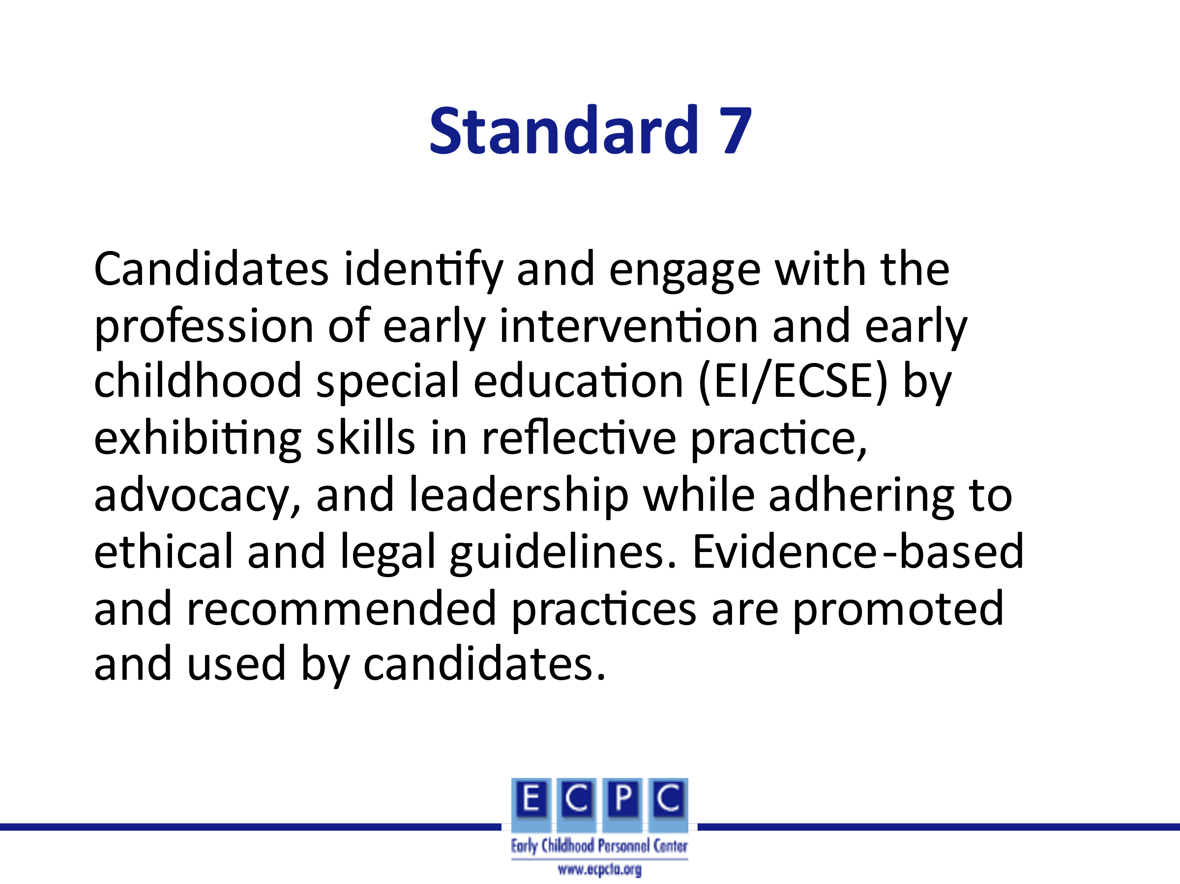 | Ask participants to silently read Standard 7. Then, progress to the next slide.
Slide 3 | 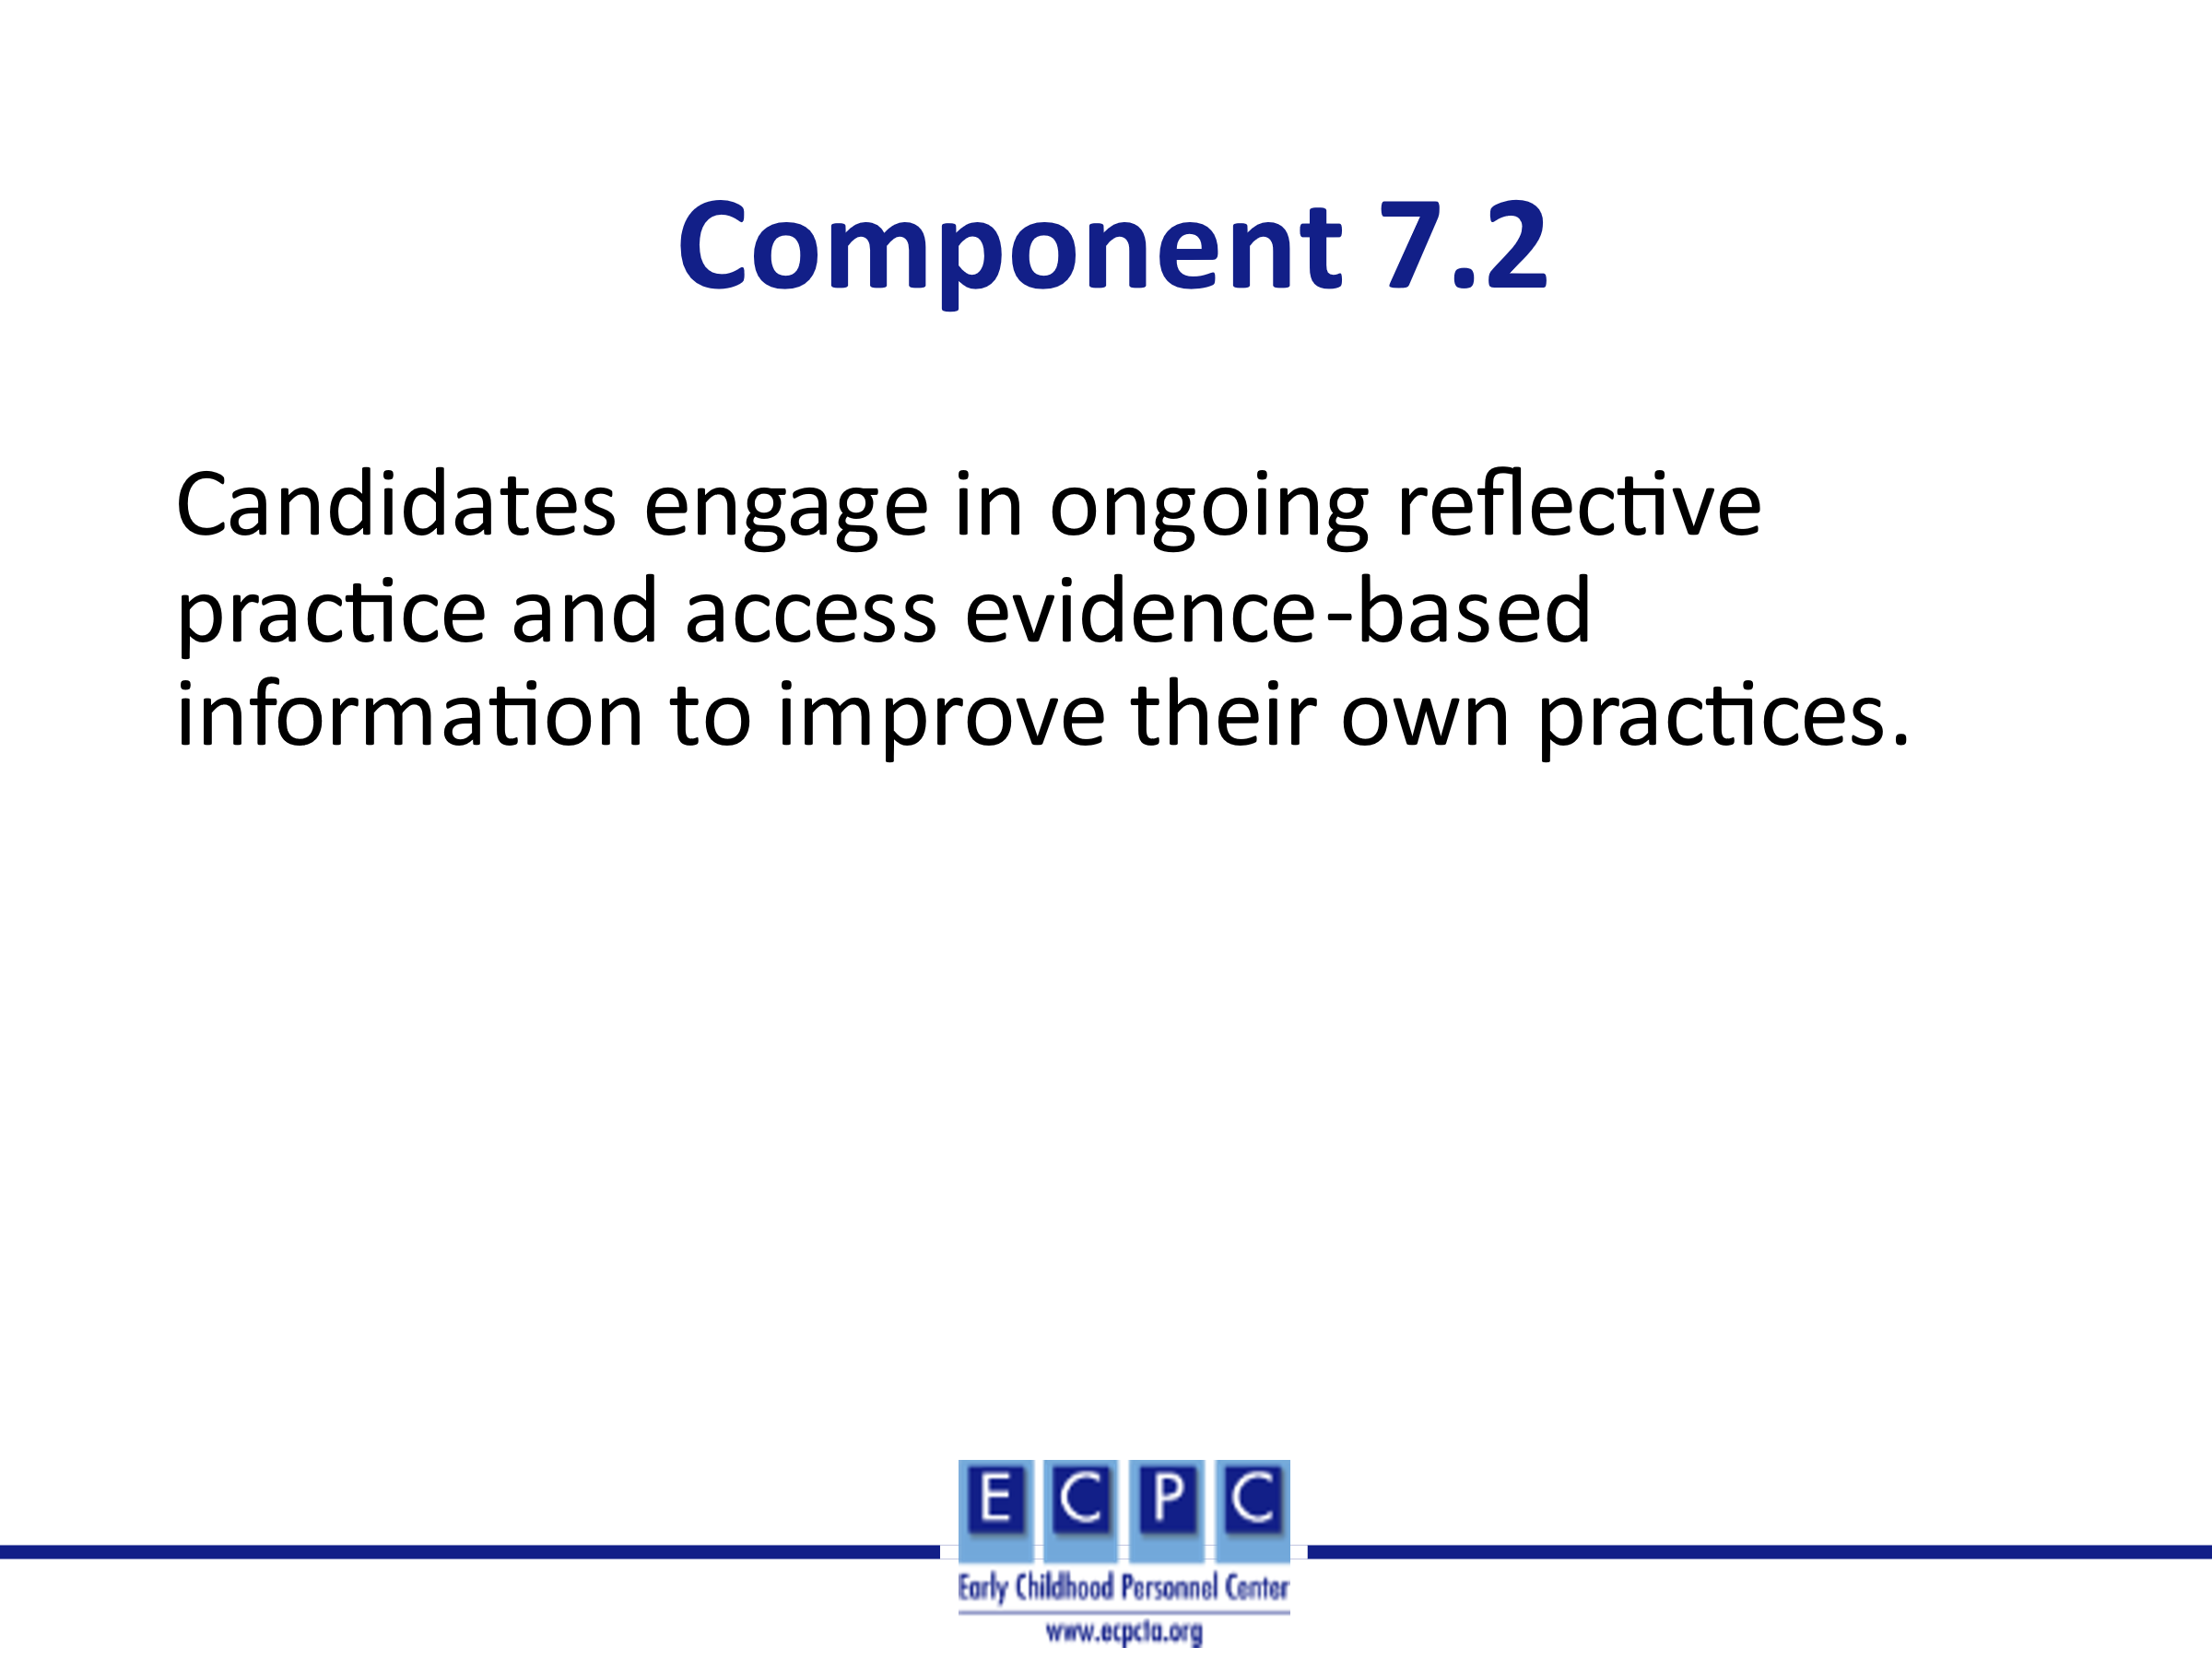 | Today, we will focus on component 7.2 for Standard 7. Then, read component 7.2 aloud to the group.
Slide 4 | 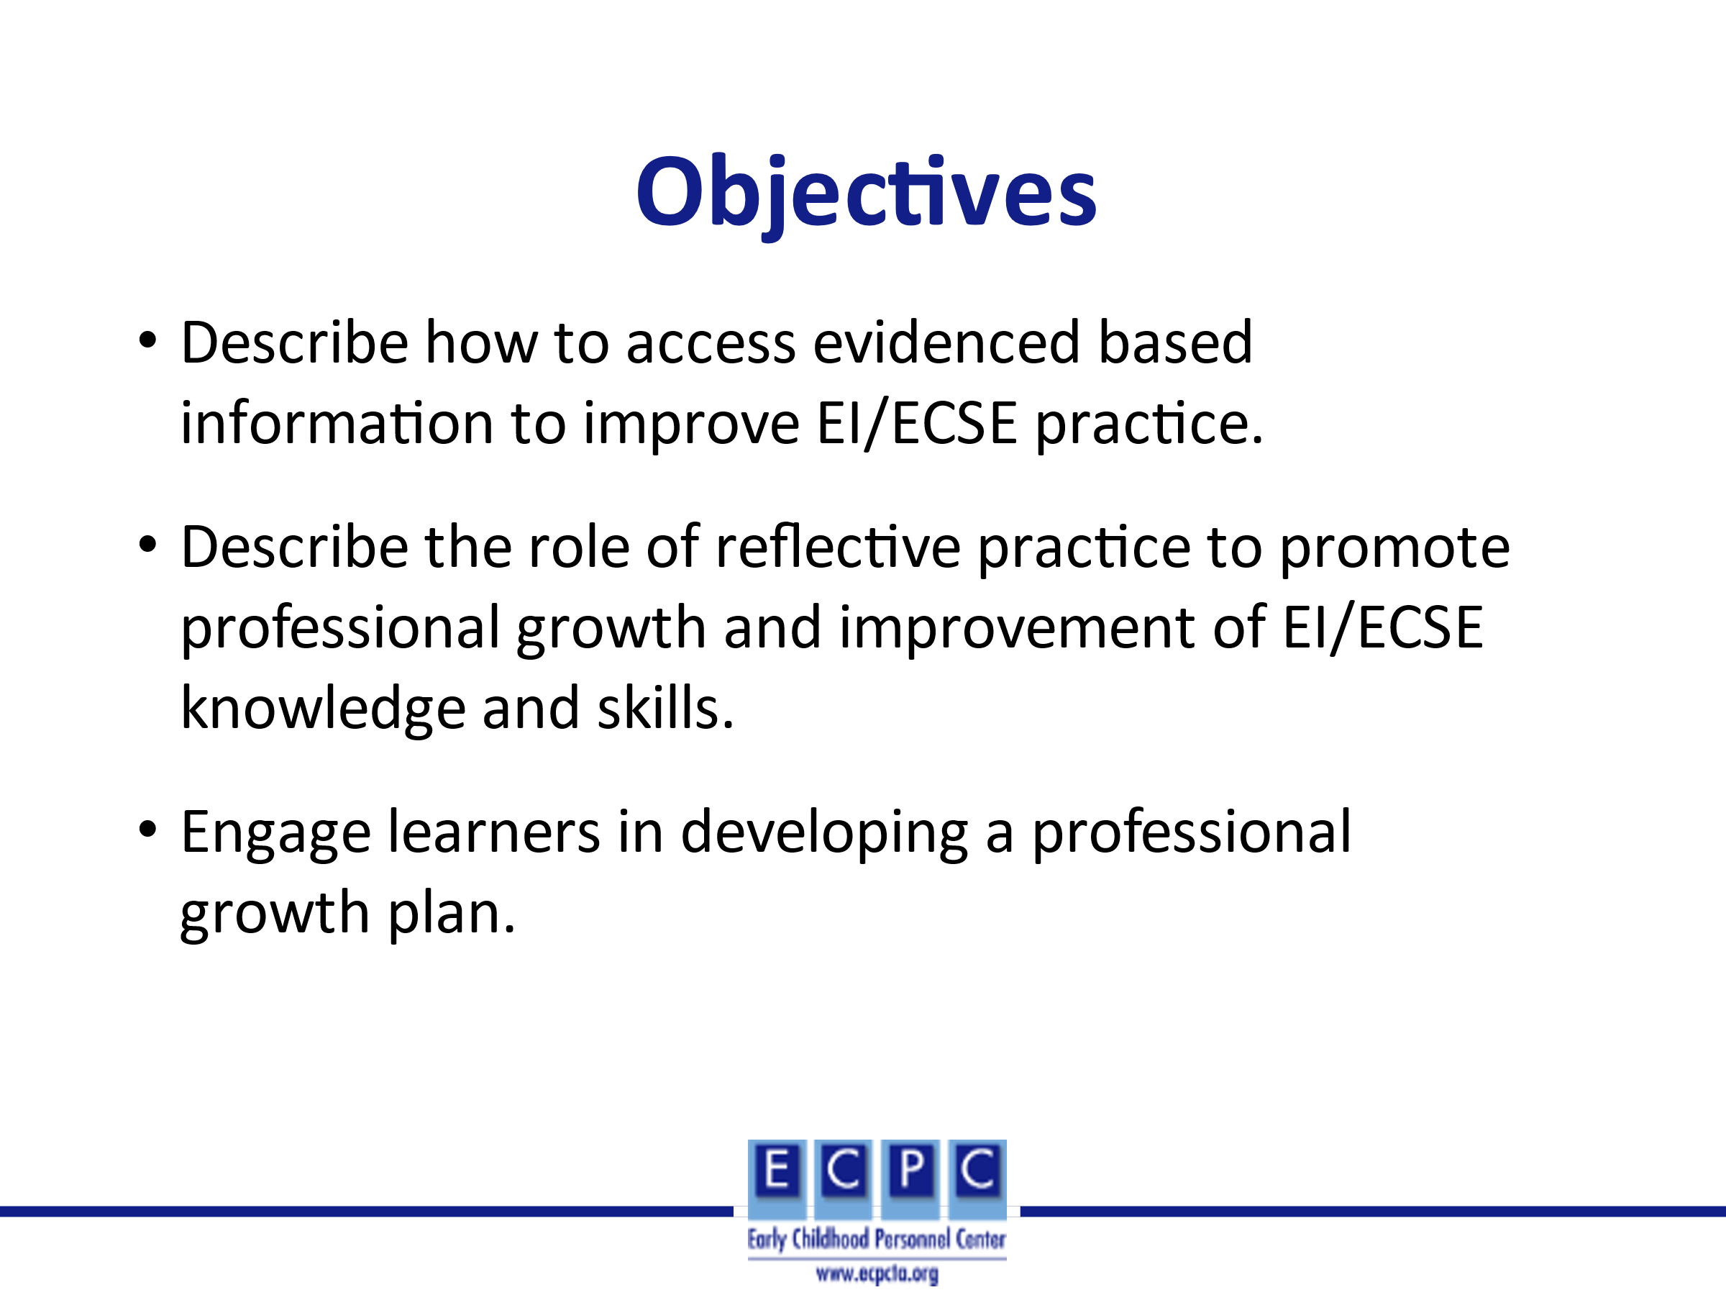
Slide 5 | 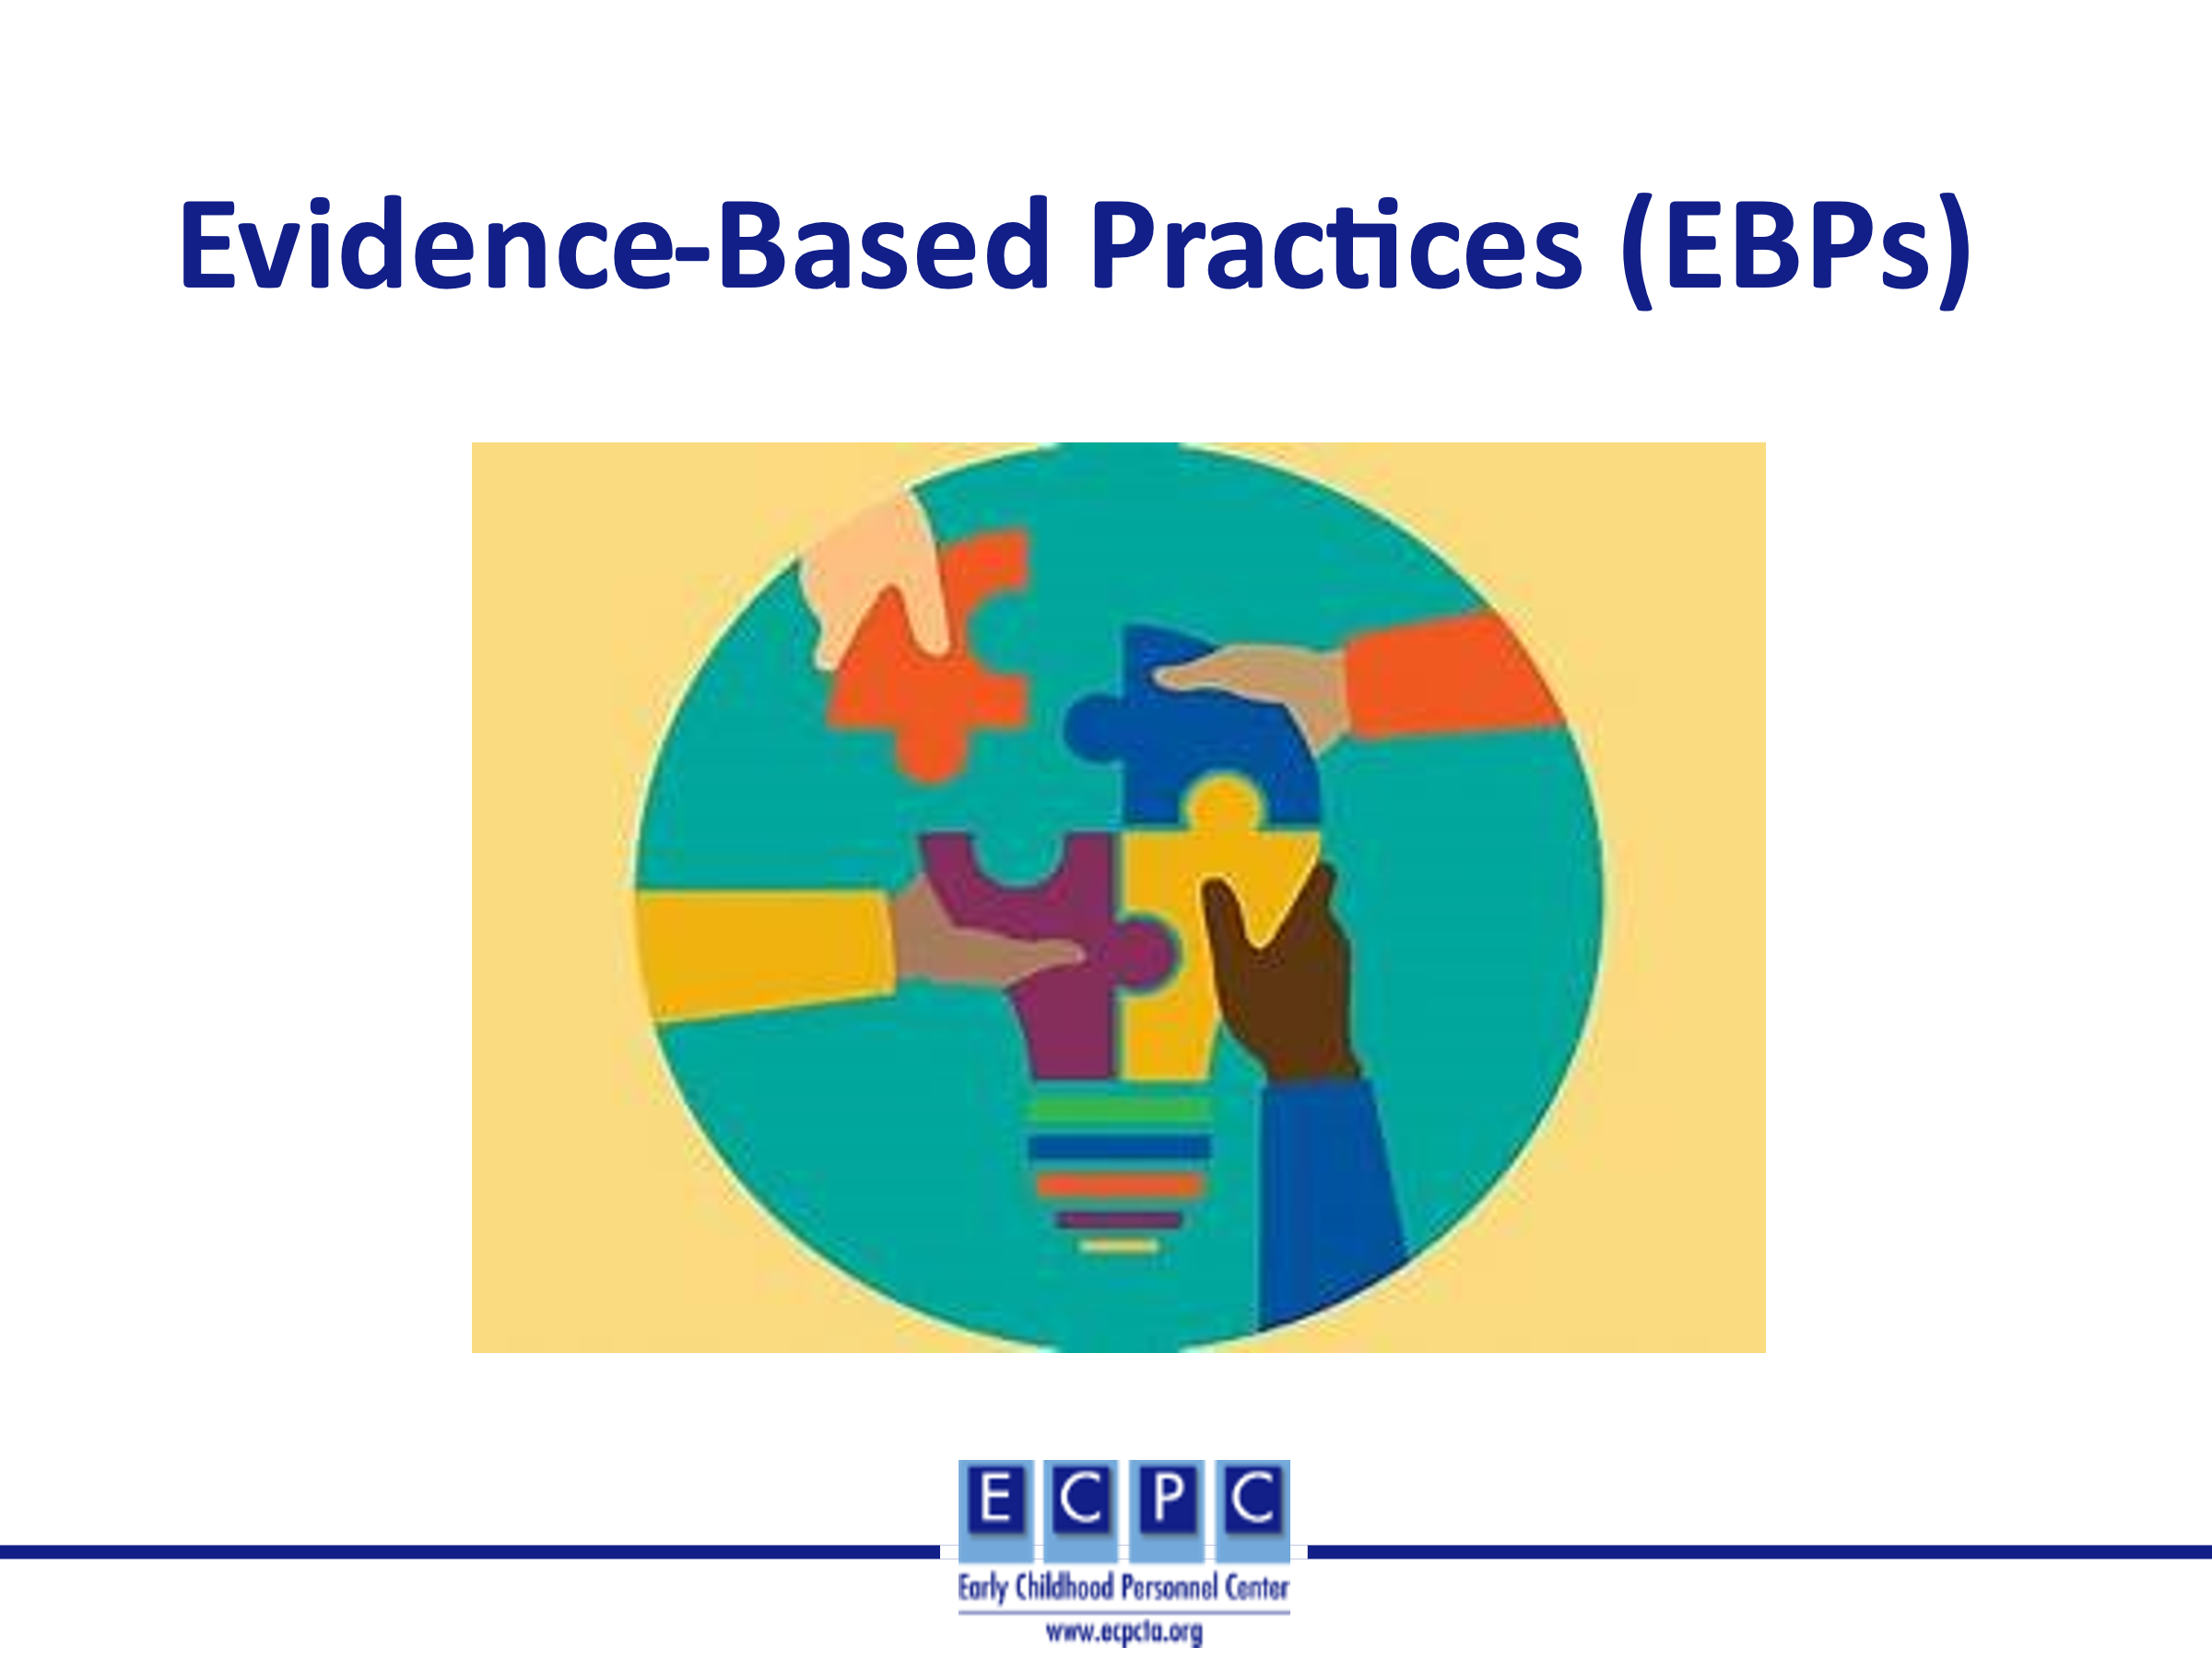 | We will now discuss evidence-based practices (EBPs) – what we mean by EBPs, how we use them in EI/ECSE settings, and resources to support the use of EBPs.
Slide 6
Slide 7 | 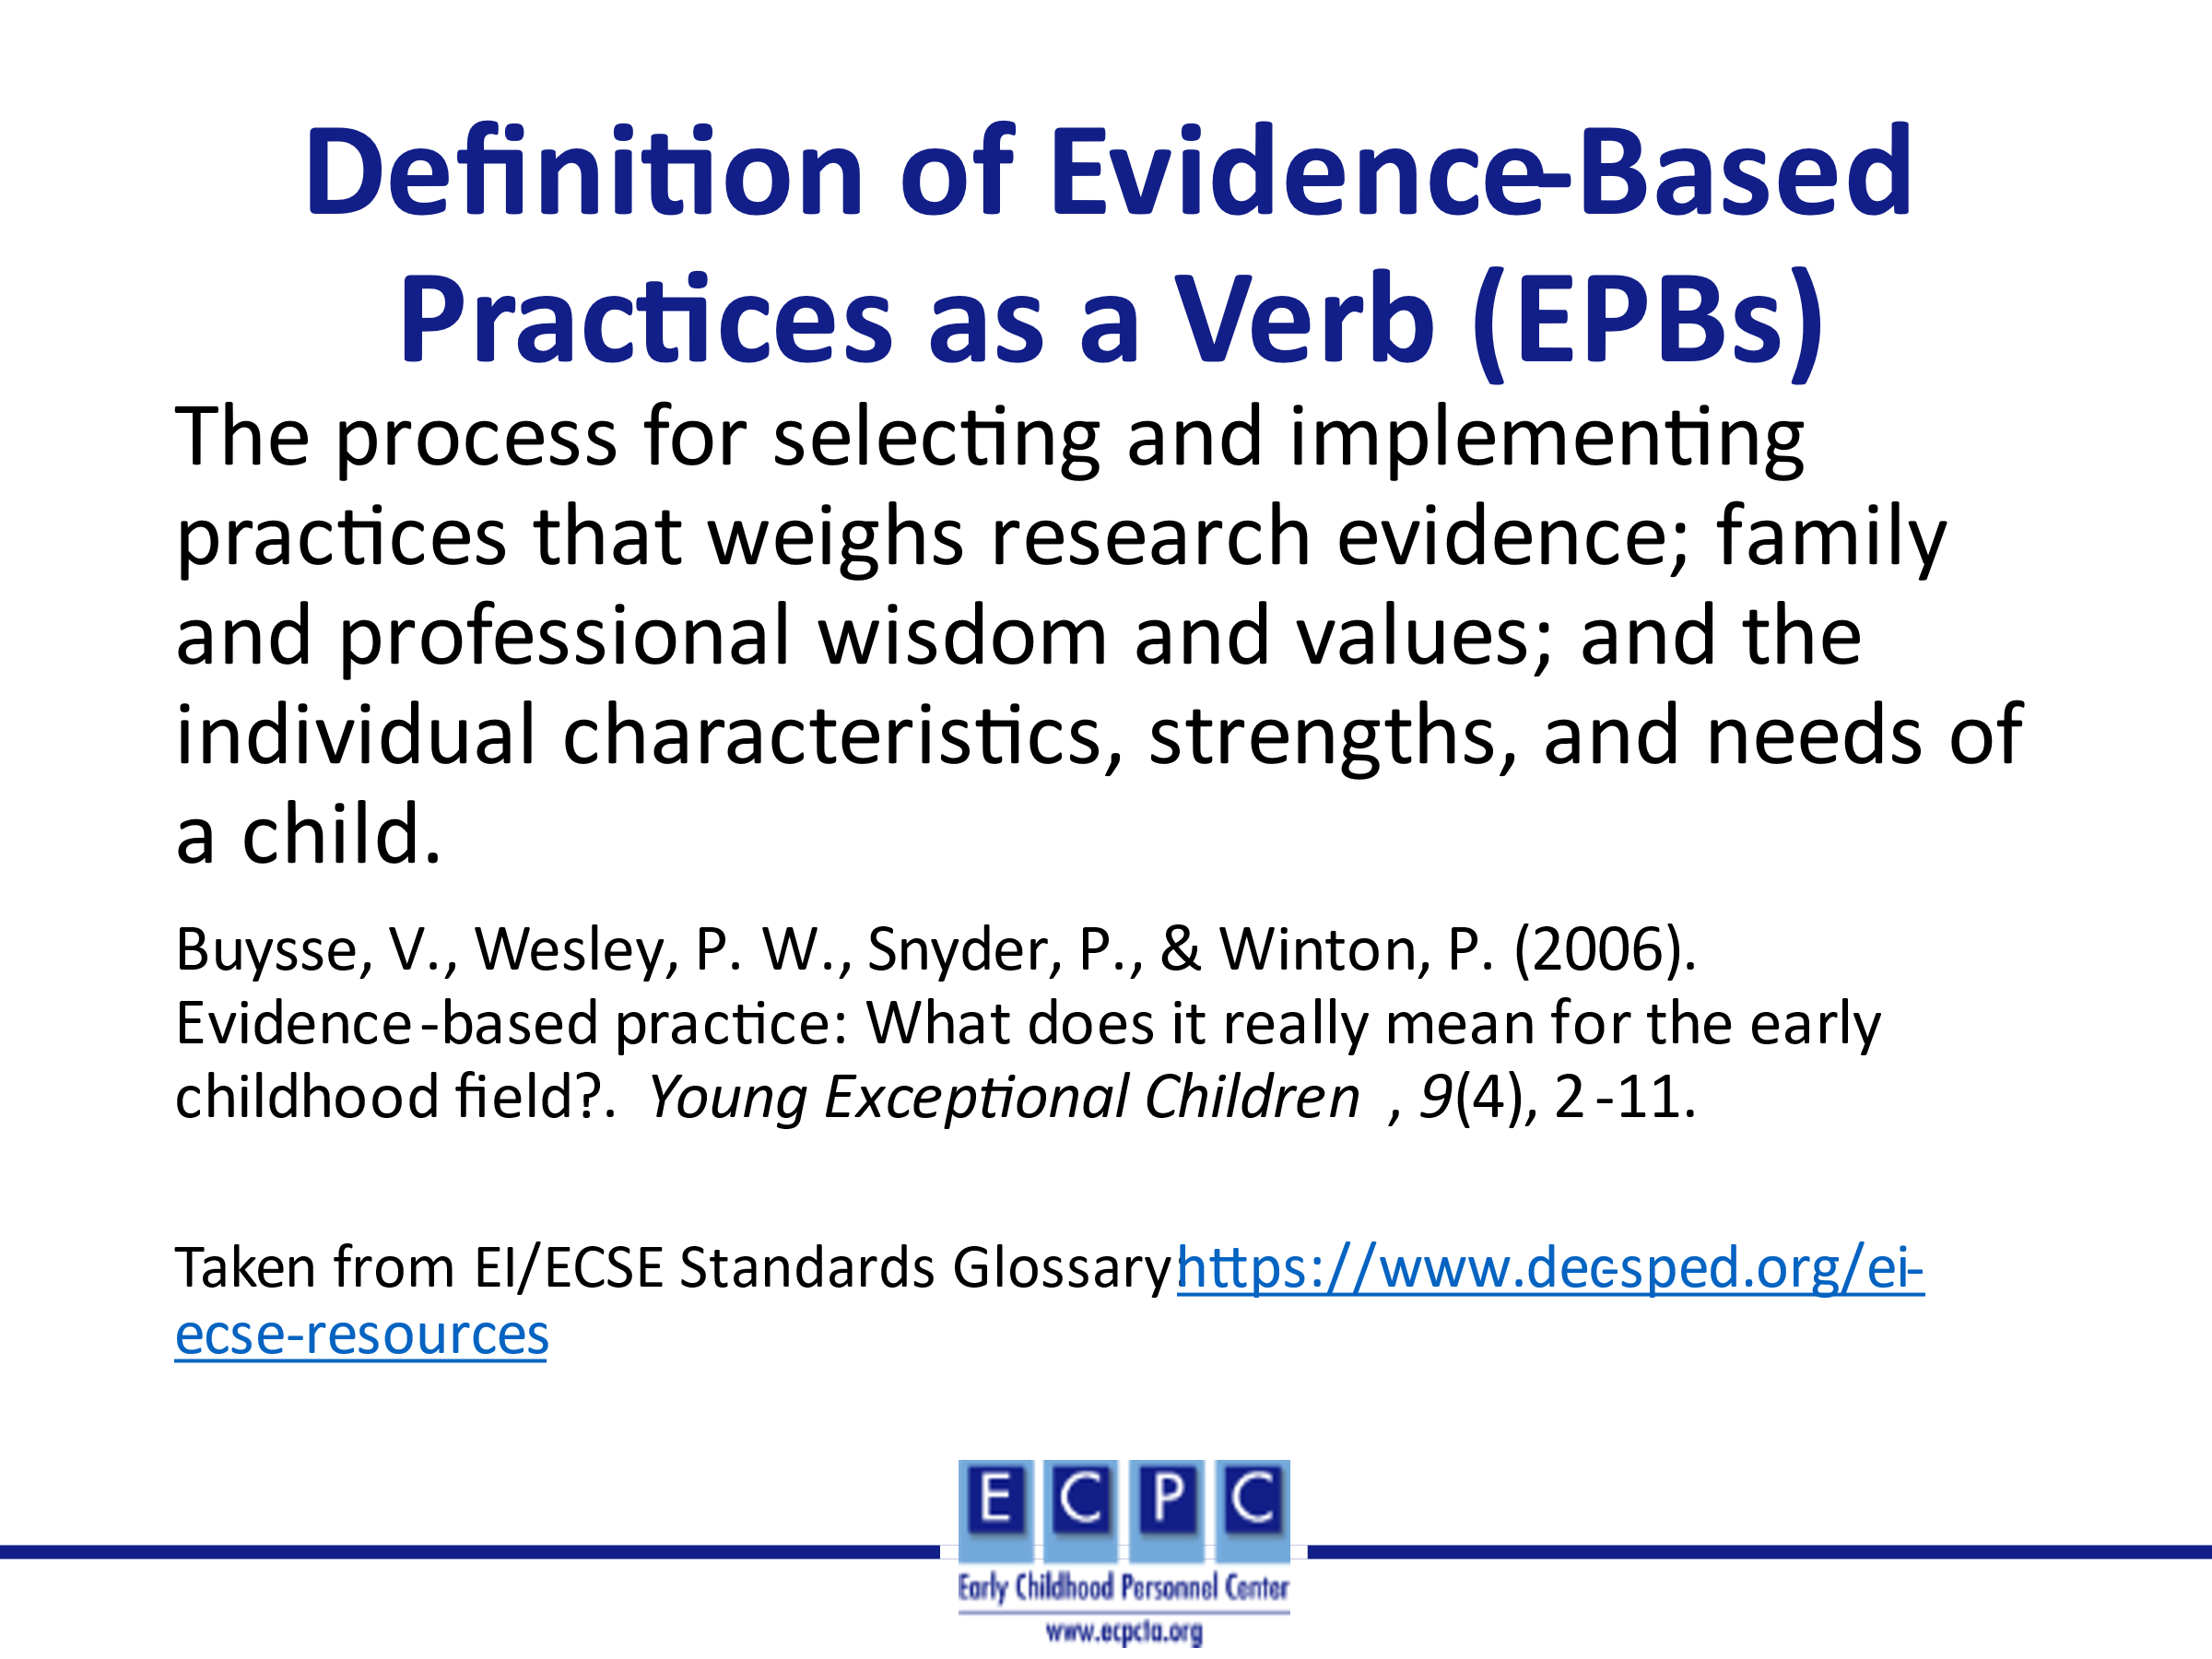
Slide 8 | 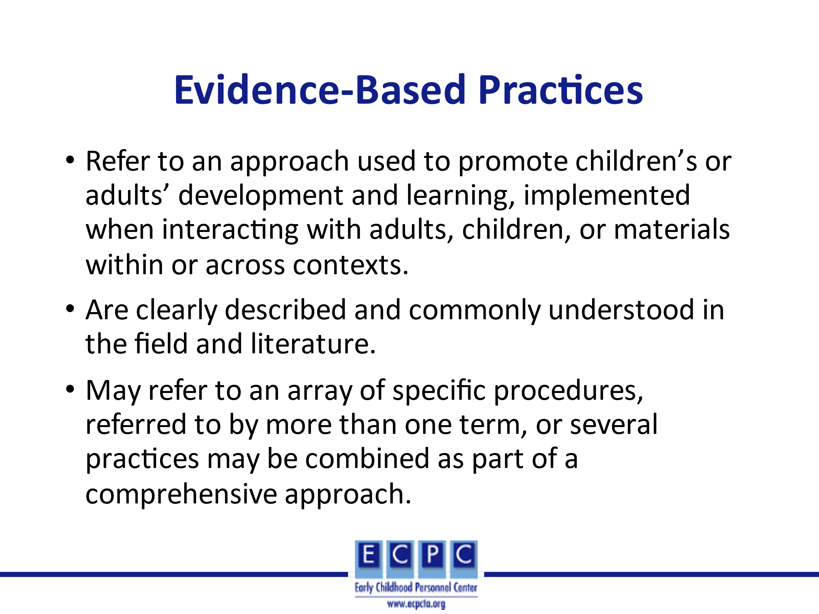 | In EI/ECSE, we use evidence-based practices (EBPs) to ensure that we are designing the learning environment and implementing effective assessment, intervention, and instruction to result in positive outcomes for children and families. The EBPs should be implemented in the same way and across settings with fidelity (I.e., implemented in the manner that they were intended to be implemented) by different EI/ECSE professionals. These may be discrete practices, such as using verbal prompts, or a combination of practices referred to as least prompts
Slide 9 | 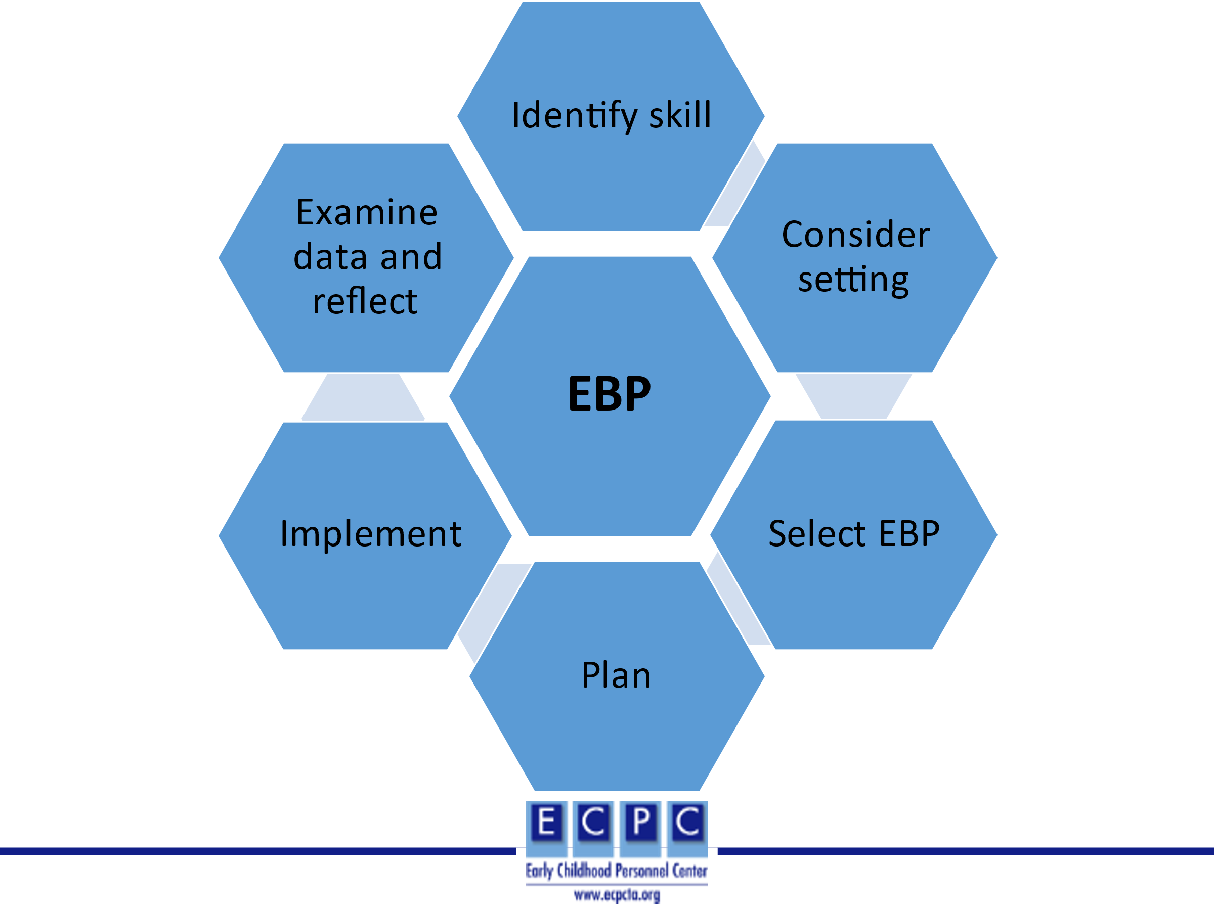 | When identifying, implementing, and evaluating the use of a specific EBP, we can use the following process that includes these steps.  1. Identify the skill or behavior that is included in the child’s goal/outcome.  2. Consider the characteristics of the setting that may influence the EBP to be selected. For example, in a home setting what toys/materials are available to use in implementing the practice. What are the interests/preferences of the child? What are the families’ priorities, including preferences for integrating practices into daily routines. The first two considerations could also be applied to center-based settings.  3. Based on the skill and environmental factors, what EBP seems to be the most appropriate to implement.  4. Include the EBP in session plans for home settings and lesson plans for center-based settings.  5. Implement the plan and collect progress data.  6. Analyze the data and reflect on what it means in terms of next steps in intervention/instruction.
Slide 10 | 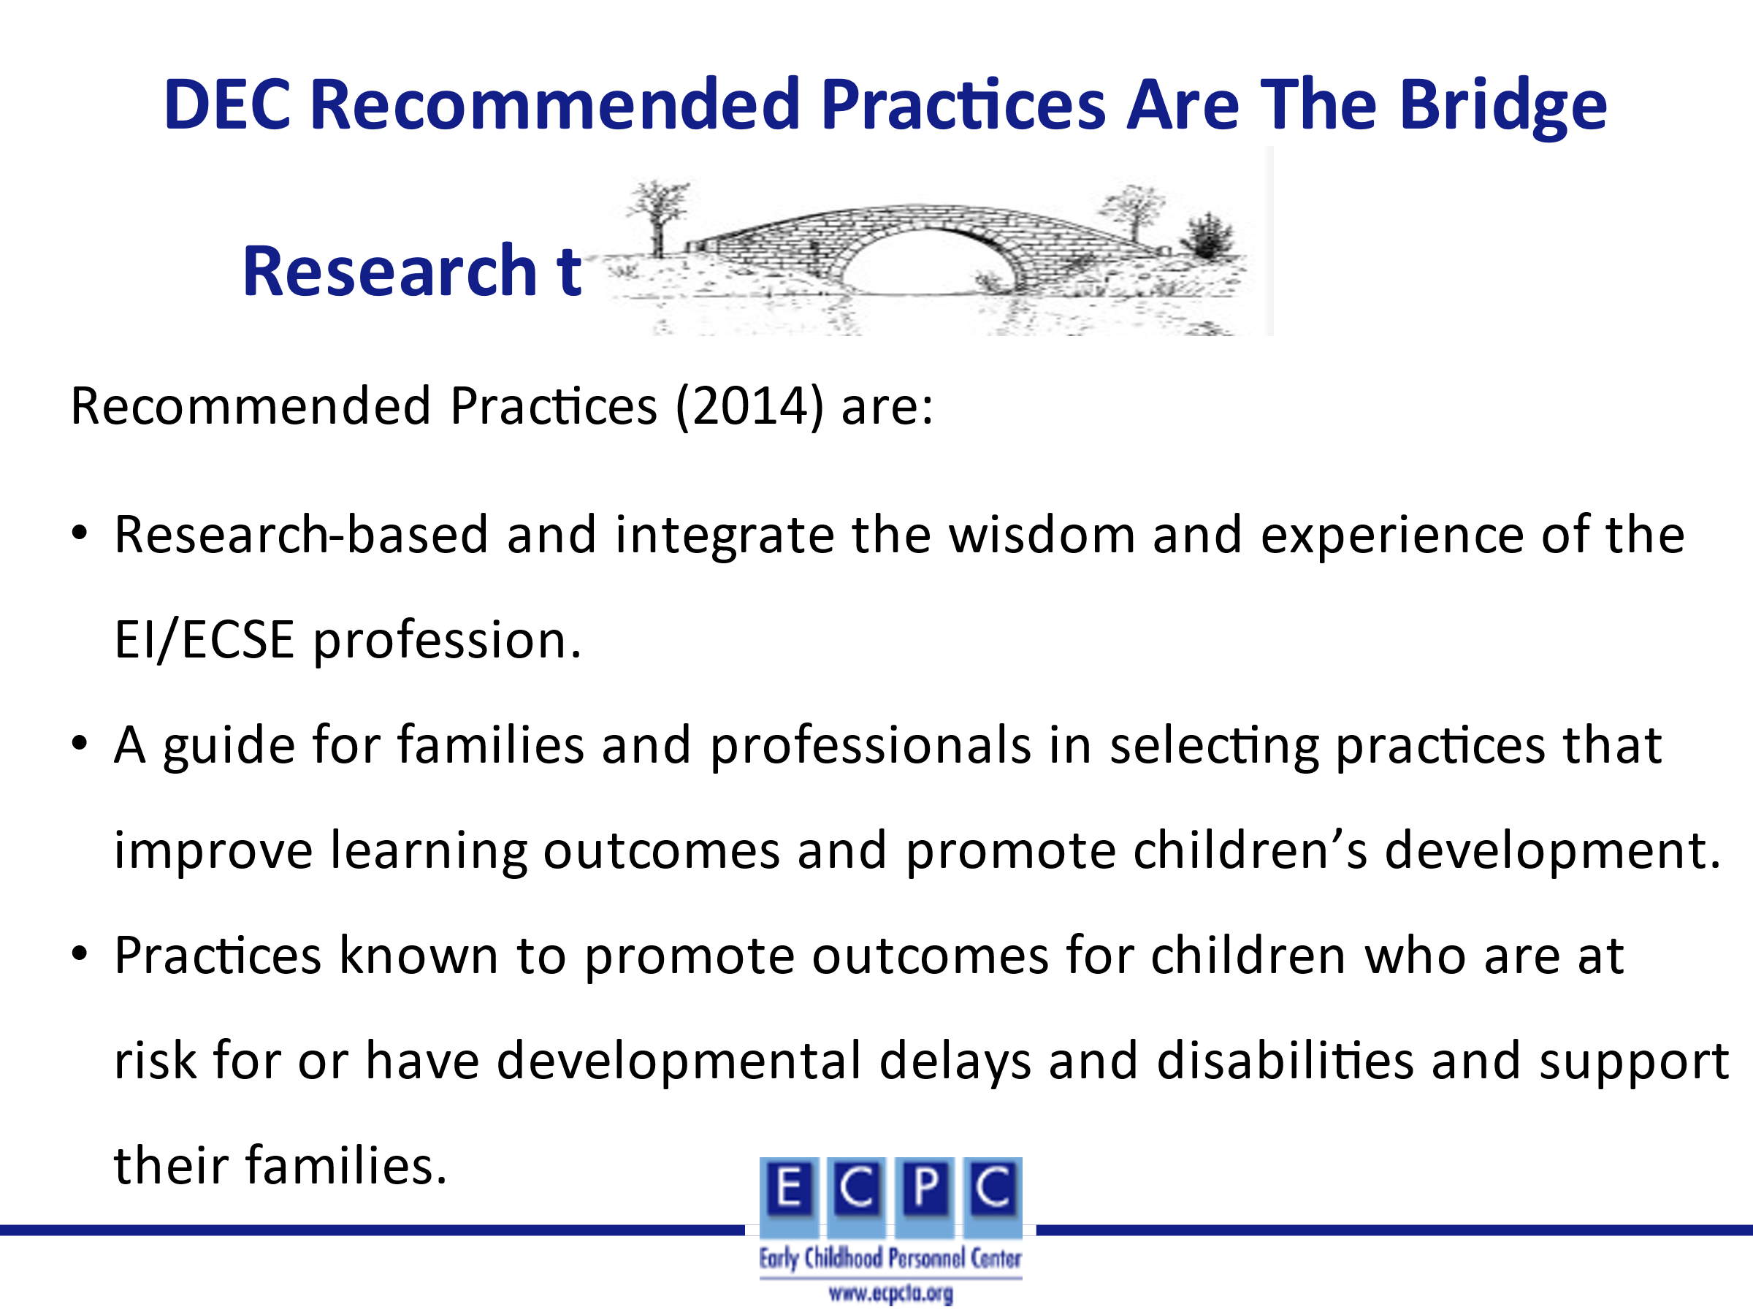 | The DEC Recommended Practices (RPs) (2014) are based on research and the professional wisdom and experience of the field. They serve as a valuable resource for both families and professionals when identifying EBPs to incorporate into individualized plans.
Slide 11 | 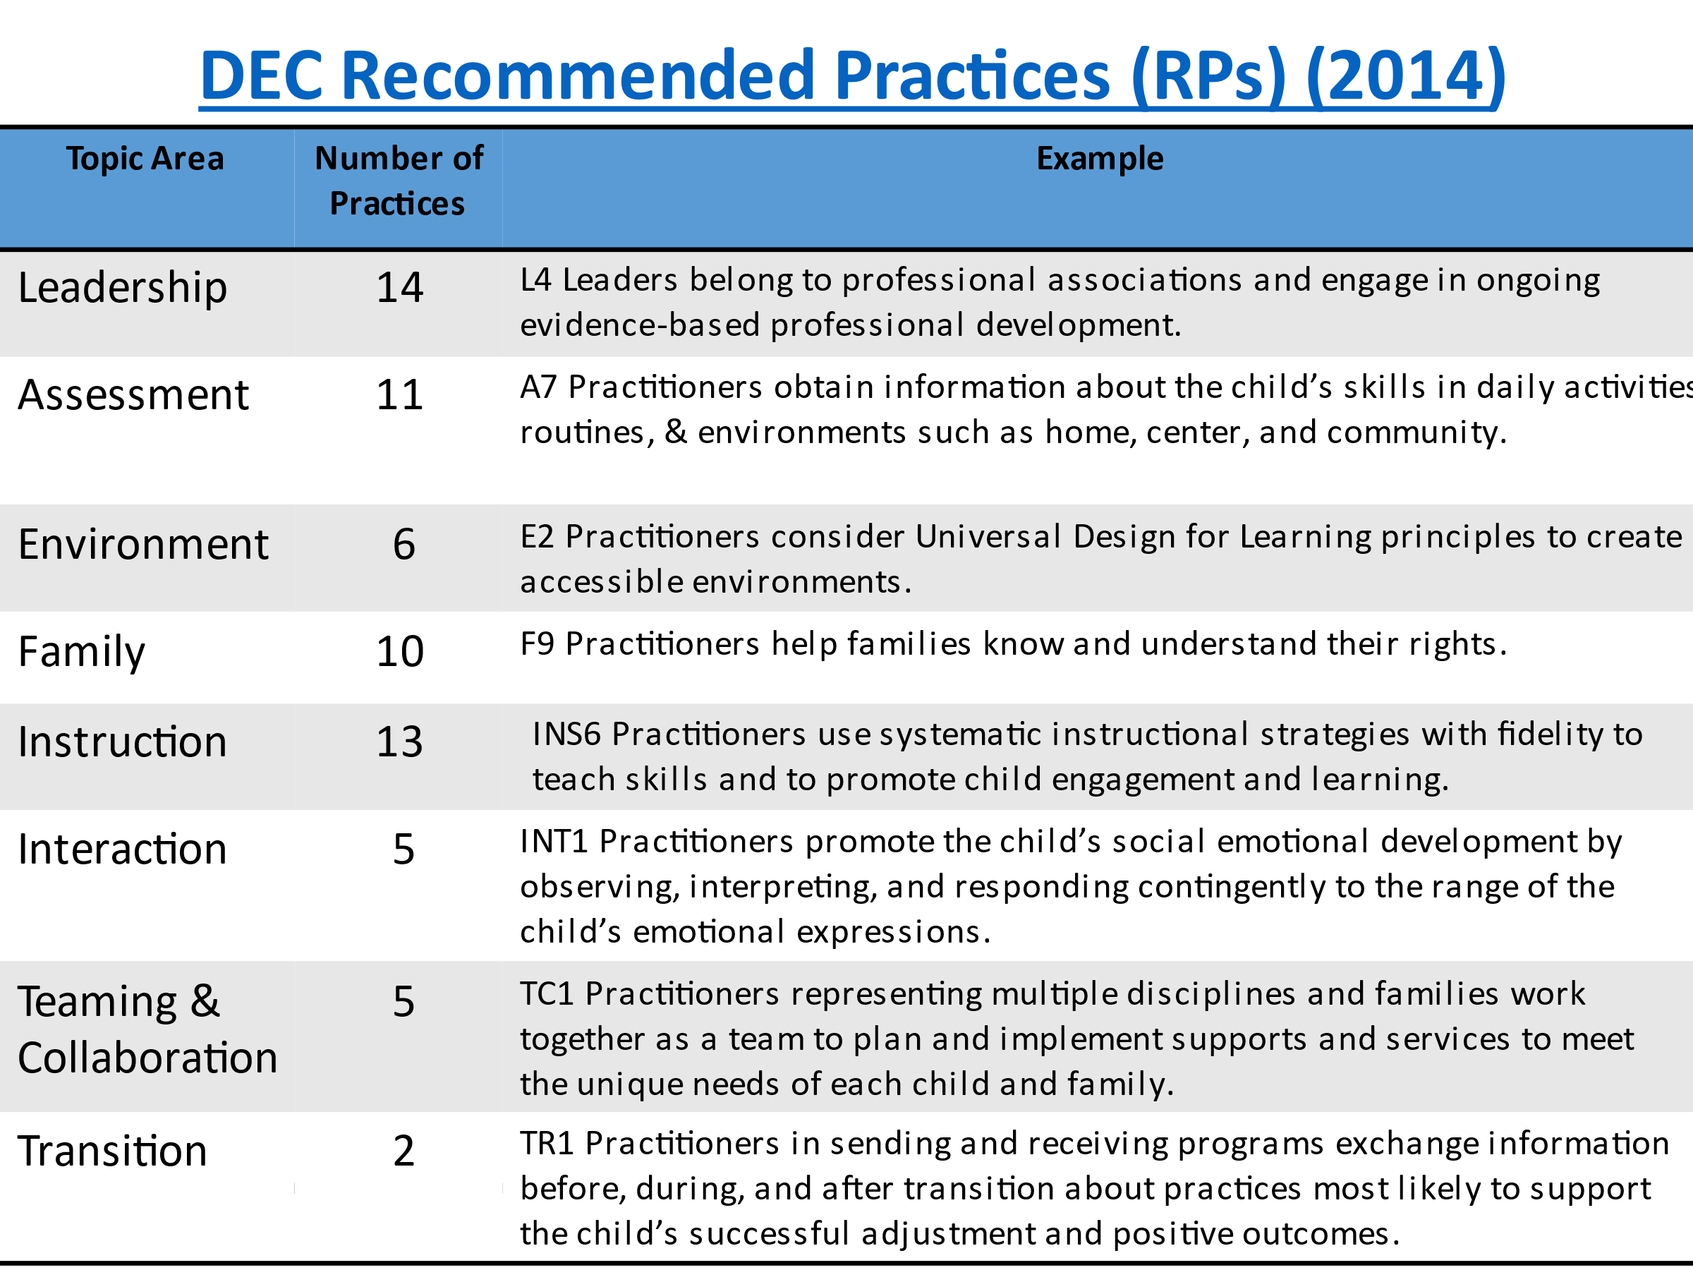 | The DEC RPs (2014) include 8 topic areas with a range of 2-14 practices within each topic area. This table identifies the 8 topic areas included in the RPs, the number of practices for each area, and an example of one of the practices for each  topic area. The practices for each topic area can be found at https://www.dec-sped.org/dec-recommended-practices.
Slide 12 | 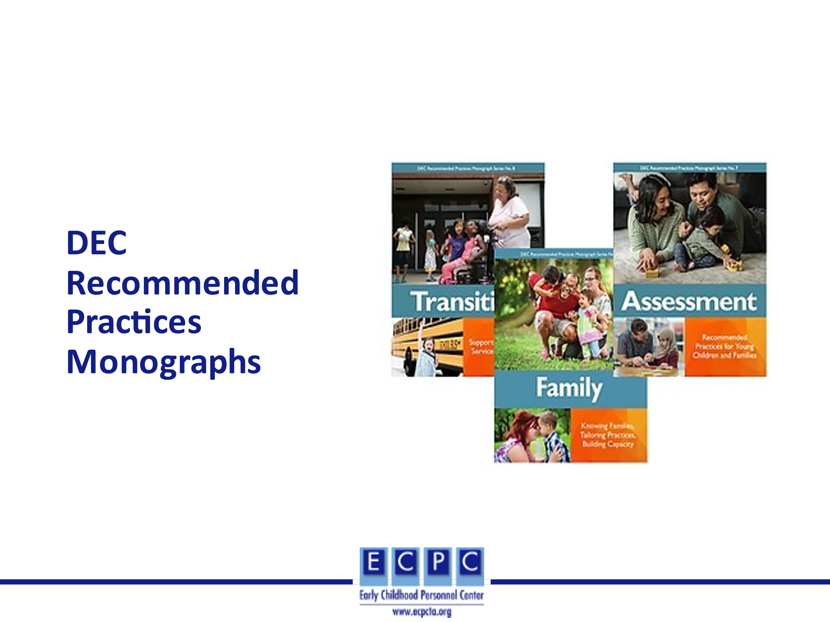 | A variety of resources have been developed to support the use of the DEC RPs (2014). This includes a monograph series, recommended practice modules, videos, and a document with examples of what the practice would look like in EI/ECSE settings. These resources can all be found at https://www.dec-sped.org/dec-recommended-practices.
Slide 13 | 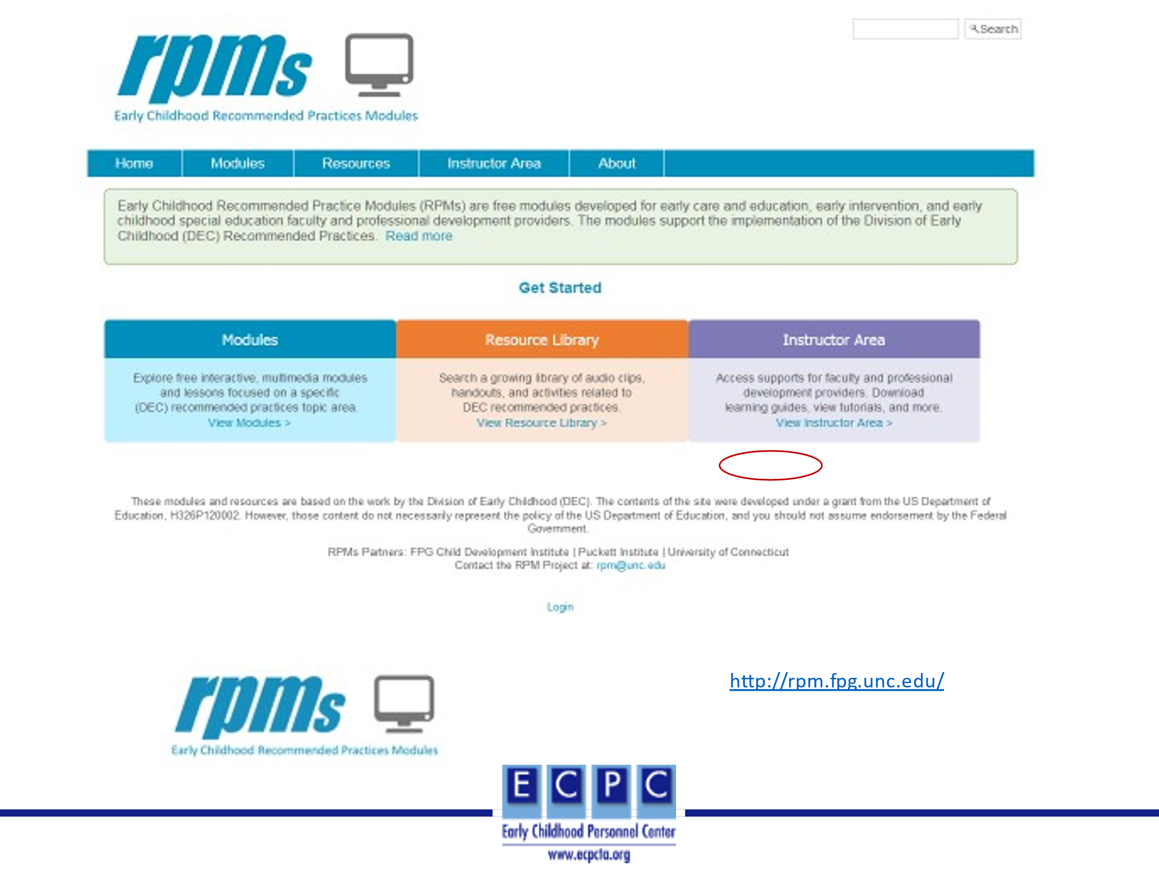
Slide 14 | 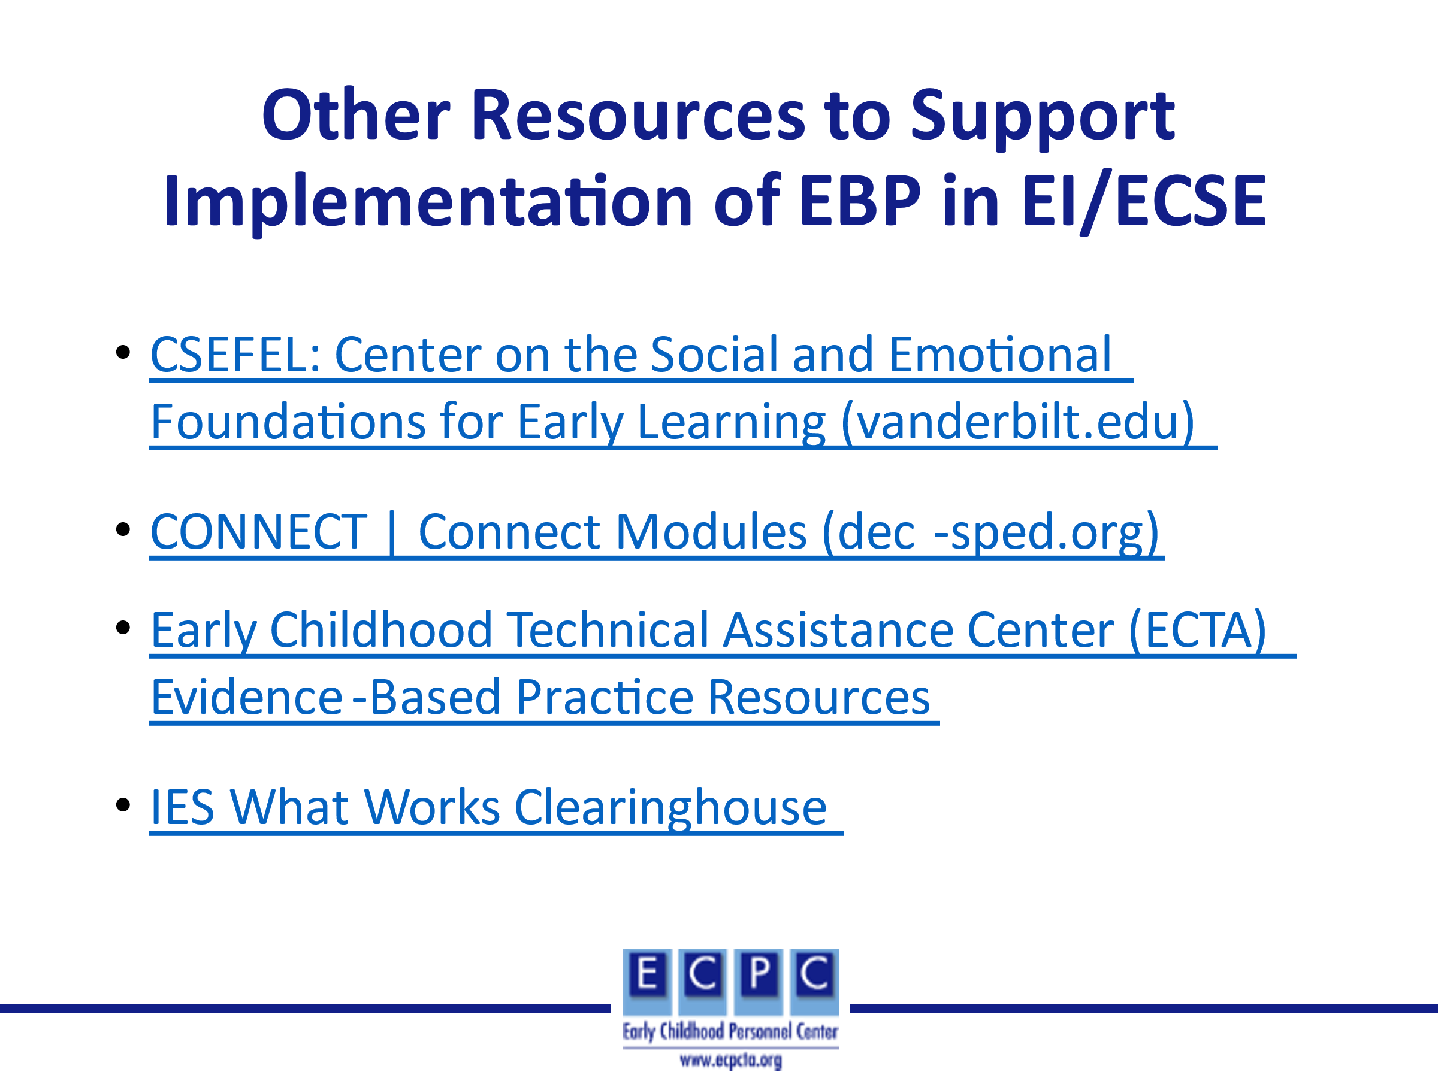 | The links on this slide and the next one are additional resources to facilitate the selection and implementation of EBPs.  http://csefel.vanderbilt.edu/#content  https://connectmodules.dec-sped.org/#content
Slide 15 | 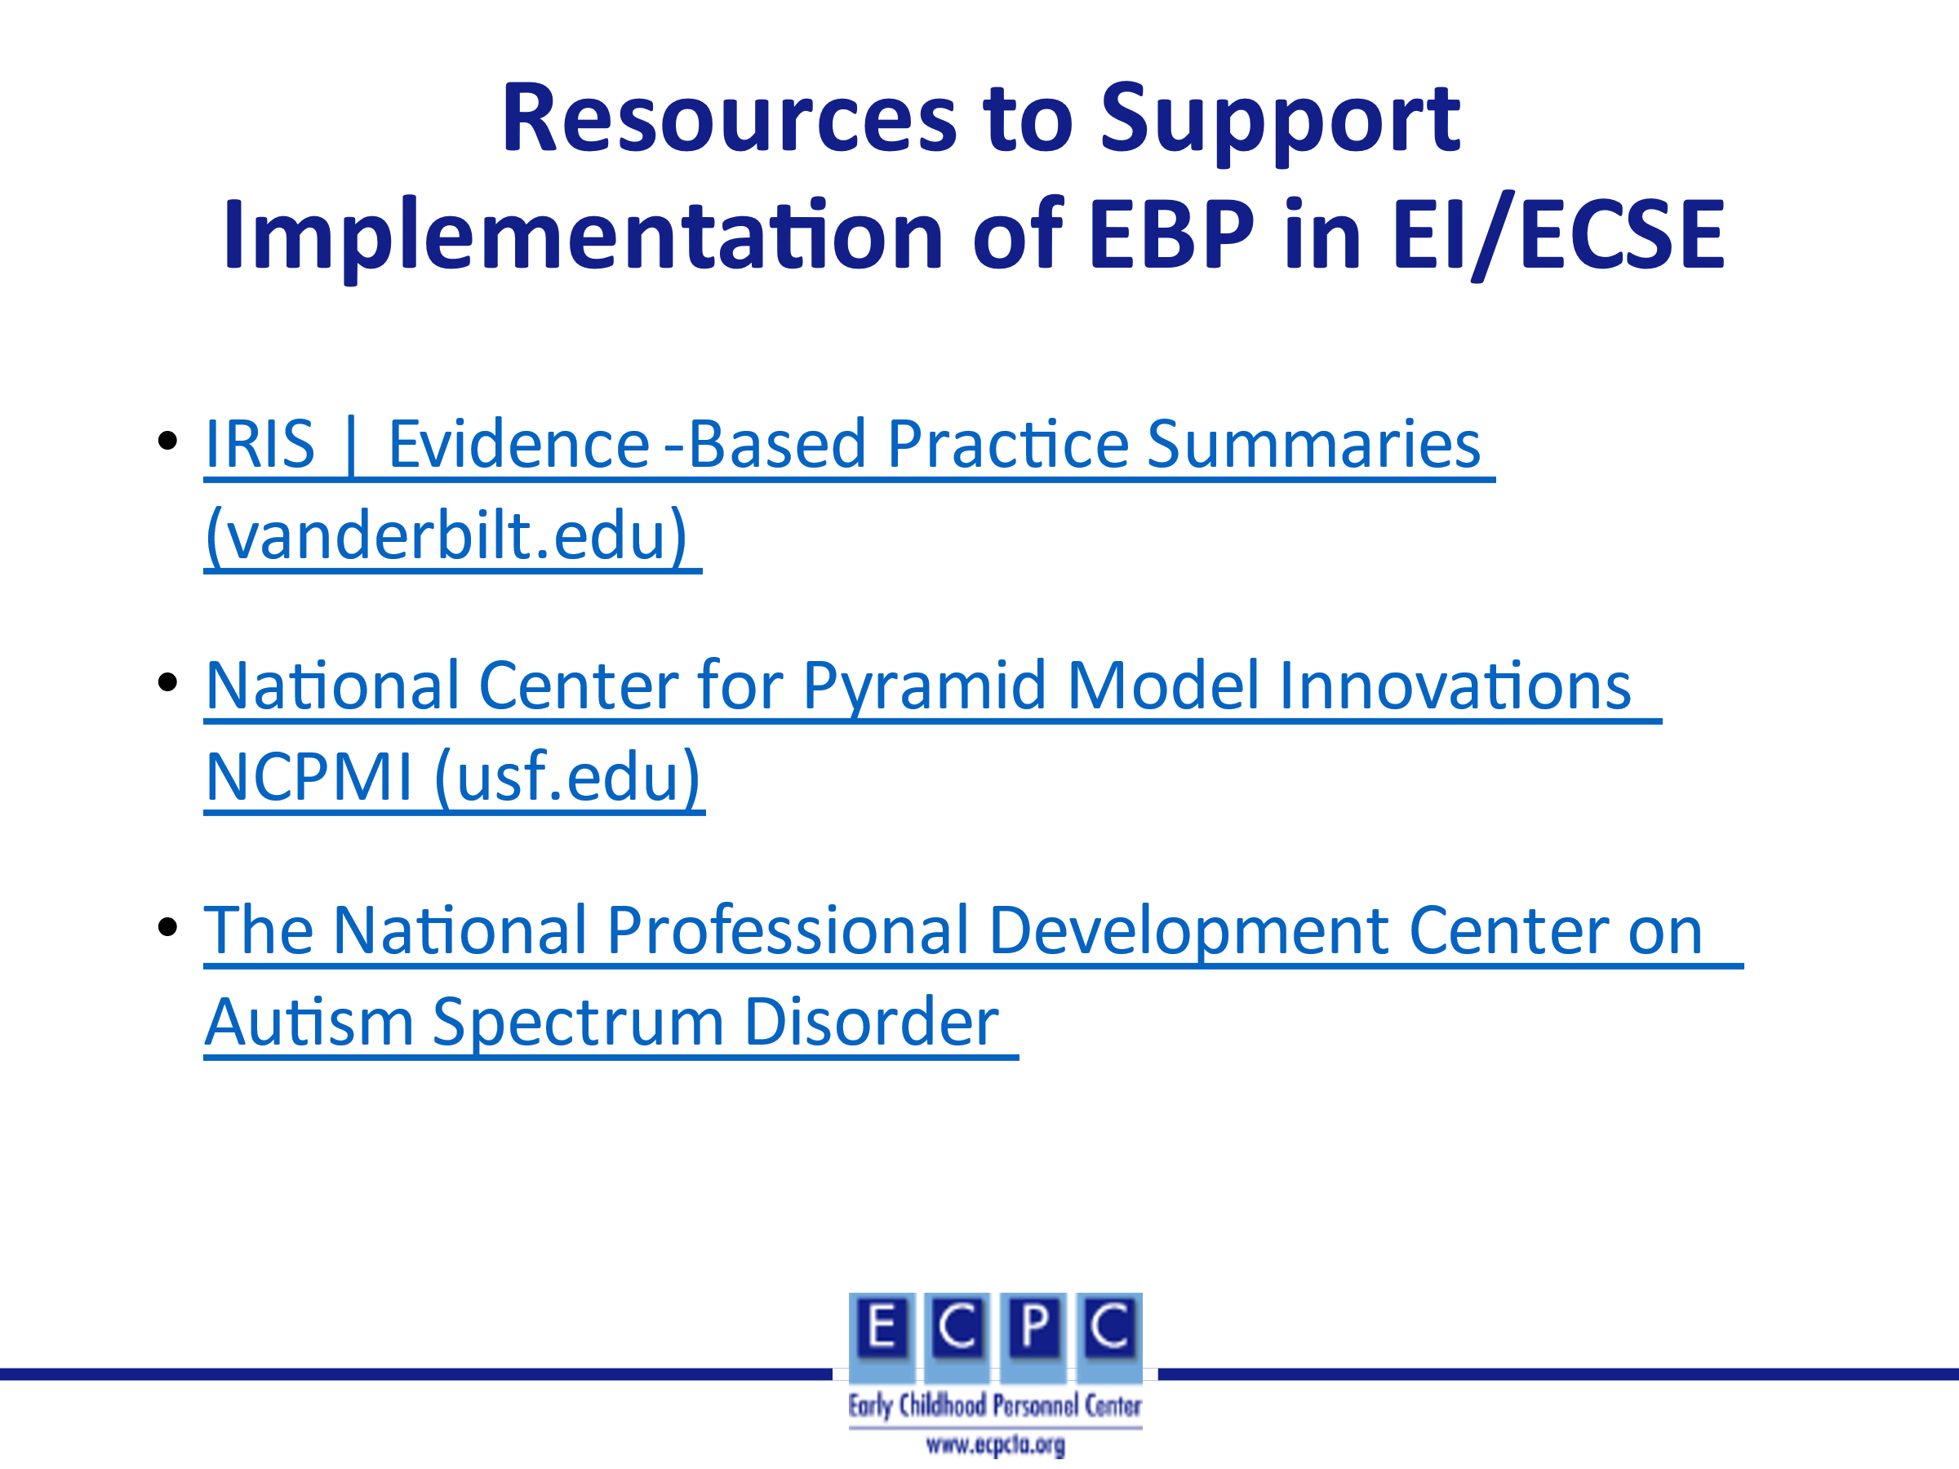 | https://iris.peabody.vanderbilt.edu/resources/ebp_summaries/#content  https://challengingbehavior.cbcs.usf.edu/
Slide 16 | 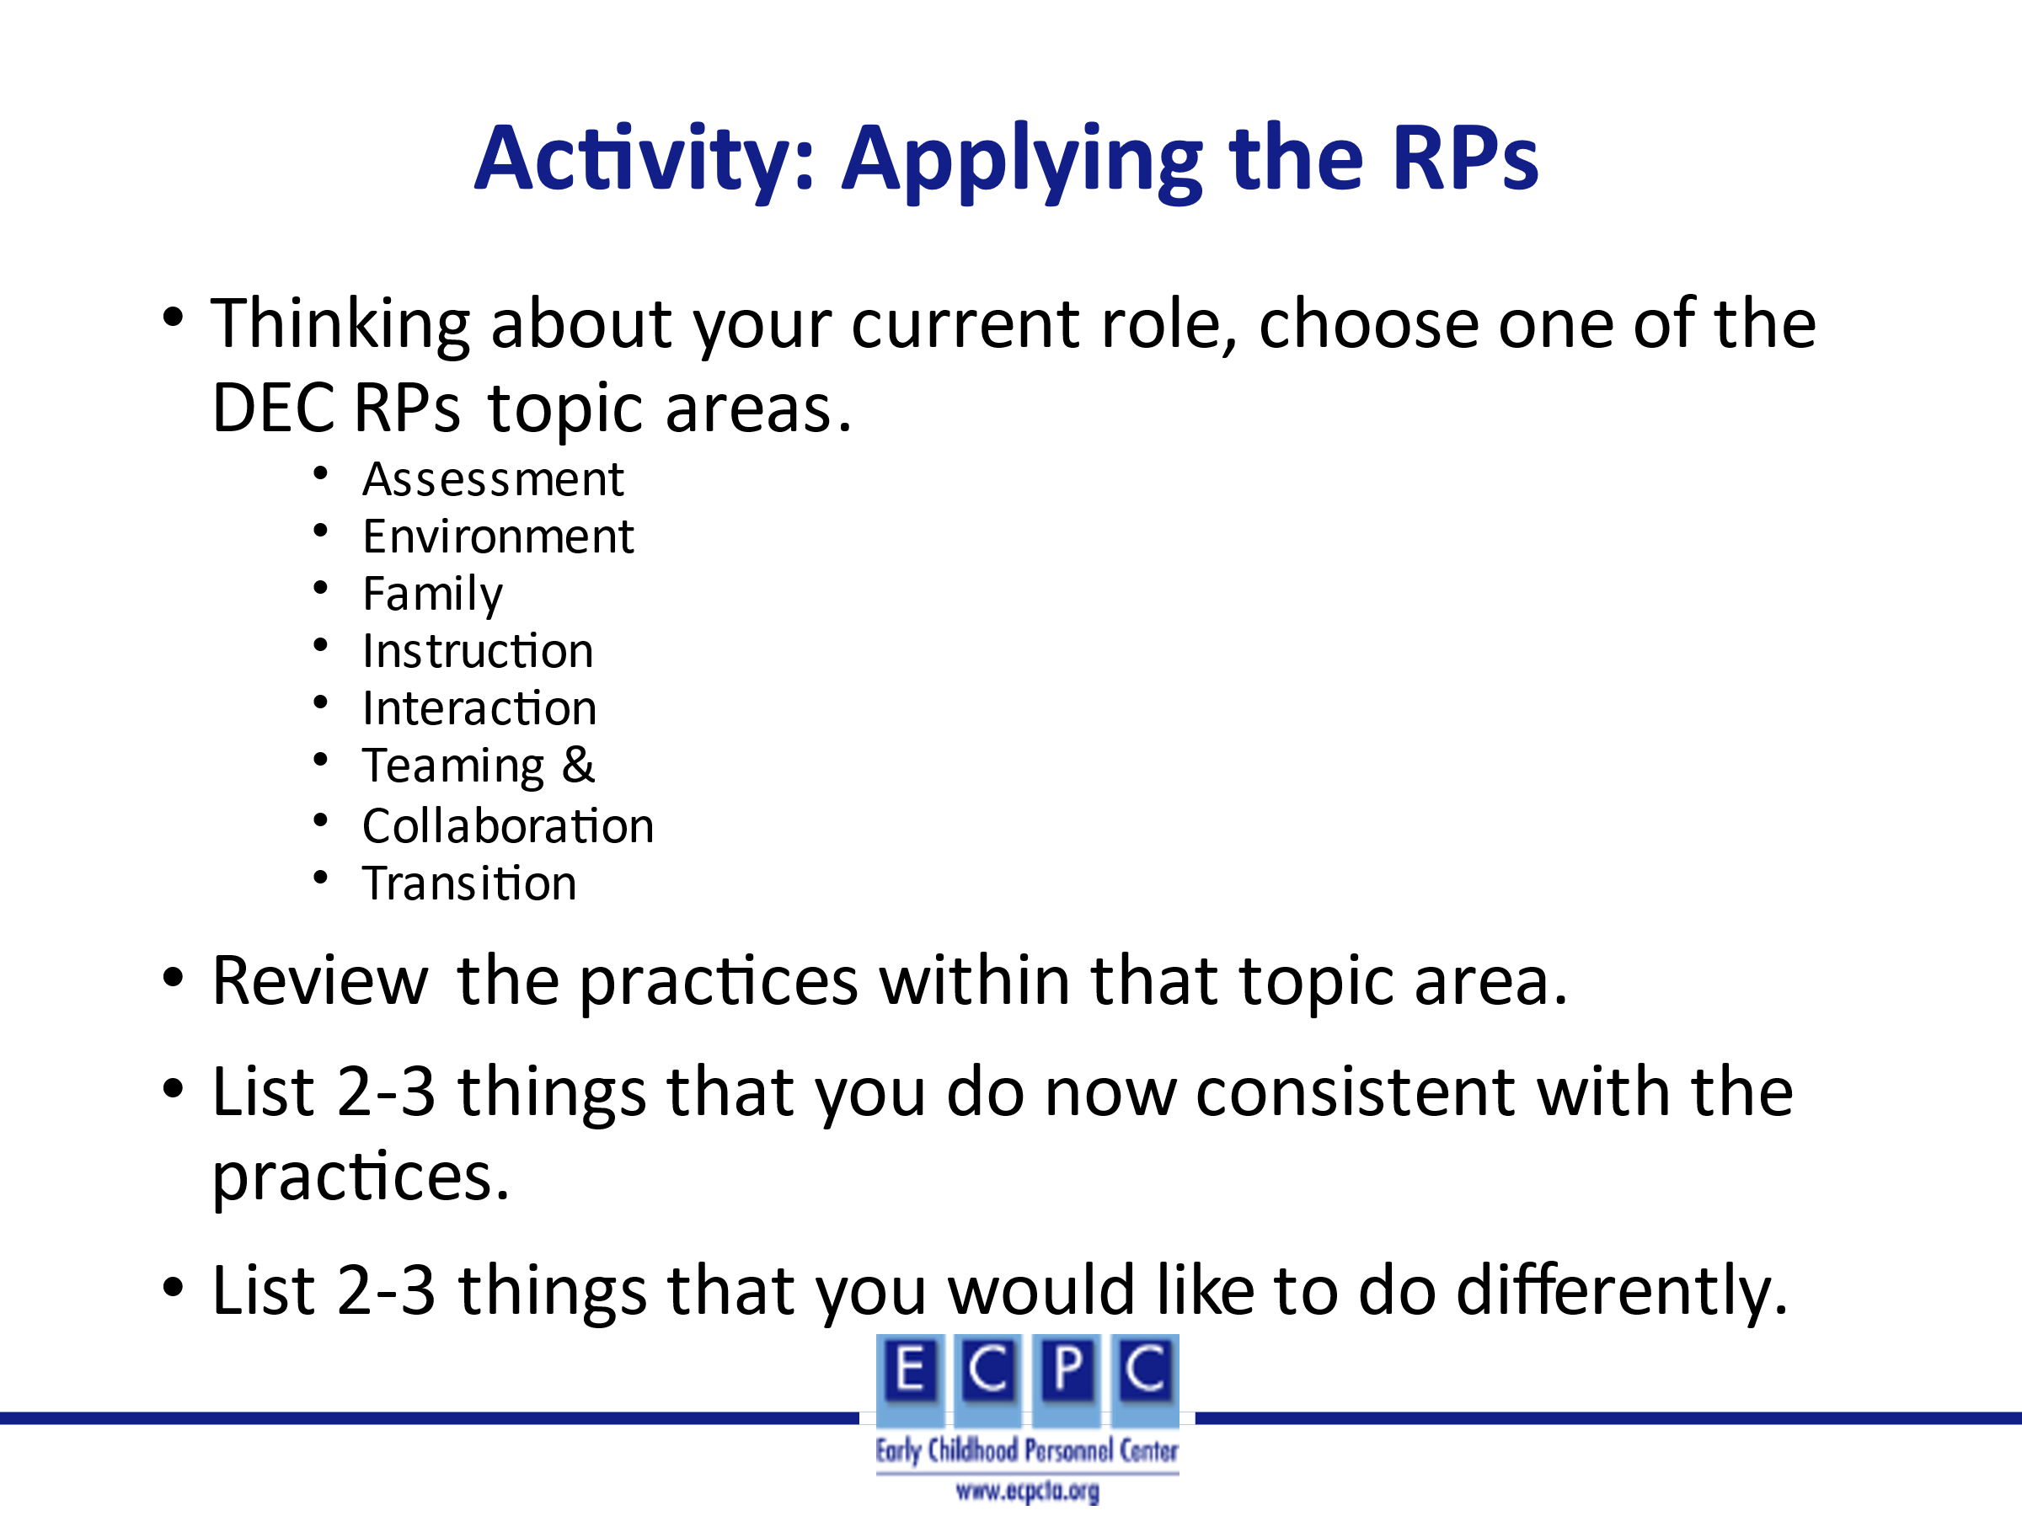 | Ask learners to complete the activity individually. Ask for volunteers to share their responses with the group.
Slide 17 | 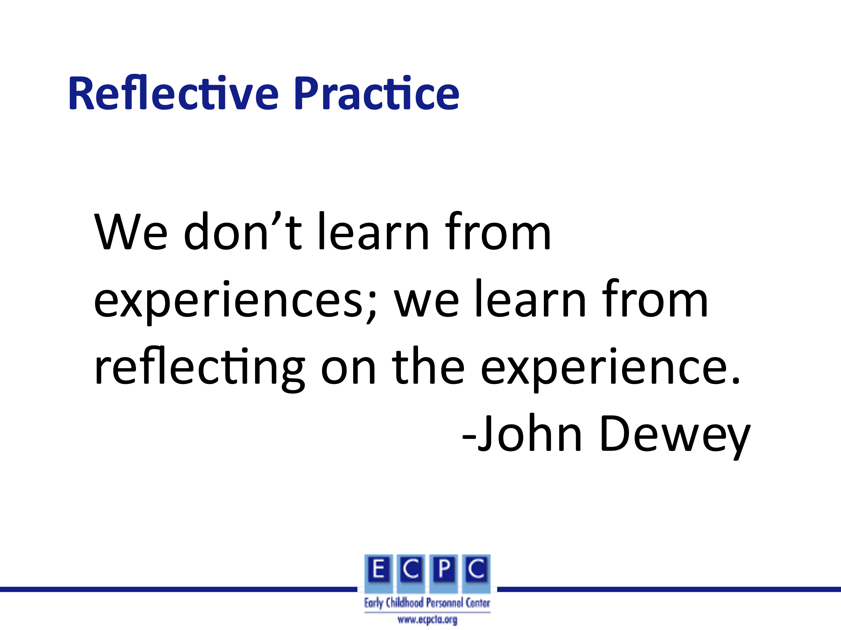
Slide 18 | 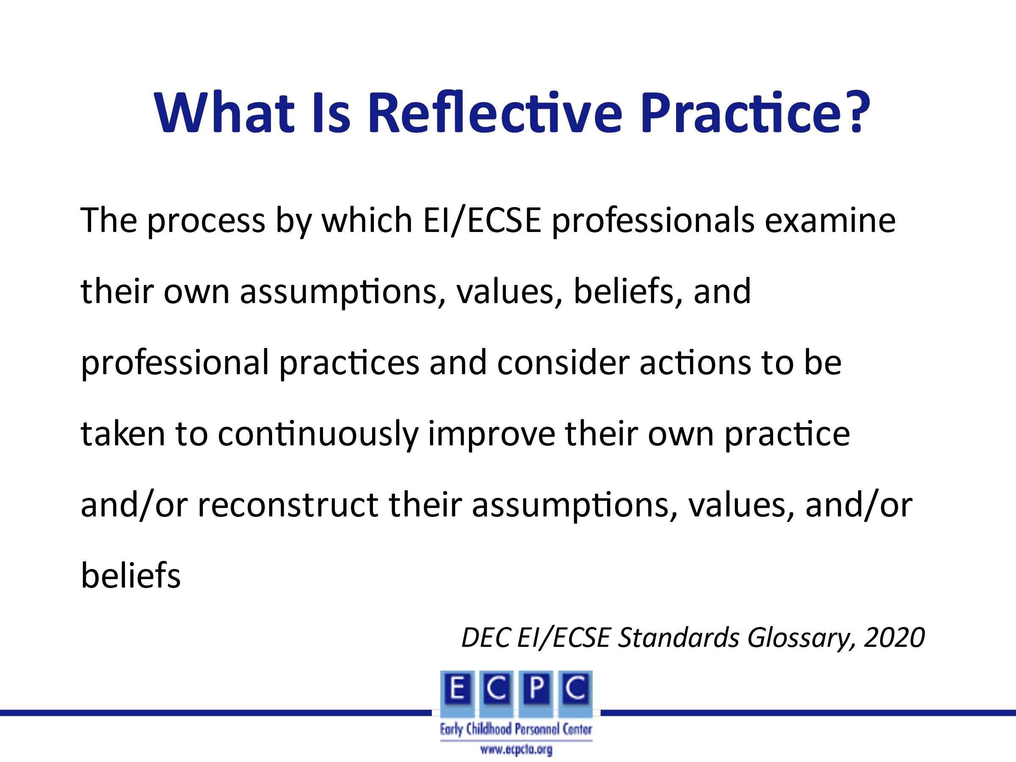 | Reflective practice involves thinking about what we did and how our assumptions, values, and beliefs about children and families, and the intervention/instruction practices that we use have implications for outcomes for children and families.
Slide 19 | 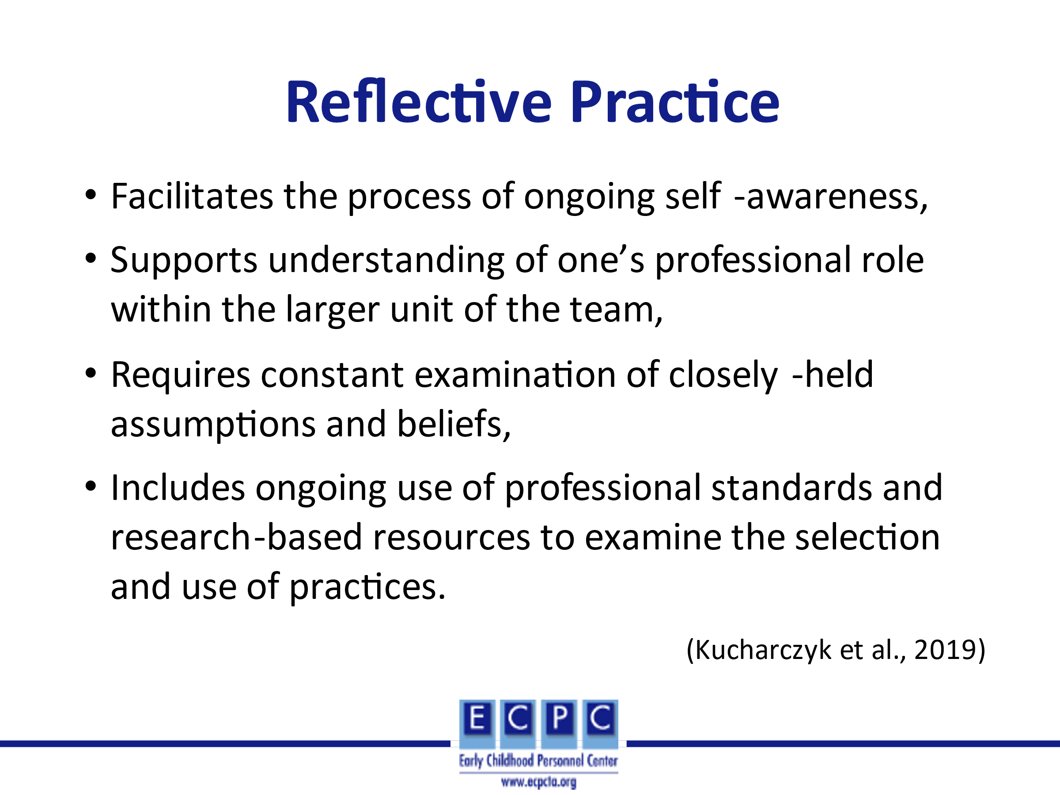 | Ongoing reflective practice leads to reliance on research-based resources and increased self-awareness or self-efficacy and thus, examination of how our assumptions, values, and beliefs impact our interactions with children and families and to the use of effective EBPs.
Slide 20 | 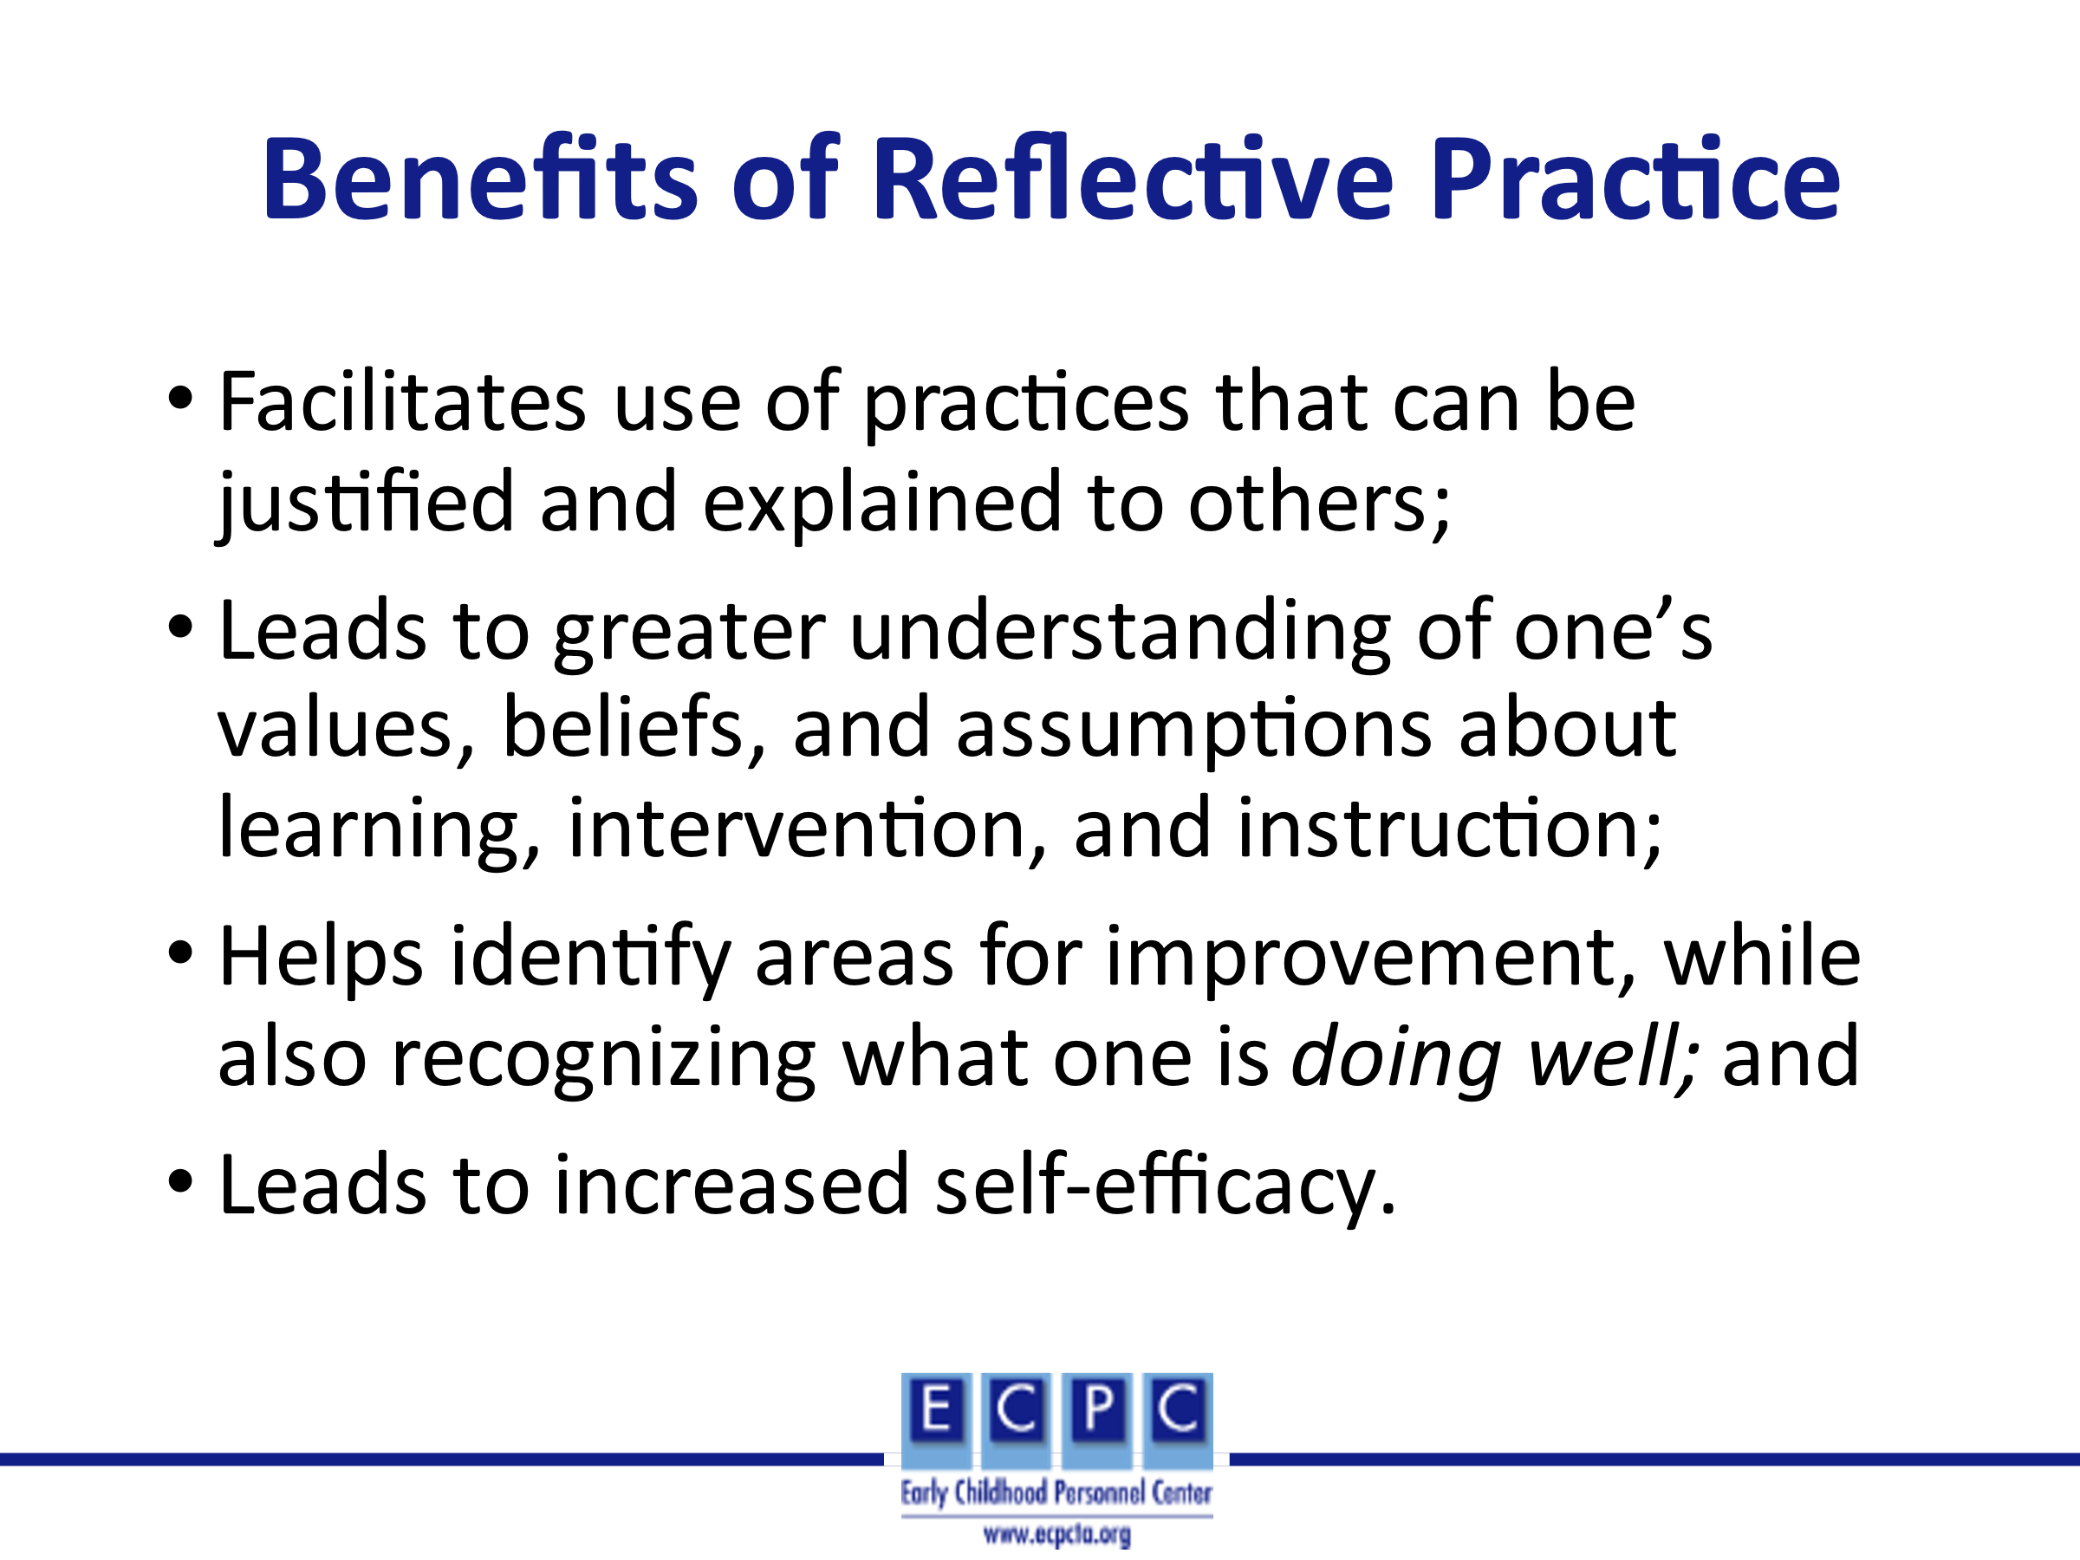 | Reflective practice helps clarify what EI/ECSE professionals are doing and why they are using specific practices, and thus, that can then be conveyed to colleagues and families. Reflective practice areas for professional growth are identified as well as strengths of the EI/ECSE professional. This leads to greater self-efficacy, which we will discuss next.
Slide 21 | 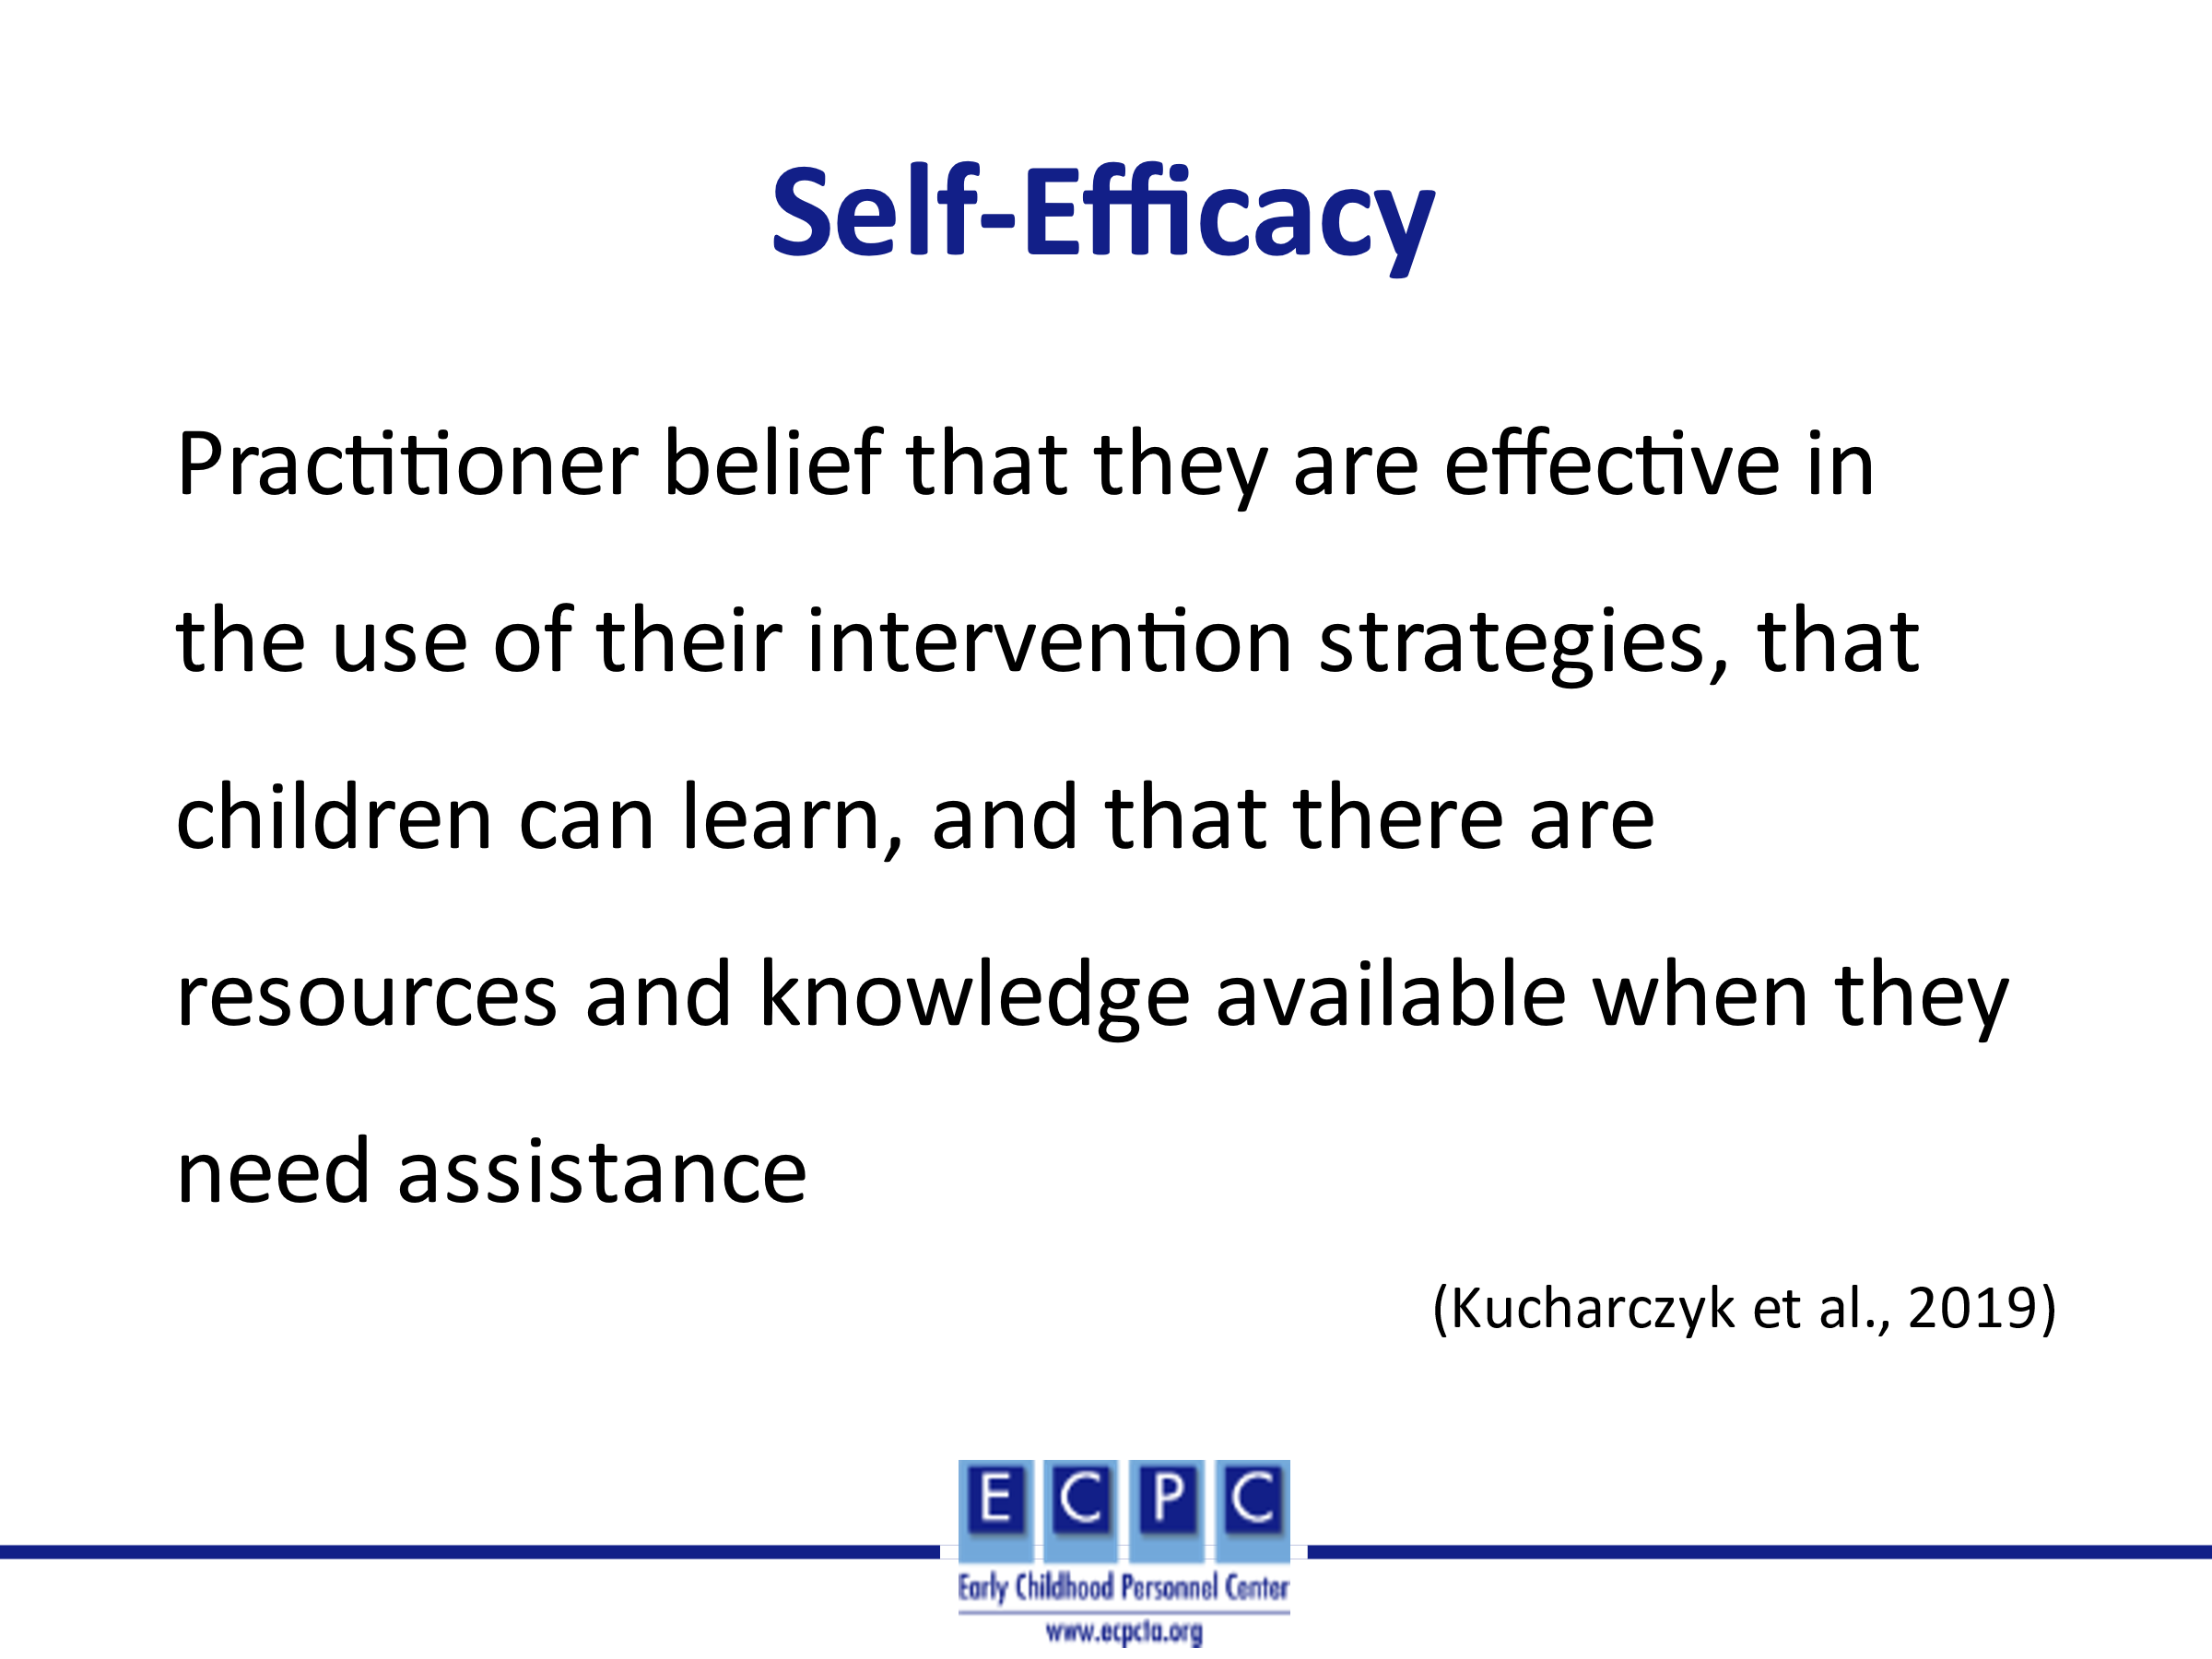 | Strong self-efficacy is associated with higher levels of family engagement and better child outcomes. When practitioners are confident about their own use of evidence-based practices, family members are more likely to engage with practitioners, ask questions, receive relevant information and feedback, and try out interventions with their own children. When a practitioner is confident about her or his own role and efficacy, there is a greater likelihood that that person will be able to work with cross-disciplinary professionals in a responsive, problem-solving way.
Slide 22 | 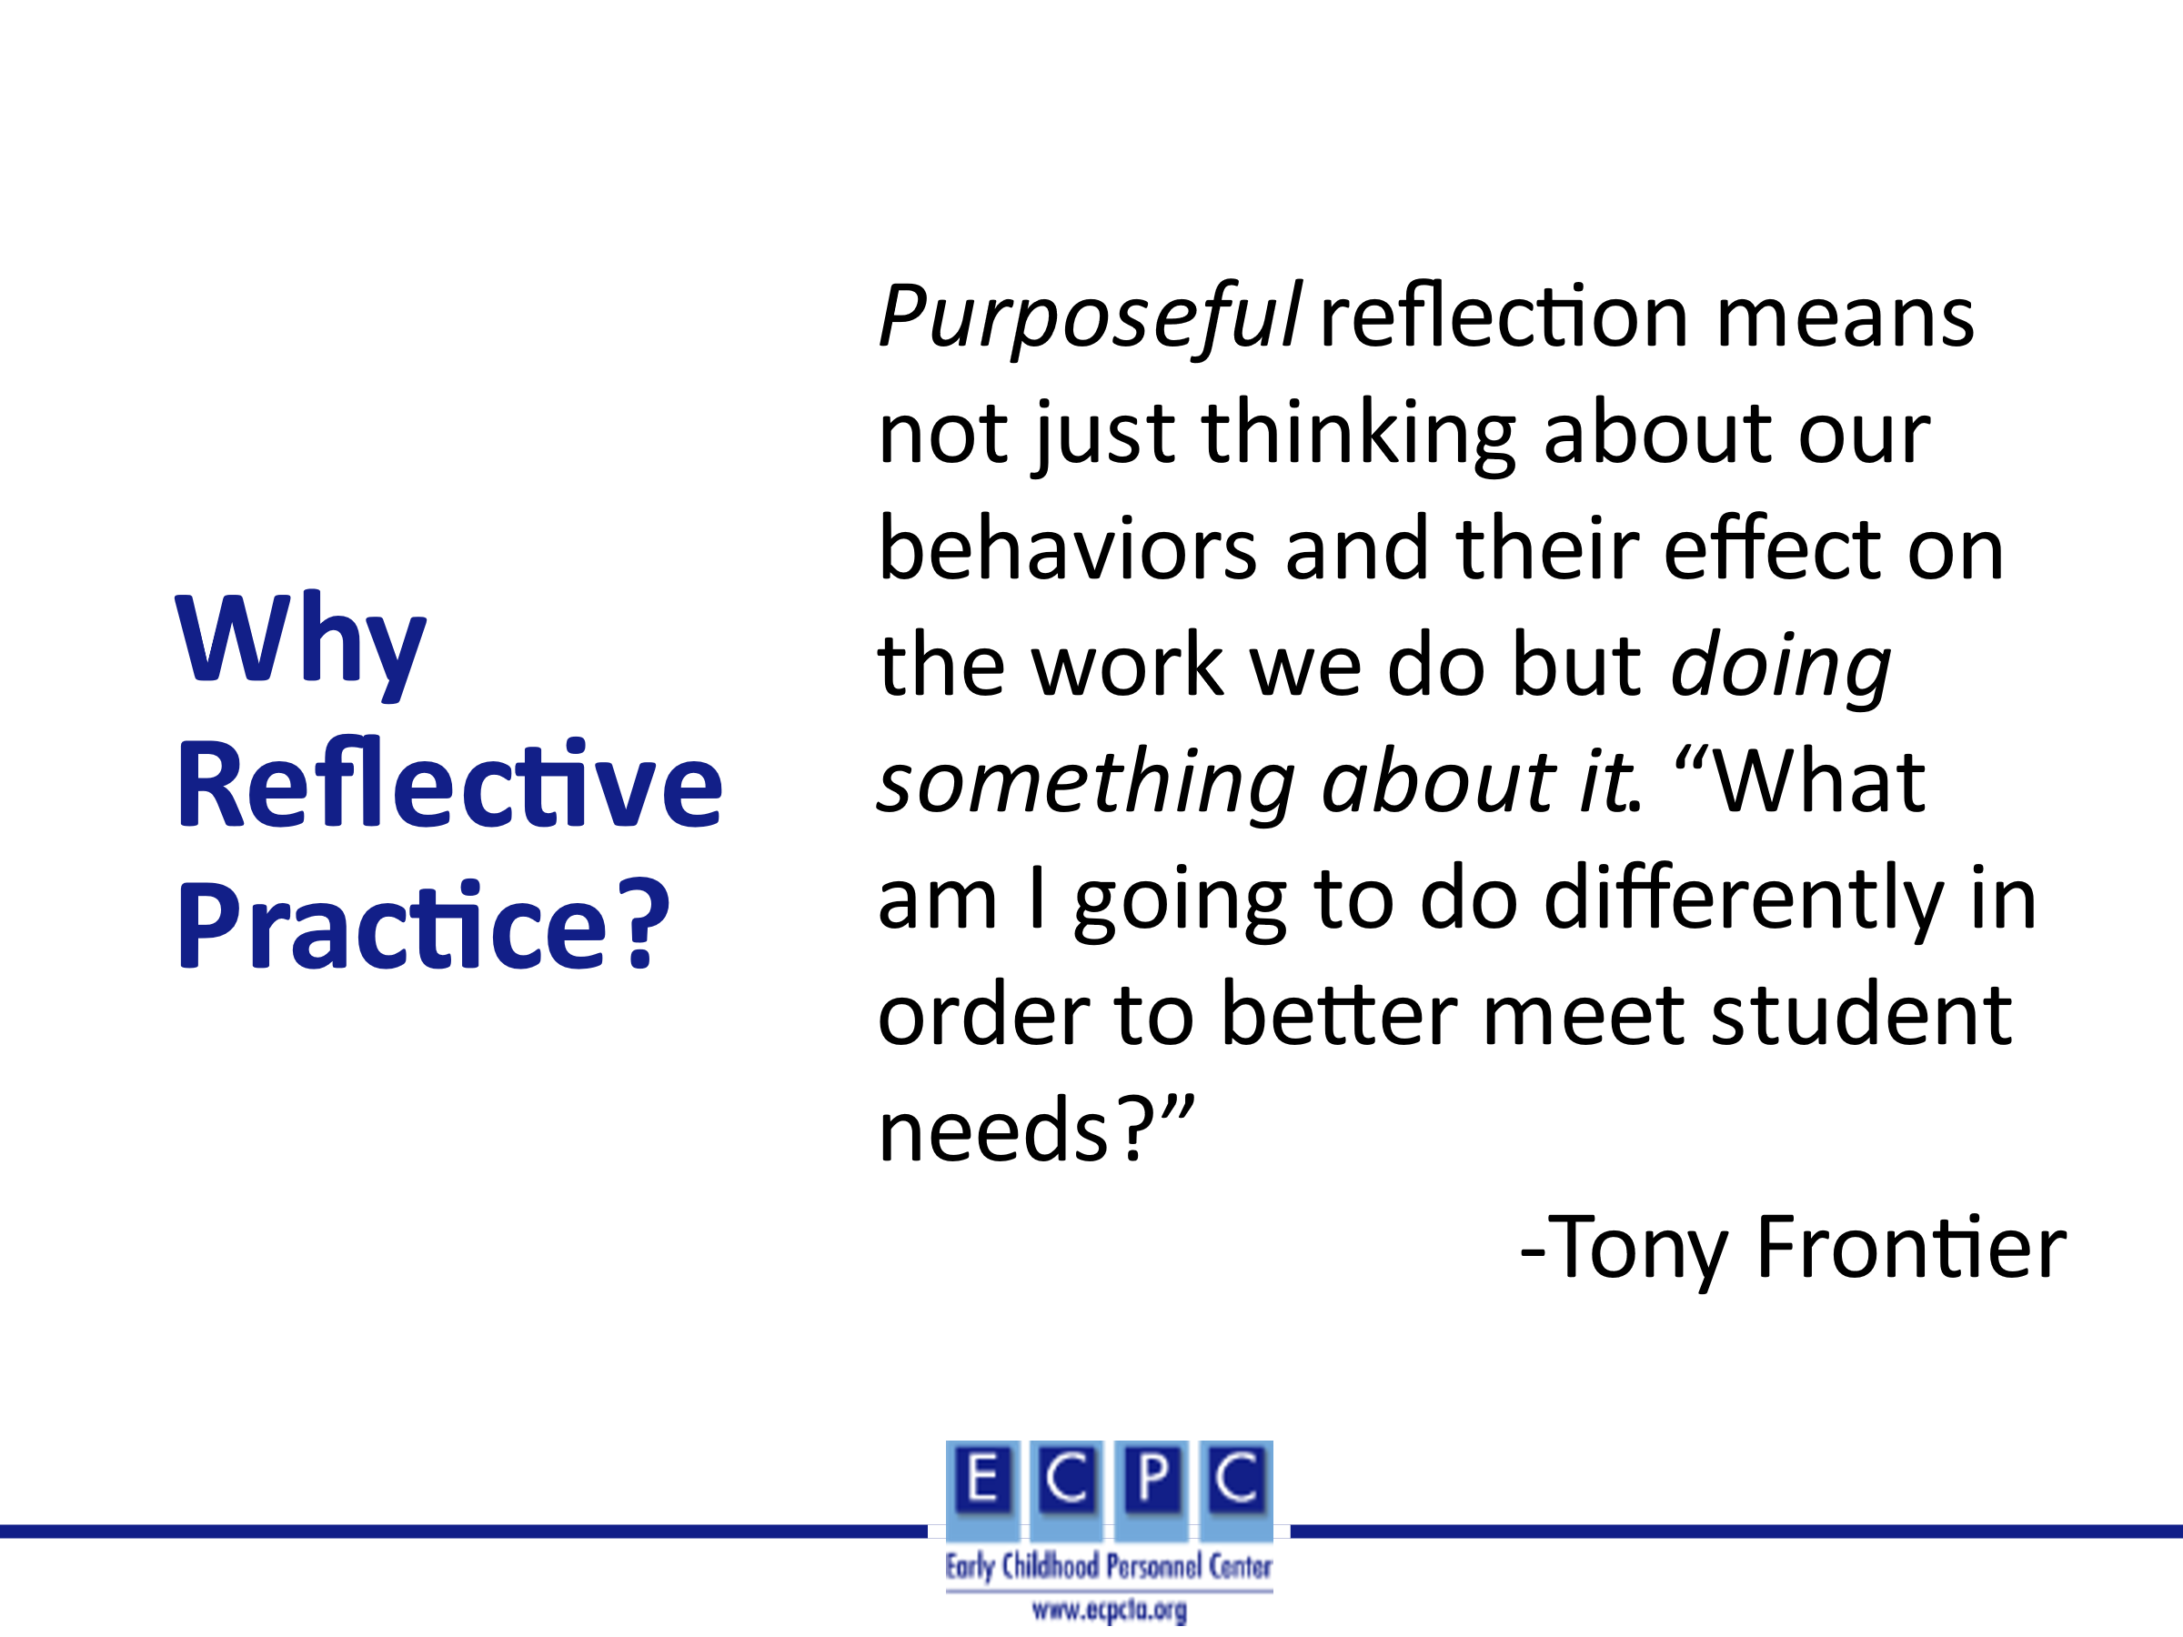 | How do we ensure that we are doing things differently? Reflective practice as an ongoing process can assist in doing things differently.
Slide 23 | 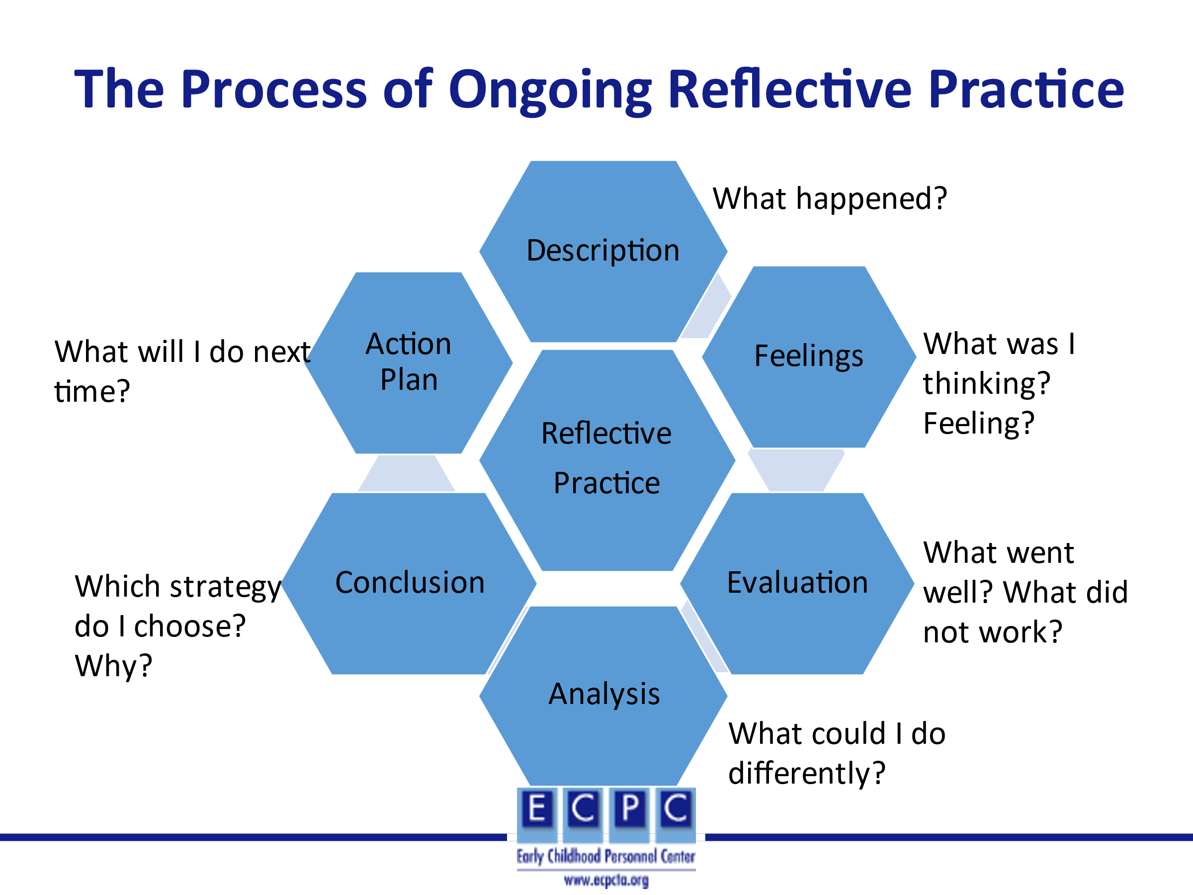 | This figure represents the ongoing reflective practice process that allows us to intentionally analyze what we have implemented and what we might need to do differently in the future. The steps in the process include:  - Description – An activity was implemented. And the EI/ECSE professional reflects on what happened.  - Feelings – What did the EI/ECSE professional think about what happened? It was a successful activity. How did they feel? They felt good about how it progressed.  - Evaluation – What seemed to work well in the activity? Be effective? What did not seem to work? Was not effective?  - Analysis – For those aspects of the activity (practices, strategies), what could I do differently based on research, standards, etc.?  - Conclusion – Choose one of the EBPs and provide a rationale as to why that EBP is chosen.  - Action Plan – Include that practice in the next activity plan and then, continue with the process.
Slide 24 | 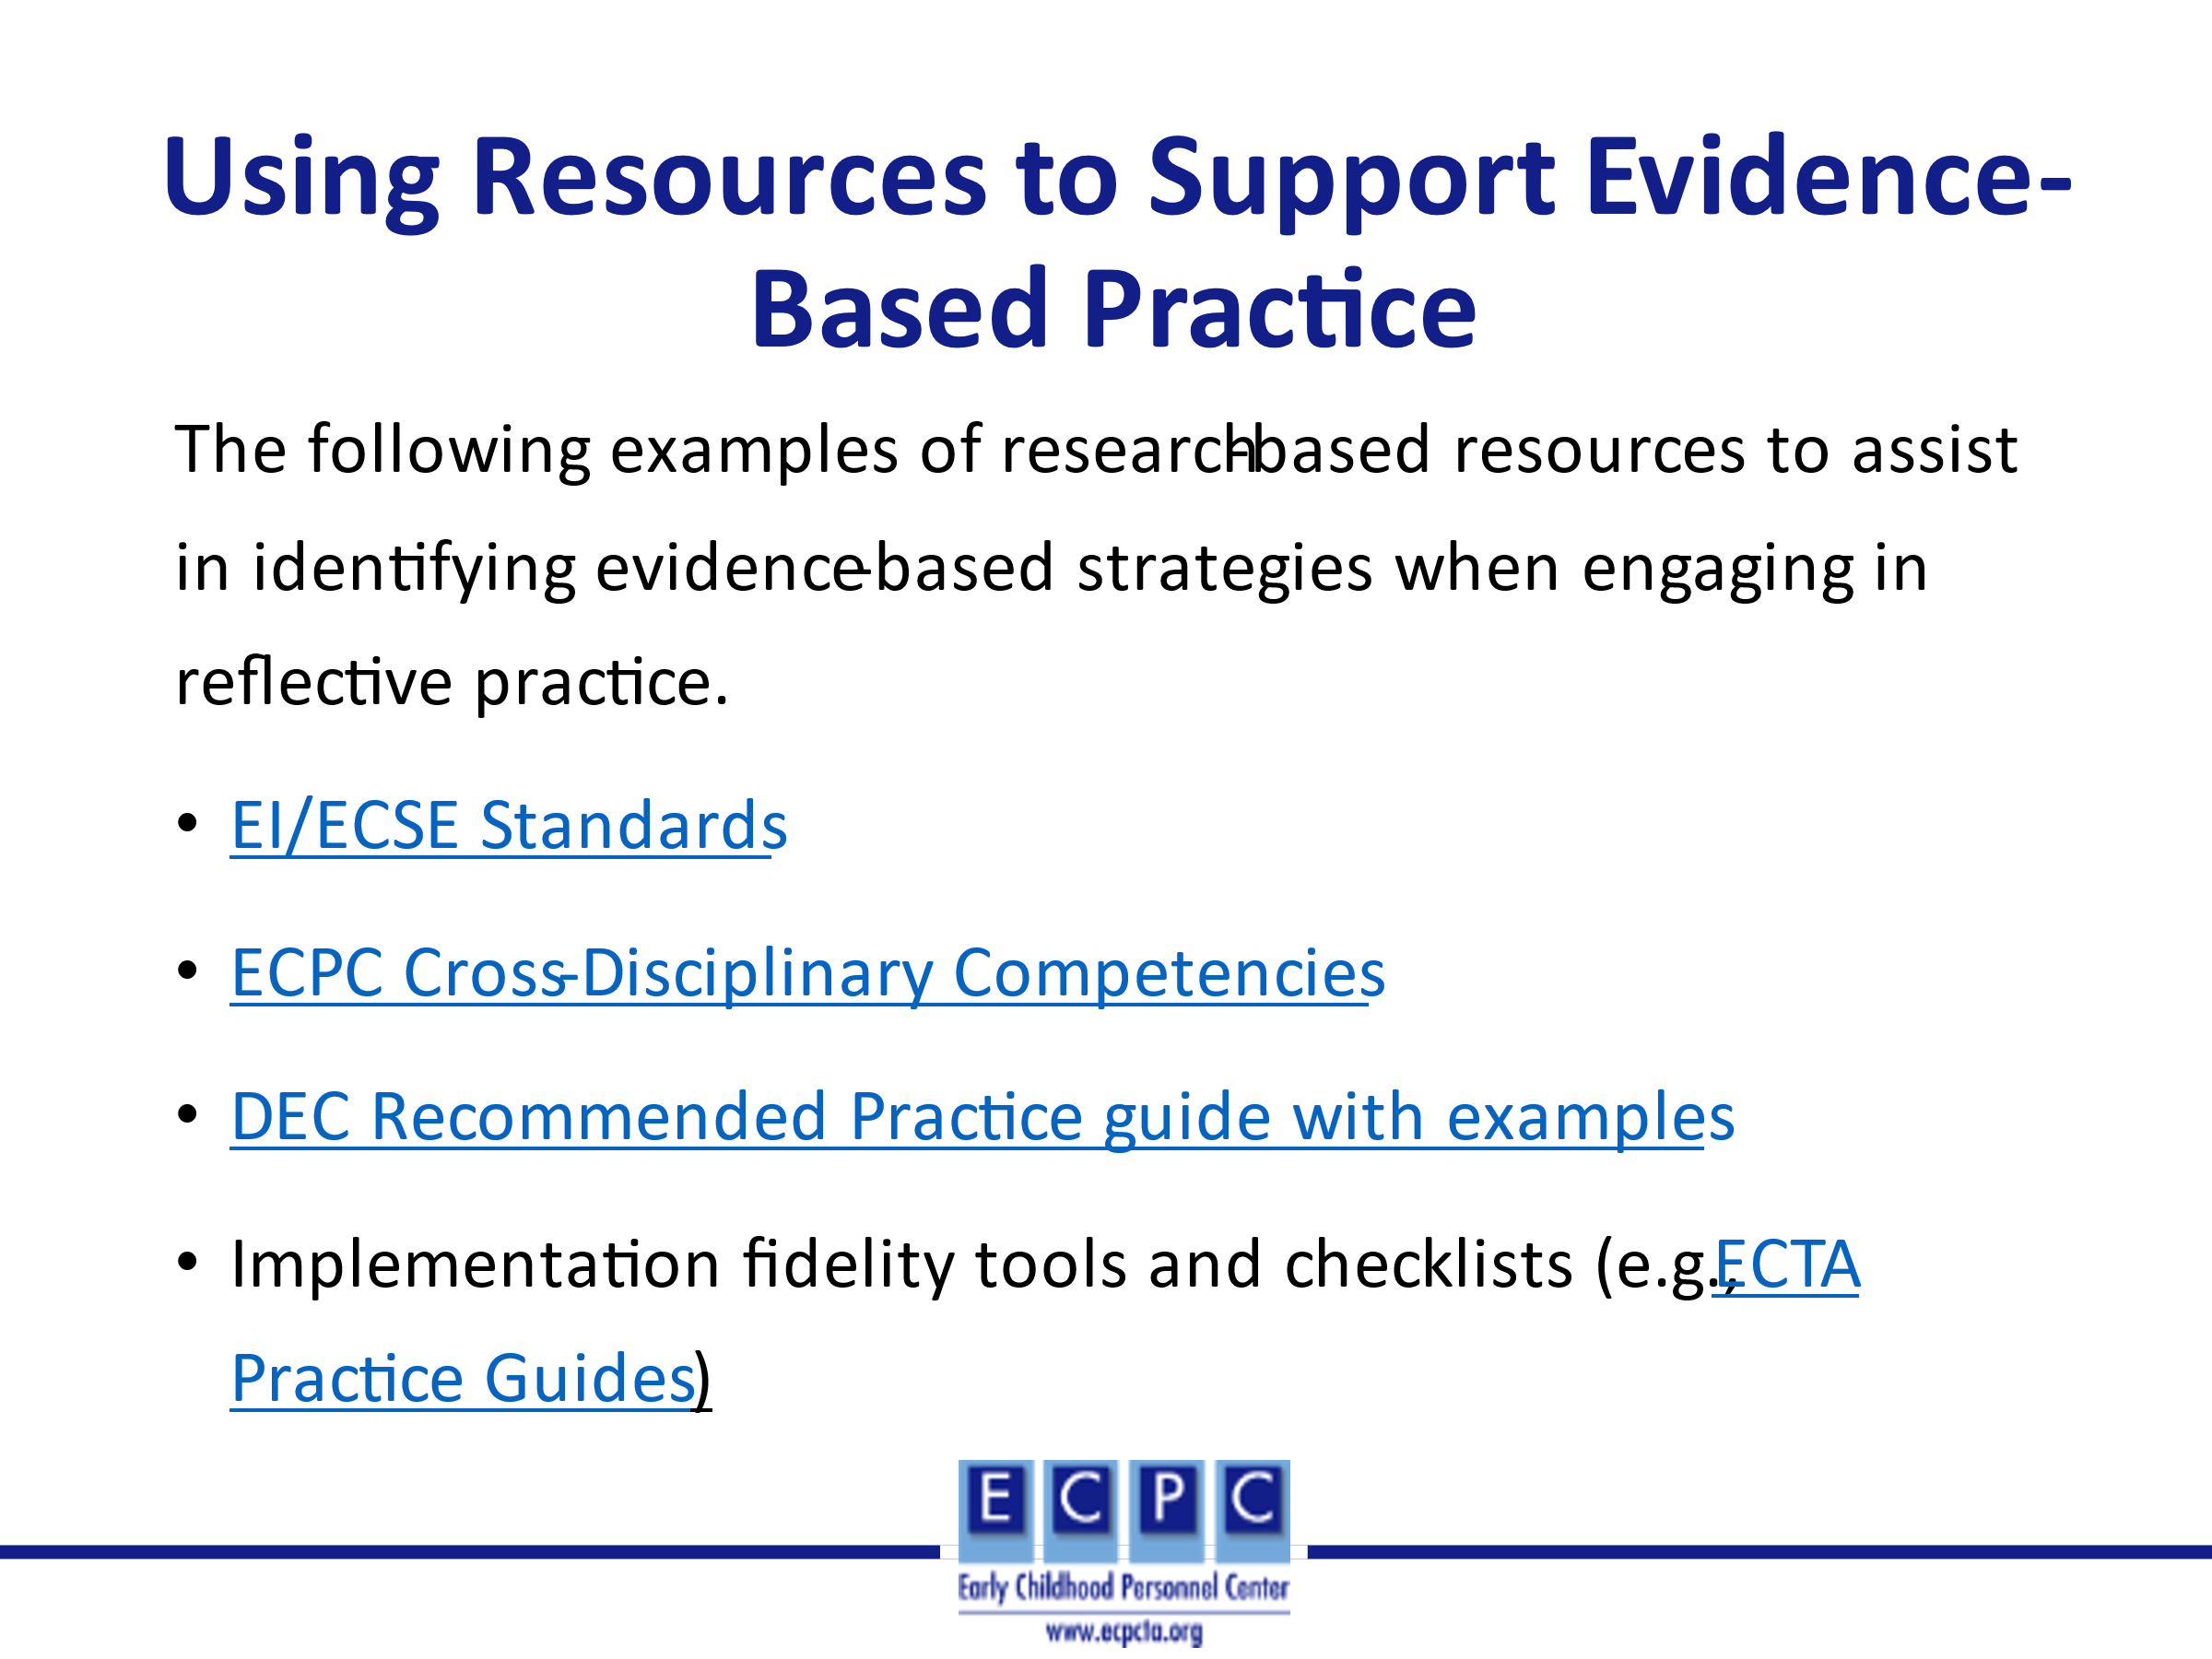 | These are some of the resources that you might choose to use in identifying practices at the analysis step of the reflective practice process.  https://www.dec-sped.org/copy-of-pps-home  https://ecpcta.org/cross-disciplinary-competencies/  https://divisionearlychildhood.egnyte.com/dl/b3QfKC3jsp/?  https://www.dec-sped.org/ei-ecse-standards  Official DEC 2014 Recommended Practices with Examples.pdf (egnyte.com)  https://ectacenter.org/decrp/  https://afirm.fpg.unc.edu/learn-affirm
Slide 25 | 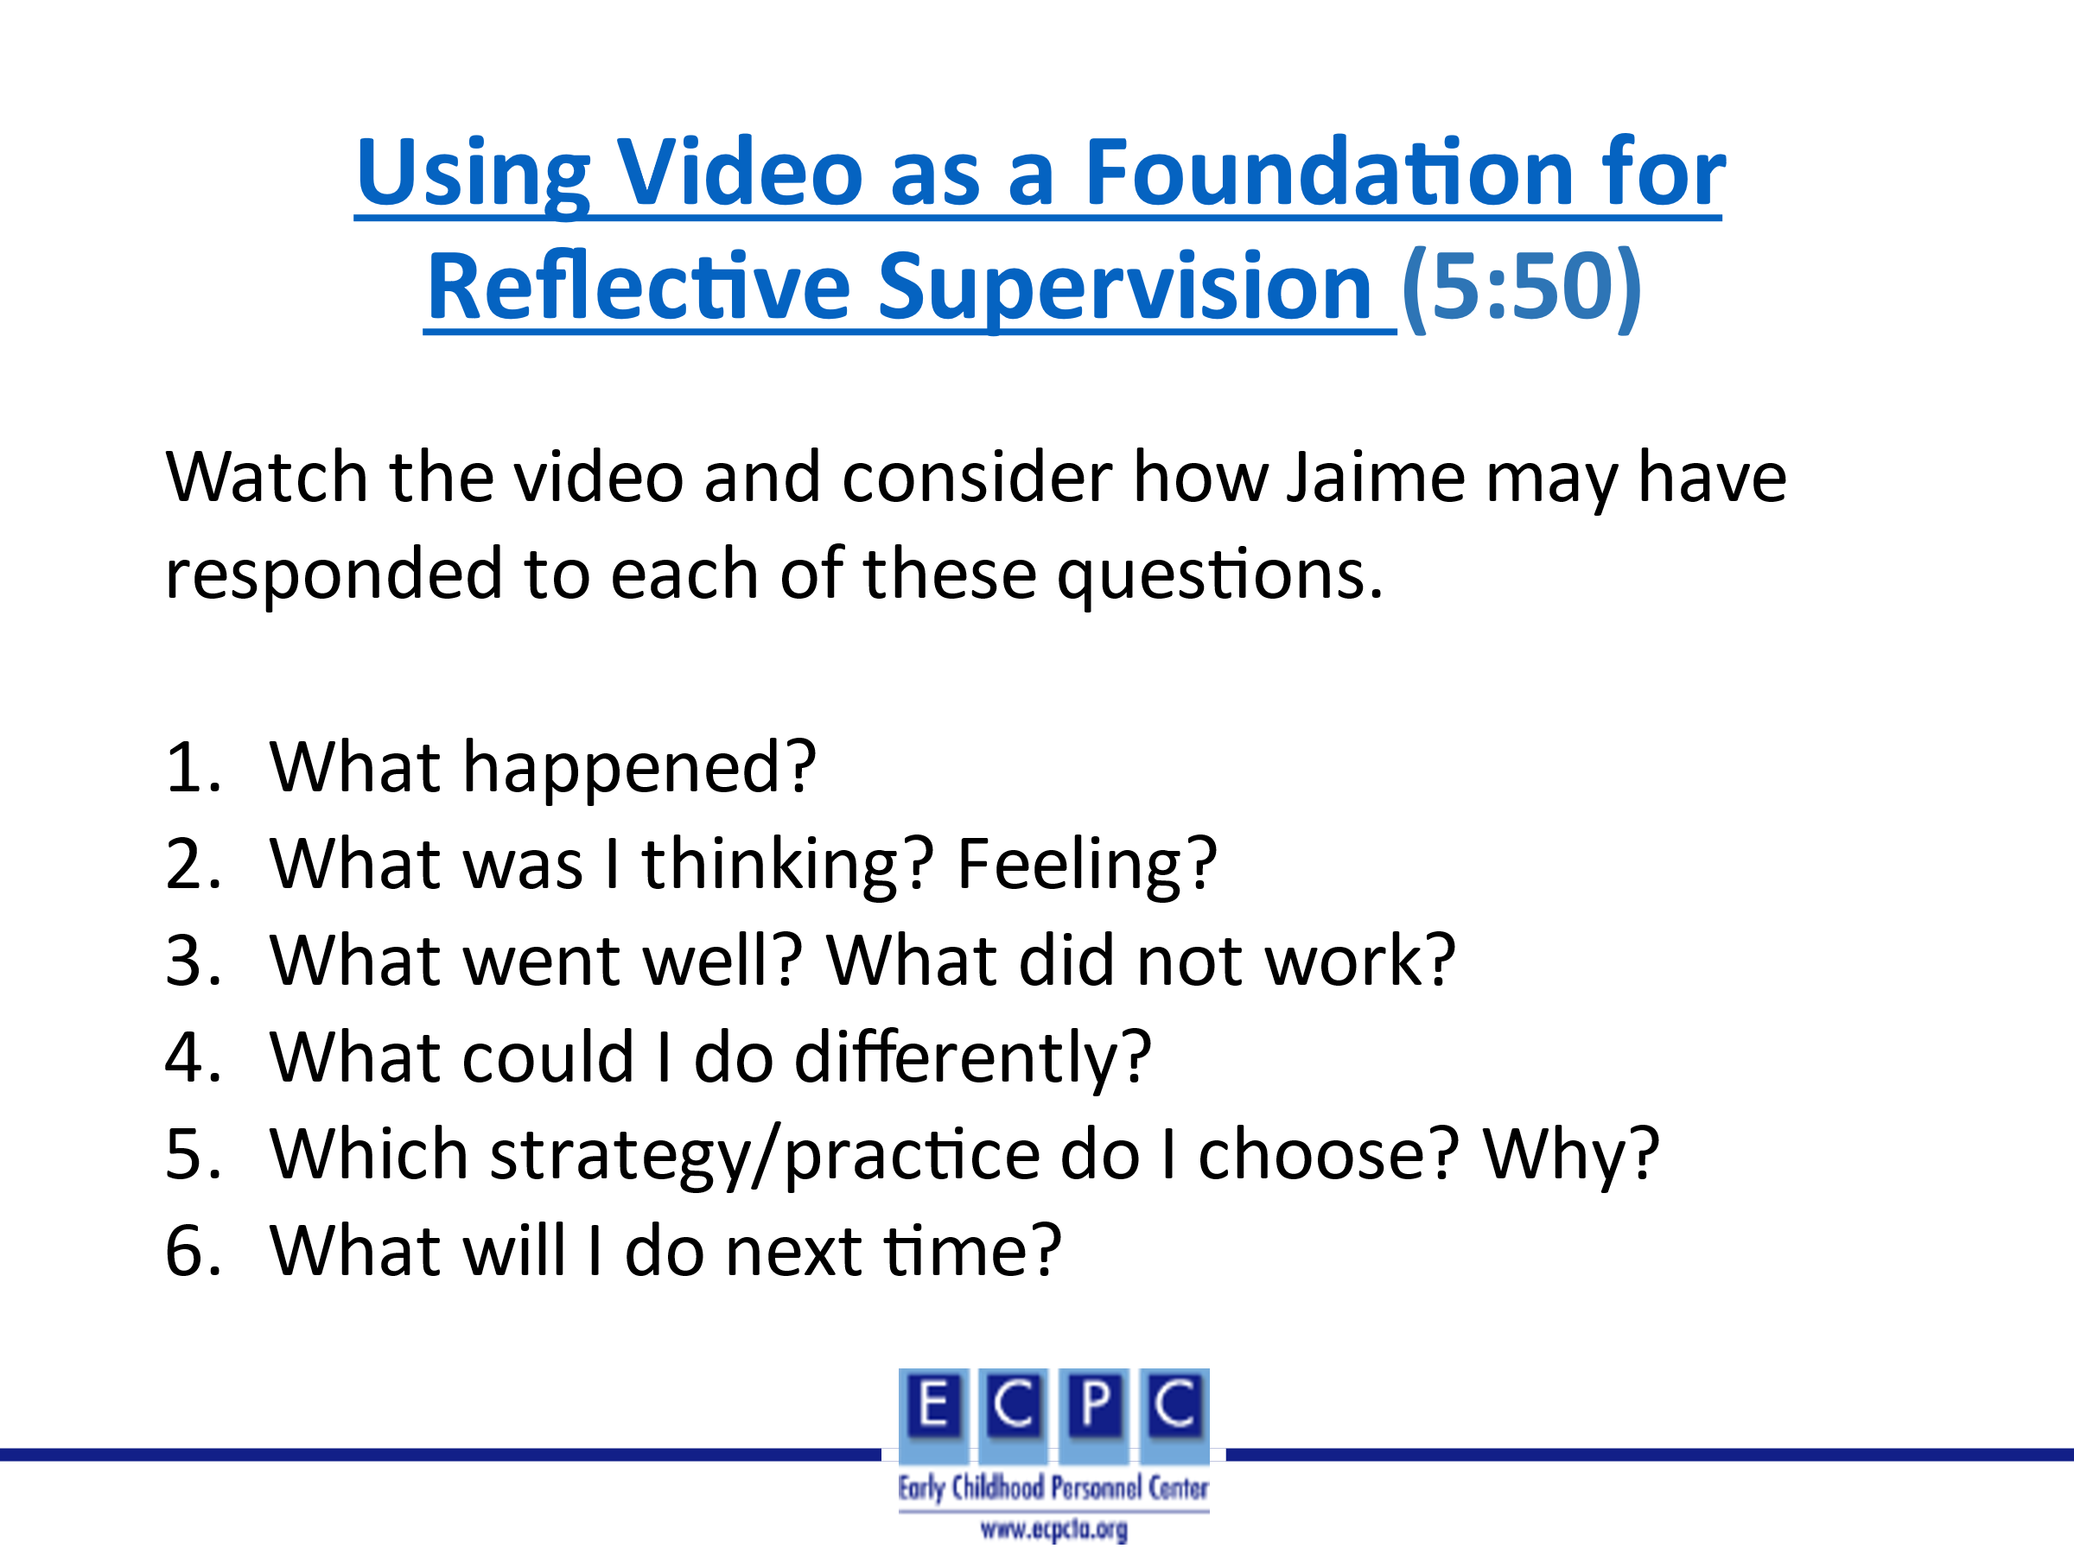 | Introduce the video. Jaime, a speech-language pathologist, and BJ, her supervisor, illustrate how they use video as a foundation for reflective supervision. BJ and Jaime review and reflect on a video that Jaime shared of a virtual home visit to better support Jaime’s coaching practices.  Ask learners to watch the video and consider each of the six questions in the ongoing reflective process as they watch the video. In small groups, ask learners to discuss their responses to the questions. Then, share in the large group.  https://www.youtube.com/watch?v=JER__EAu-Vg&ab_channel=OhioDevelopmentalDisabilitiesCouncil
Slide 26 | 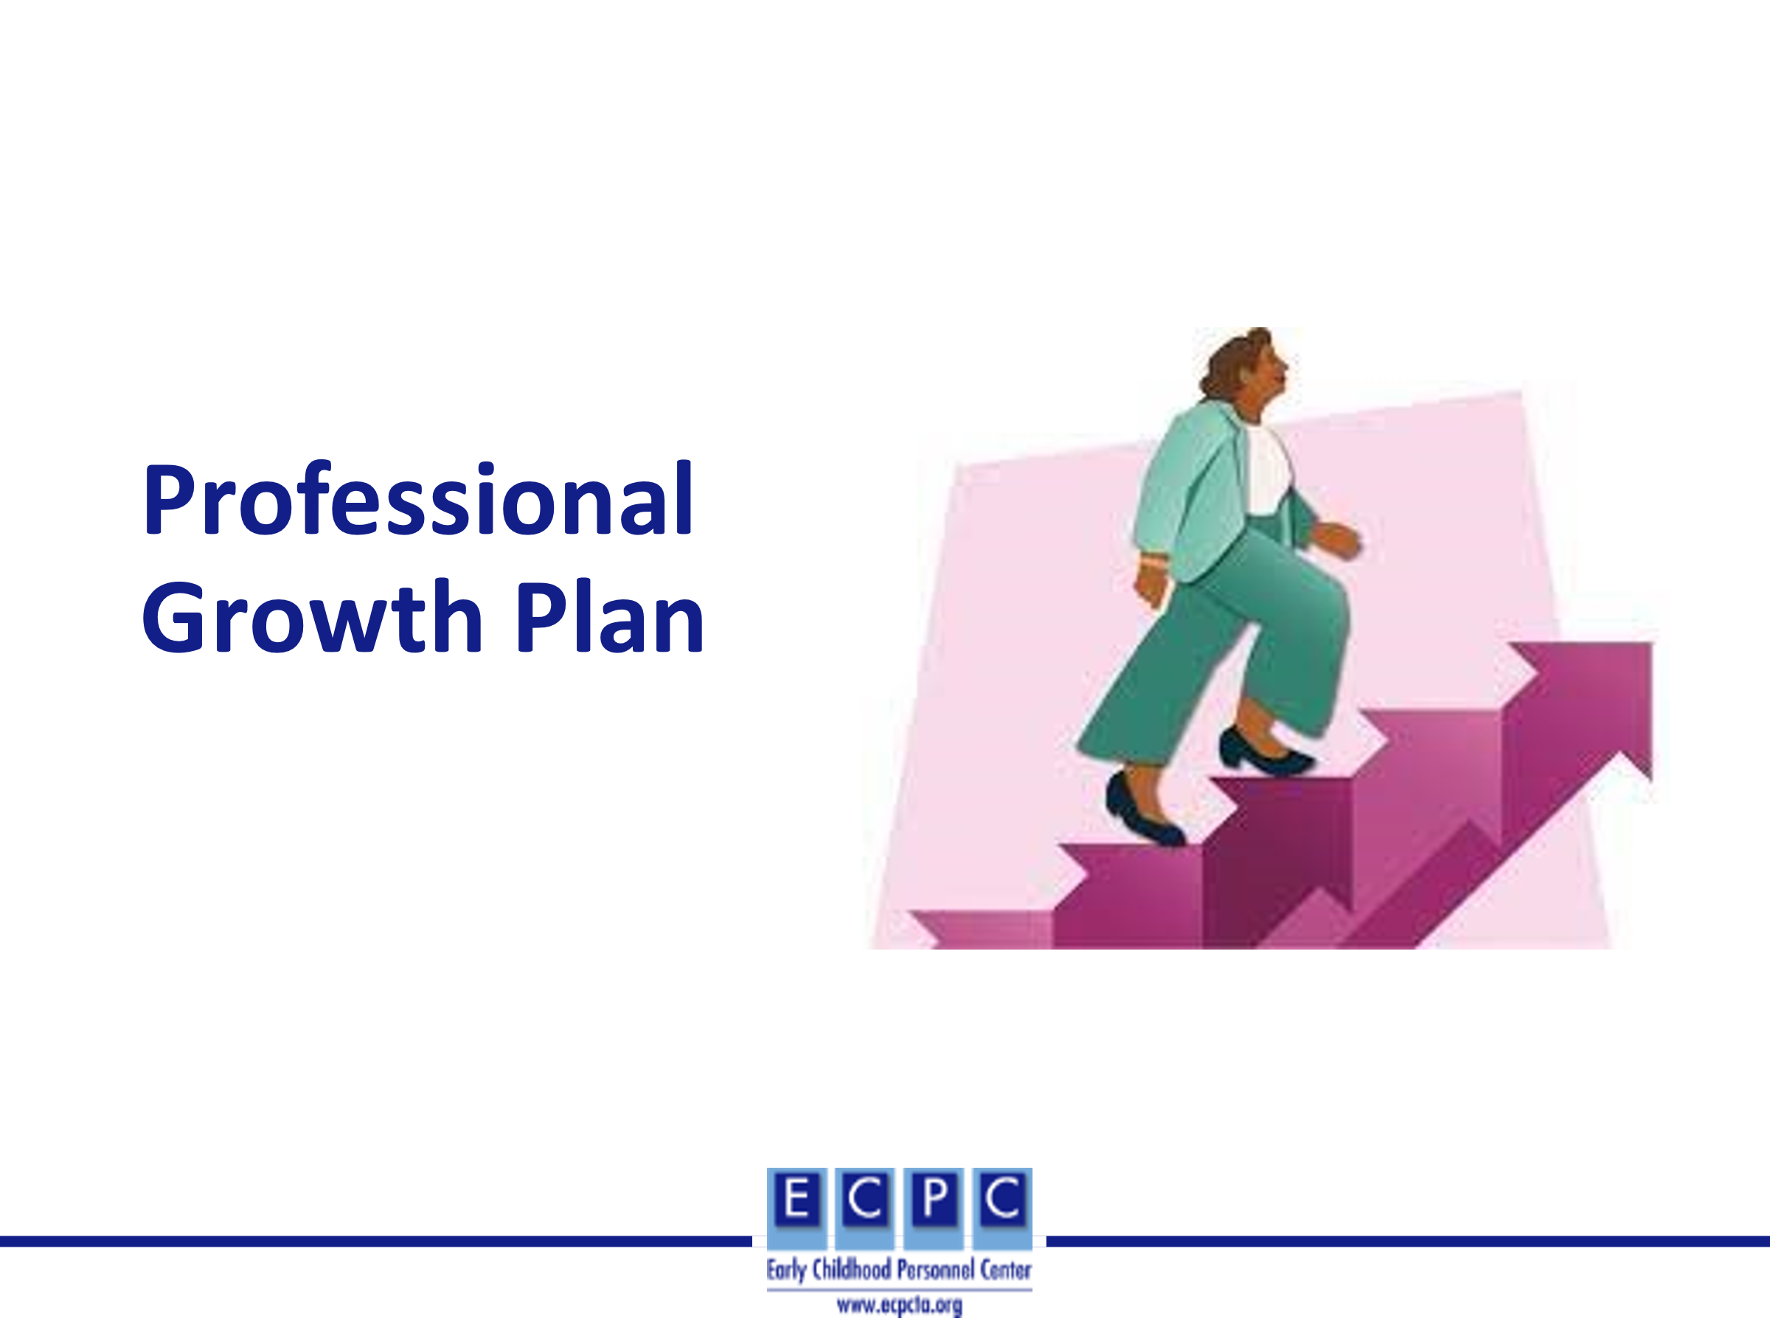 | Through reflective practice, learners will have identified areas for professional growth. Areas for professional growth may also be identified through a self-assessment of application of the EI/ECSE Standards and feedback from colleagues and/or administrators based on their observations in home and/or classroom settings. A professional growth plan (PGP) will then be developed for these professional growth areas.
Slide 27 | 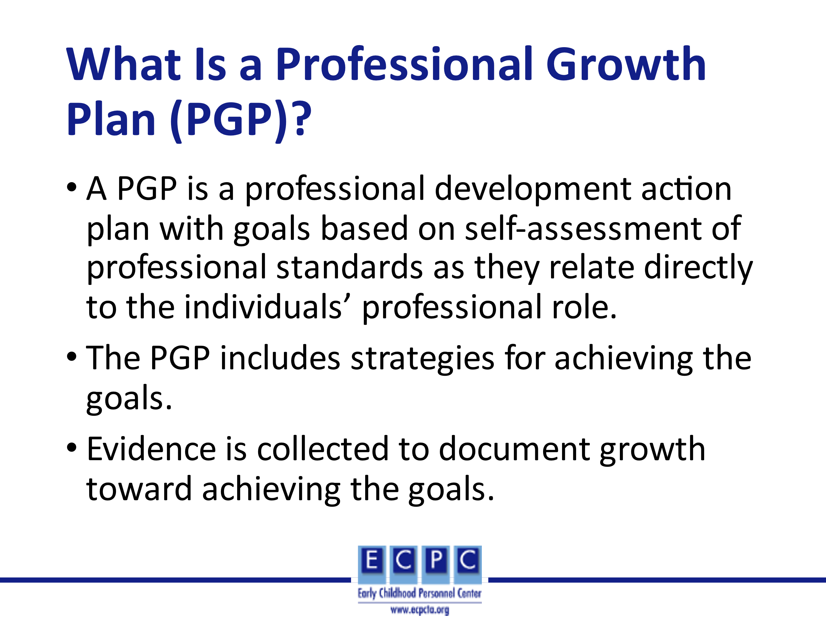
Slide 28 | 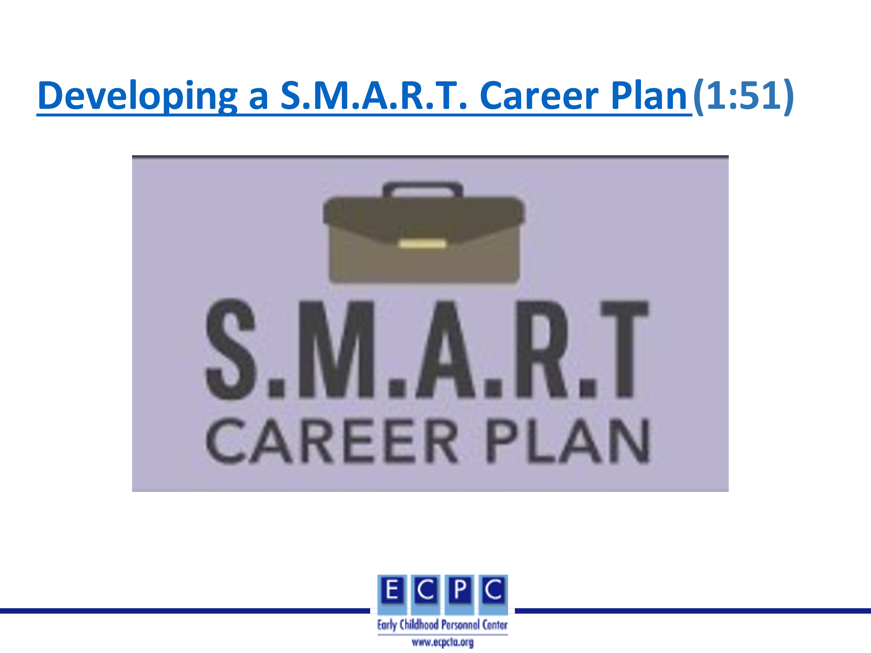 | This video discusses developing a career plan when looking for a new job. We are using the video today to think about how to develop goals for your Professional Growth Plan. The characteristics of goals as discussed in the video provide guidance for developing the PGP goals.
Slide 29 | 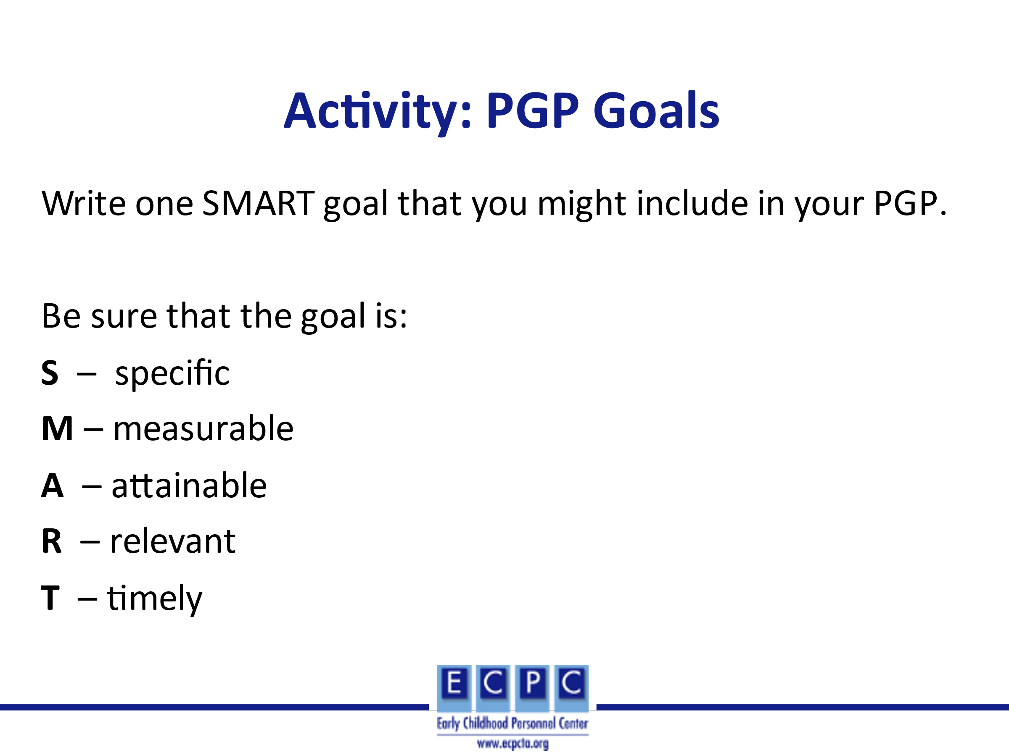 | After watching the video, ask learners to think about their current role and identify an area for professional growth. For that area of professional growth, write one goal using the S.M.A.R.T. characteristics for goals and be prepared to share the goal with the group. Ask other group members to give feedback on the SMART features of the goal.
Slide 30 | 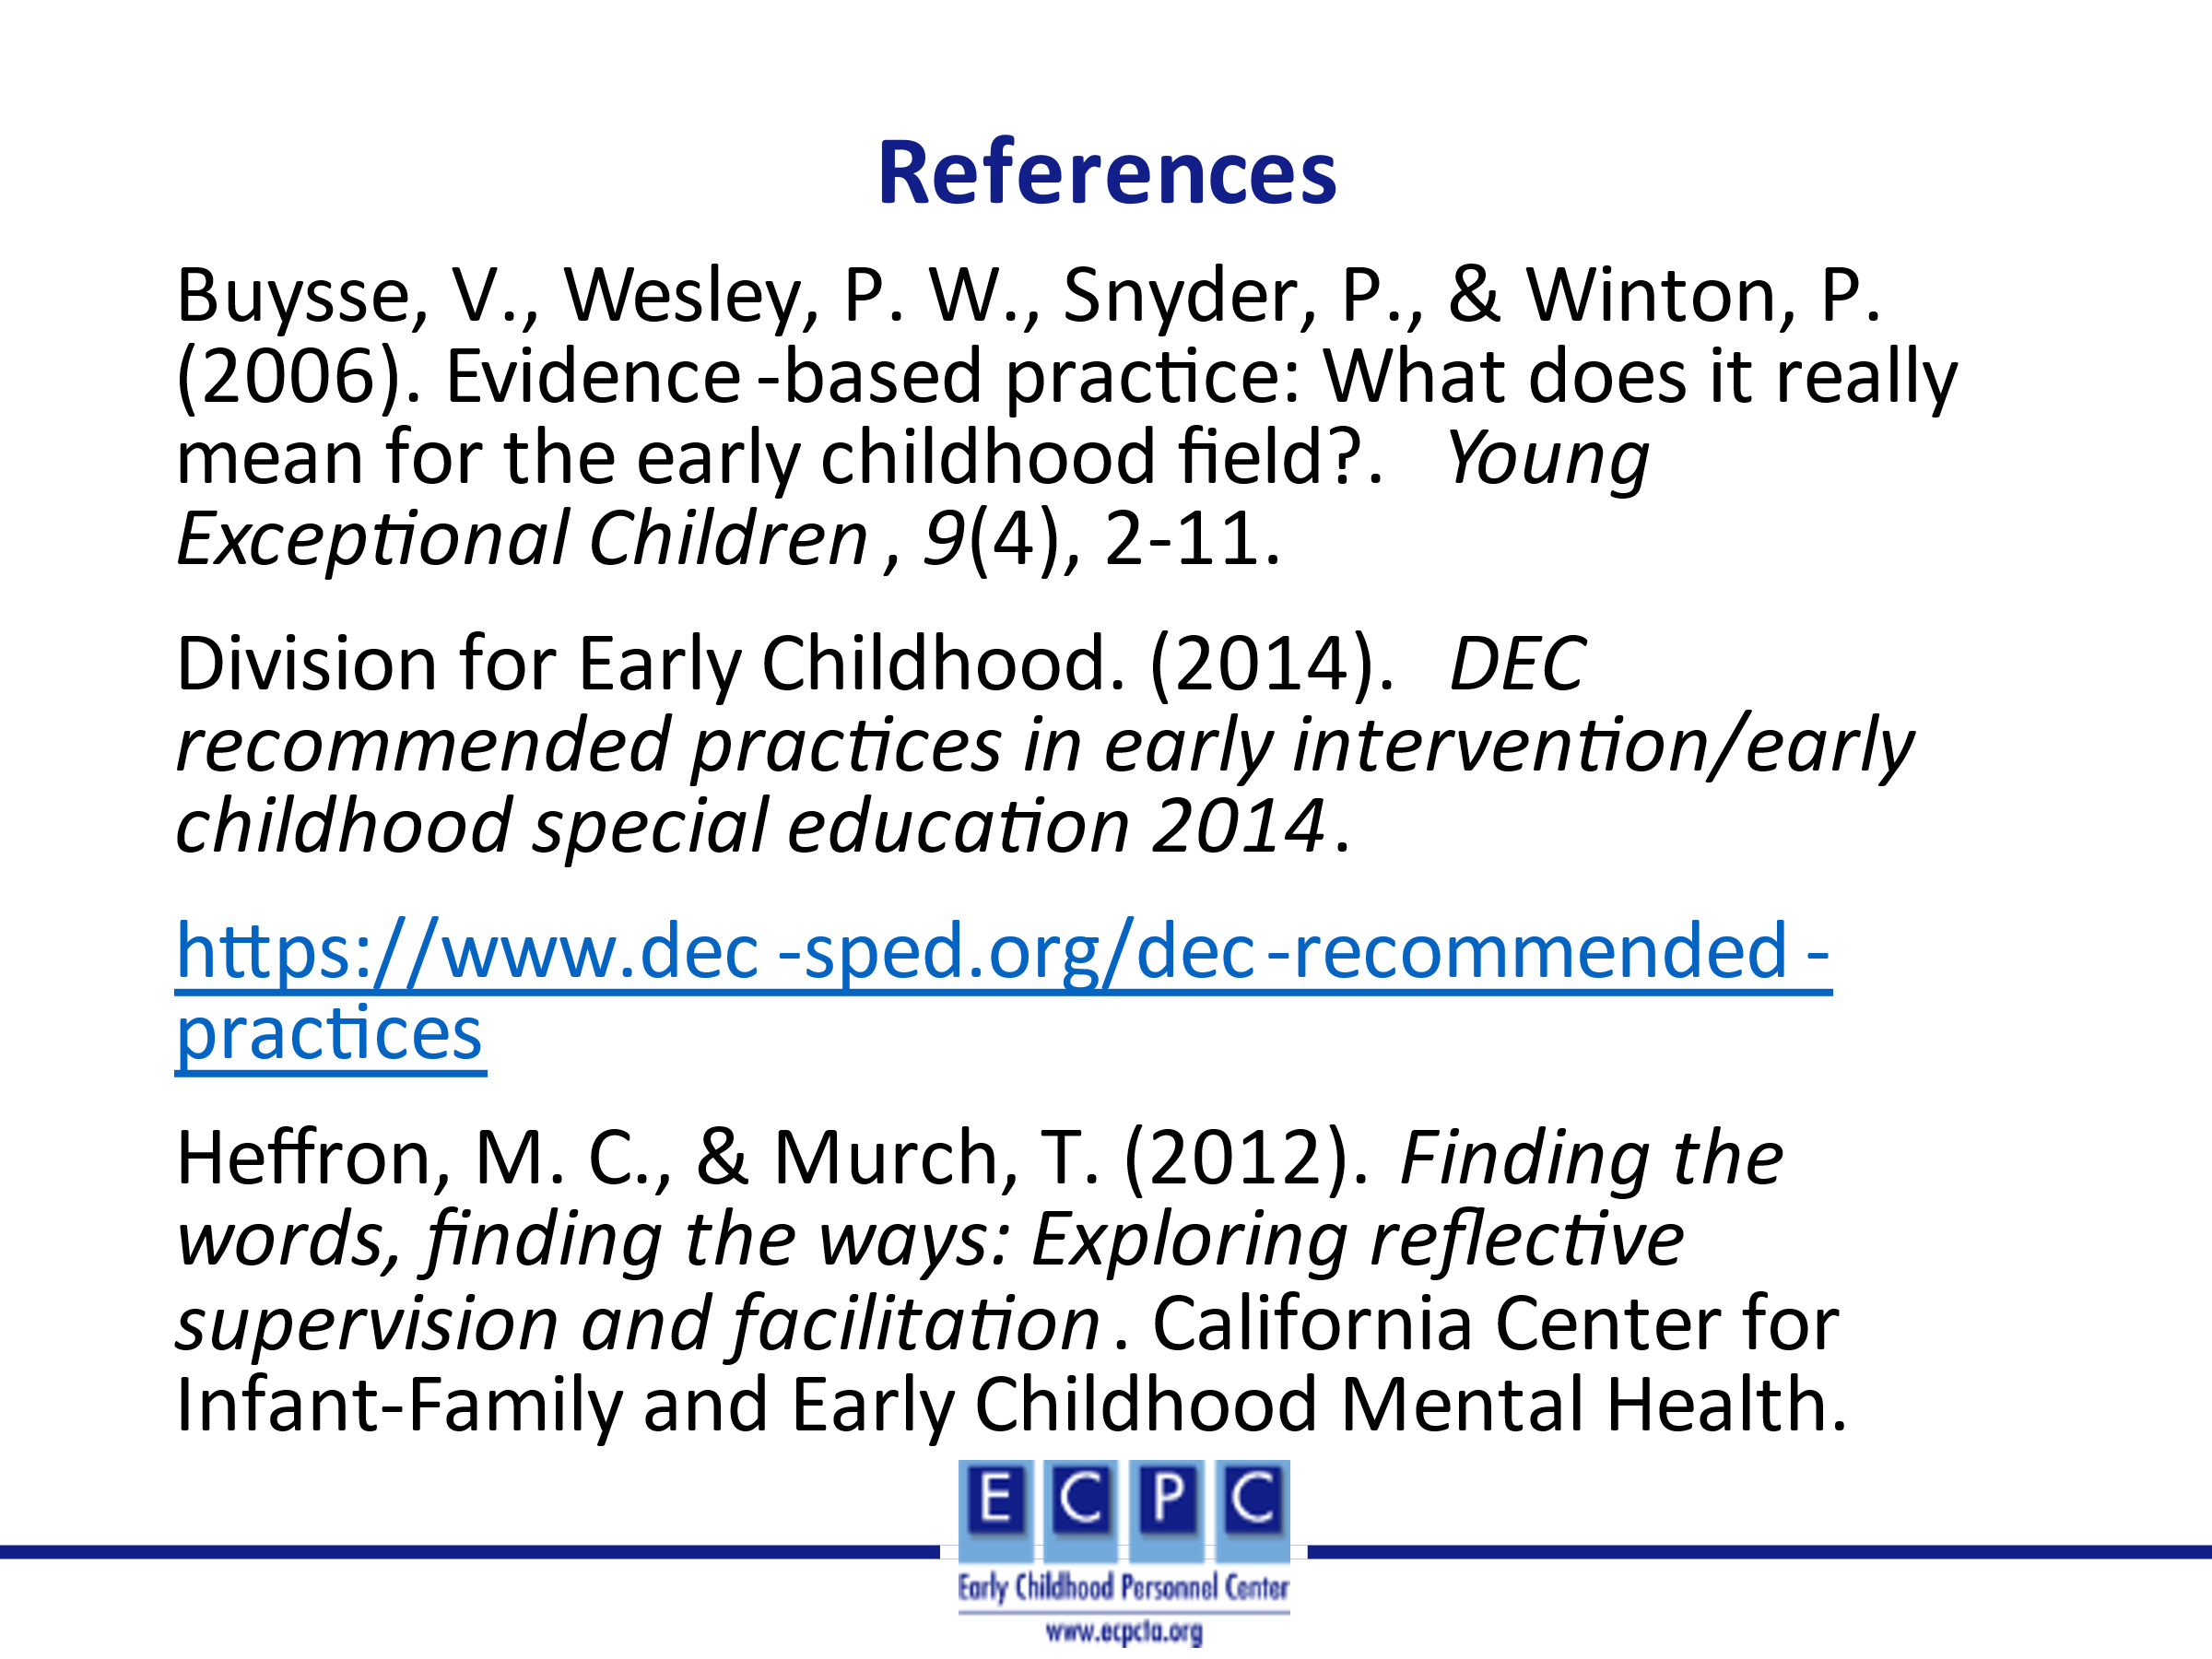
Slid 31 | 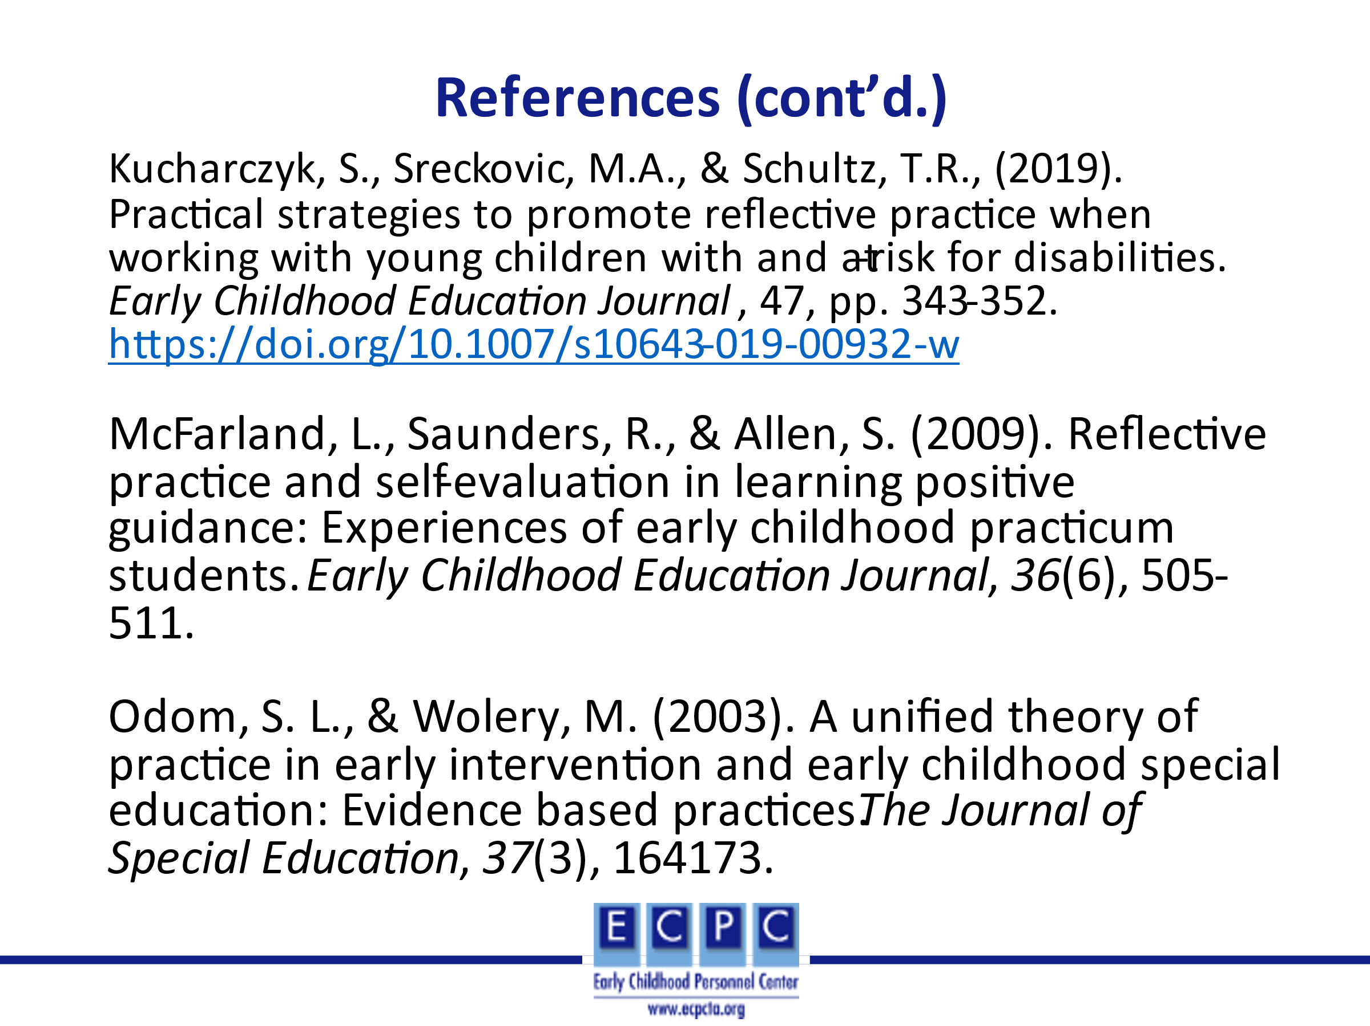
Slide 32

