EI/ECSE Standard 7
Component 7.1

Overview and Speaker Notes

Intended Audience:

Overview for Facilitators:
ECPC has developed an anchor presentation for each of the Initial Practice-Based Professional Preparation Standards for Early Interventionists/Early Childhood Special Educators (EI/ECSE). The components under each Standard are presented separately. The materials are designed for an in-service professional development (PD) program but can be used in a pre-service teacher preparation course. This resource will increase professionals’ ability to address each of the EI/ECSE Standards and components. Additional materials for each Standard can be found on the ECPC Website: Curriculum Module | The Early Childhood Personnel Center (ecpcta.org)

Speaker Notes
The speaker notes provide a narrative and activities for each slide. You will see speaker notes for most of the slides within the slide deck. The notes provide additional details about the information on a particular slide, including the context for the information and key points. The notes are a guide, and speakers should feel free to modify these as needed. Please note the following:
- The narrative is a sample script for the presenter. Although you may read it verbatim, speaker notes are intended as a guide for the presenter, and you may modify them as needed.

Materials required for face to face
- Share the outline with timelines for the training (build in breaks)
- Conduct an opening activity (introductions/ice breaker)
- Computers or tablets with internet access for participants (if possible)
- Handouts
- Projector with audio capable for playing video with speakers
- Presentation slides with speaker notes
- Develop an evaluation tool for all attendees (e.g., continuous improvement activity)

Materials required for virtual:
- Distribute the link to the online platform in advance
- Share the outline with timelines for the training (build in breaks)
- Conduct an opening activity (introductions/ice breaker)
- Determine how participants will receive handouts and materials, on the cloud, using a storage platform (e.g., Dropbox, google, etc.)
- Platform to share presentation (e.g., zoom, teams, etc.) with polling questions prepared in advance and breakout room capability
- Upload or send handouts in advance or through platform (insert through chat)
- Download videos ahead of time to prepare for low bandwidth from slide deck
- Share screen capability (be sure to enable sound for videos)
- Develop an evaluation tool for all attendees (e.g., continuous improvement activity)

Objectives for Standard 7, Component 7.1:
After participating in this professional learning opportunity, participants will be able to:
- Define EI/ECSE as a profession,
- Identify supports and services provided by EI/ECSE related professional organizations,
- Examine state early learning standards,
- List and review professional standards, and
- Identify resources for learning about trends and issues within the profession.

Outline of Session Activities
Topic | Slides | Activity
Introduction/Objectives | 1-4
Defining the Profession | 5-10
Activity/Video: Meaning Inclusion in Early Childhood (5:53) | 11 | Activity/Video (Slide 11)
Professional Organizations  Activity/Video: Learn About the National Association for the Education of Young Children (2:22)  Activity: CEC, DEC, and NAEYC Resources: What Can I Use Tomorrow? | 12-23 | Activity/Video (Slide 22)  Activity (Slide 23)
Early Learning Standards  Activity: Researching Your State’s Early Learning Standards | 24-28 | Activity (Slide 28)
Professional Standards  Activity/Video: EI/ECSE Standards Overview (4:39) | 29-35 | Activity (Slide 31)
Issues and Trends  Activity: What Are the Current Issues and Trends in EI/ECSE | 36-38 | Activity (Slide 38)
Websites | 39
References | 40-41

Speaker Notes with Slides

Slide 1 | 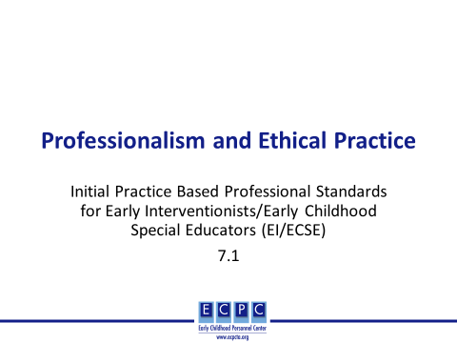 | Today we will discuss component 7.1 of the EI/ECSE Standard 7, Professionalism and Ethical Practice.
Slide 2 | 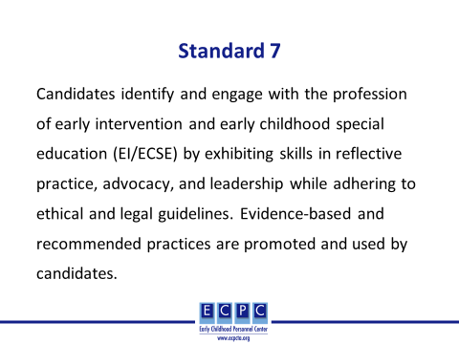 | Ask participants to silently read Standard 7. Then, progress to the next slide.
Slide 3 | 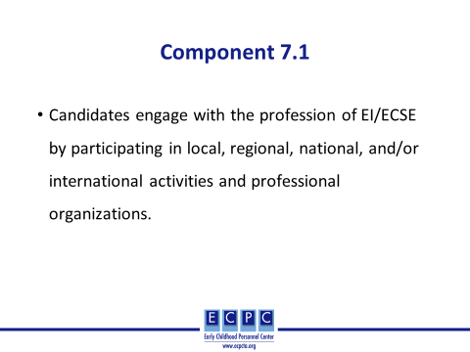 | Today, we will focus on component 7.1 for Standard 7. Then, read component 7.1 aloud to the group.
Slide 4 | 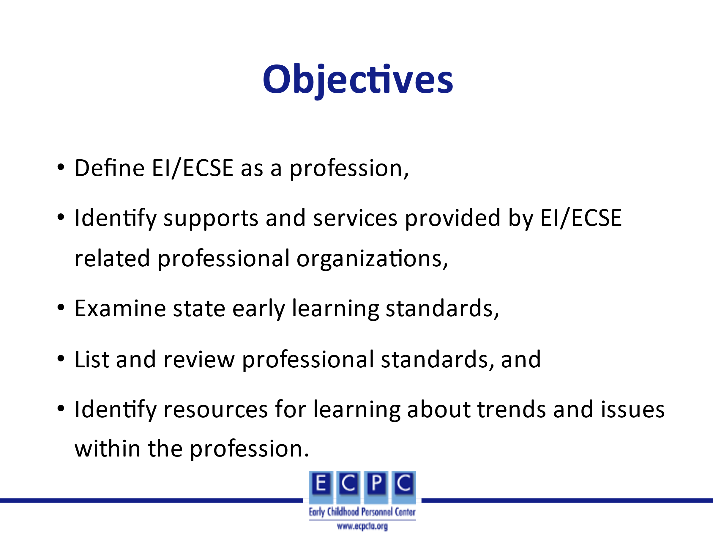
Slide 5 | 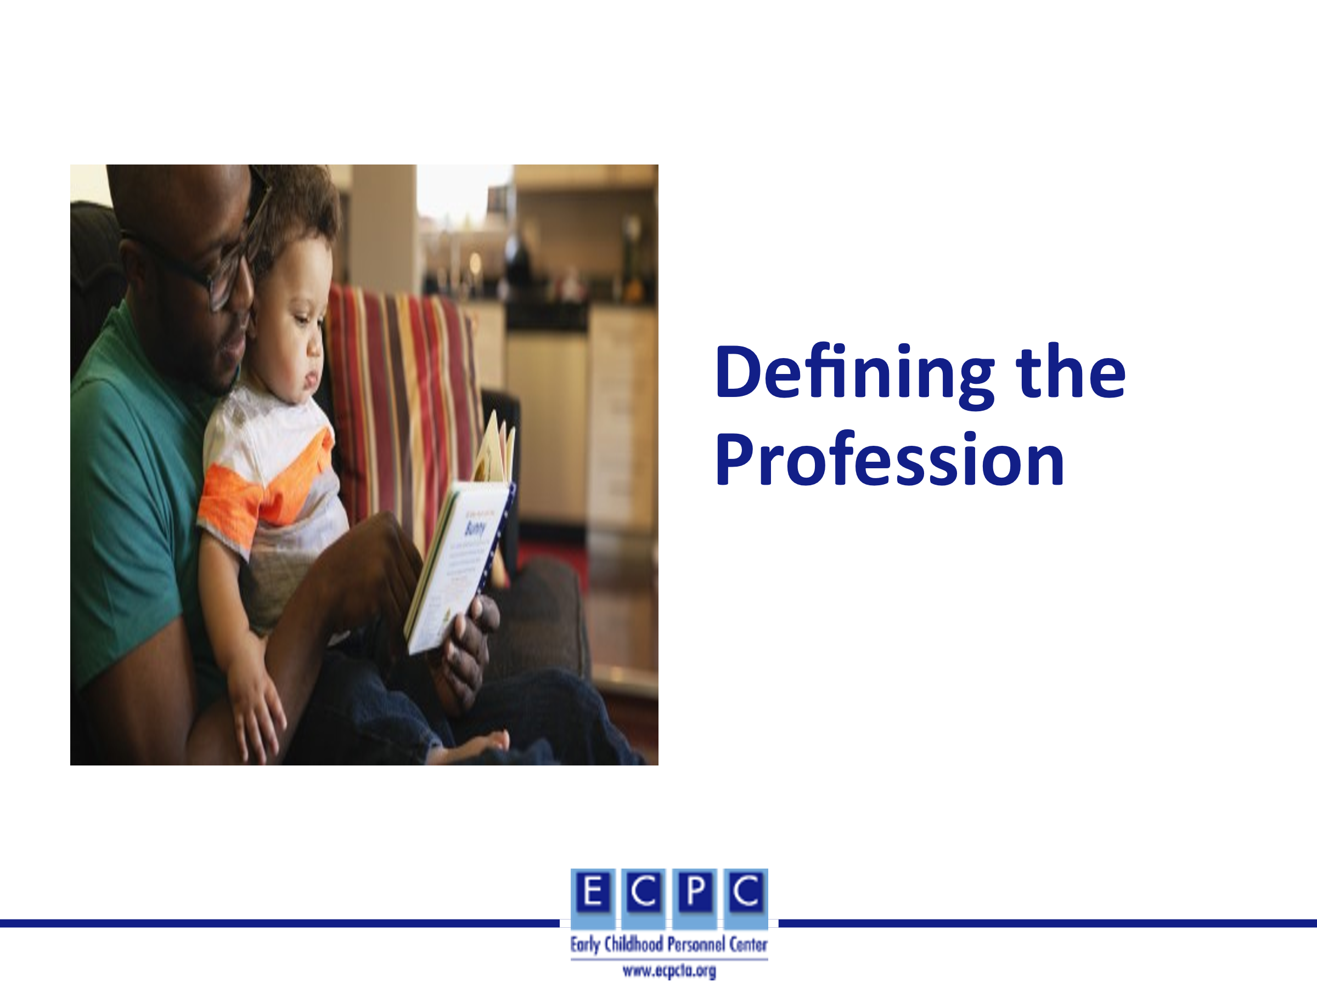
Slide 6 | 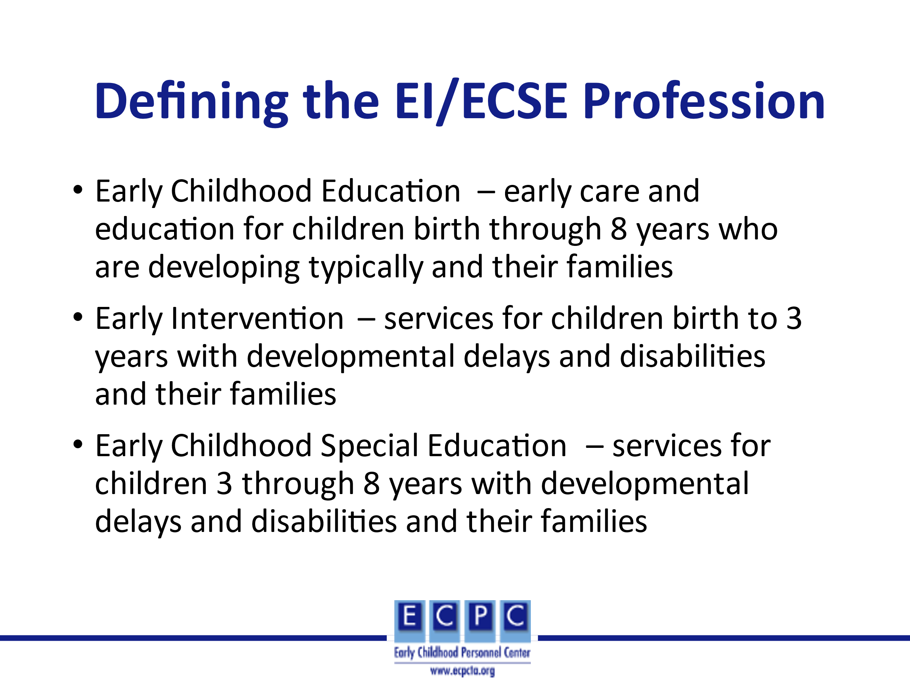 | Early Childhood Education - Early care and education services are provided in a variety of public and private settings (e.g., Head Start, childcare). Even though the settings in which these services are provided may include young children with developmental delays and disabilities, the primary focus of the professionals who work in these settings is preparation to work with young children who are developing typically.  Early intervention services are provided in natural environments, homes and other community settings. A primary goal of early intervention with children birth to 3 years with developmental delays and disabilities is to partner with the family to promote the child’s development and learning. Early intervention services are provided through Part C of IDEA. Additional information about Part C requirements is provided in the PD Guide for Standard 7, Component 7.4.  Early Childhood Special Education services are provided in a variety of public and private settings (e.g., public schools, Head Start, childcare). These services are provided under IDEA, Part B, Section 619. For the purposes of this PD guide, our focus will be on services for children with developmental delays and disabilities three through five years and their families.
Slide 7 | 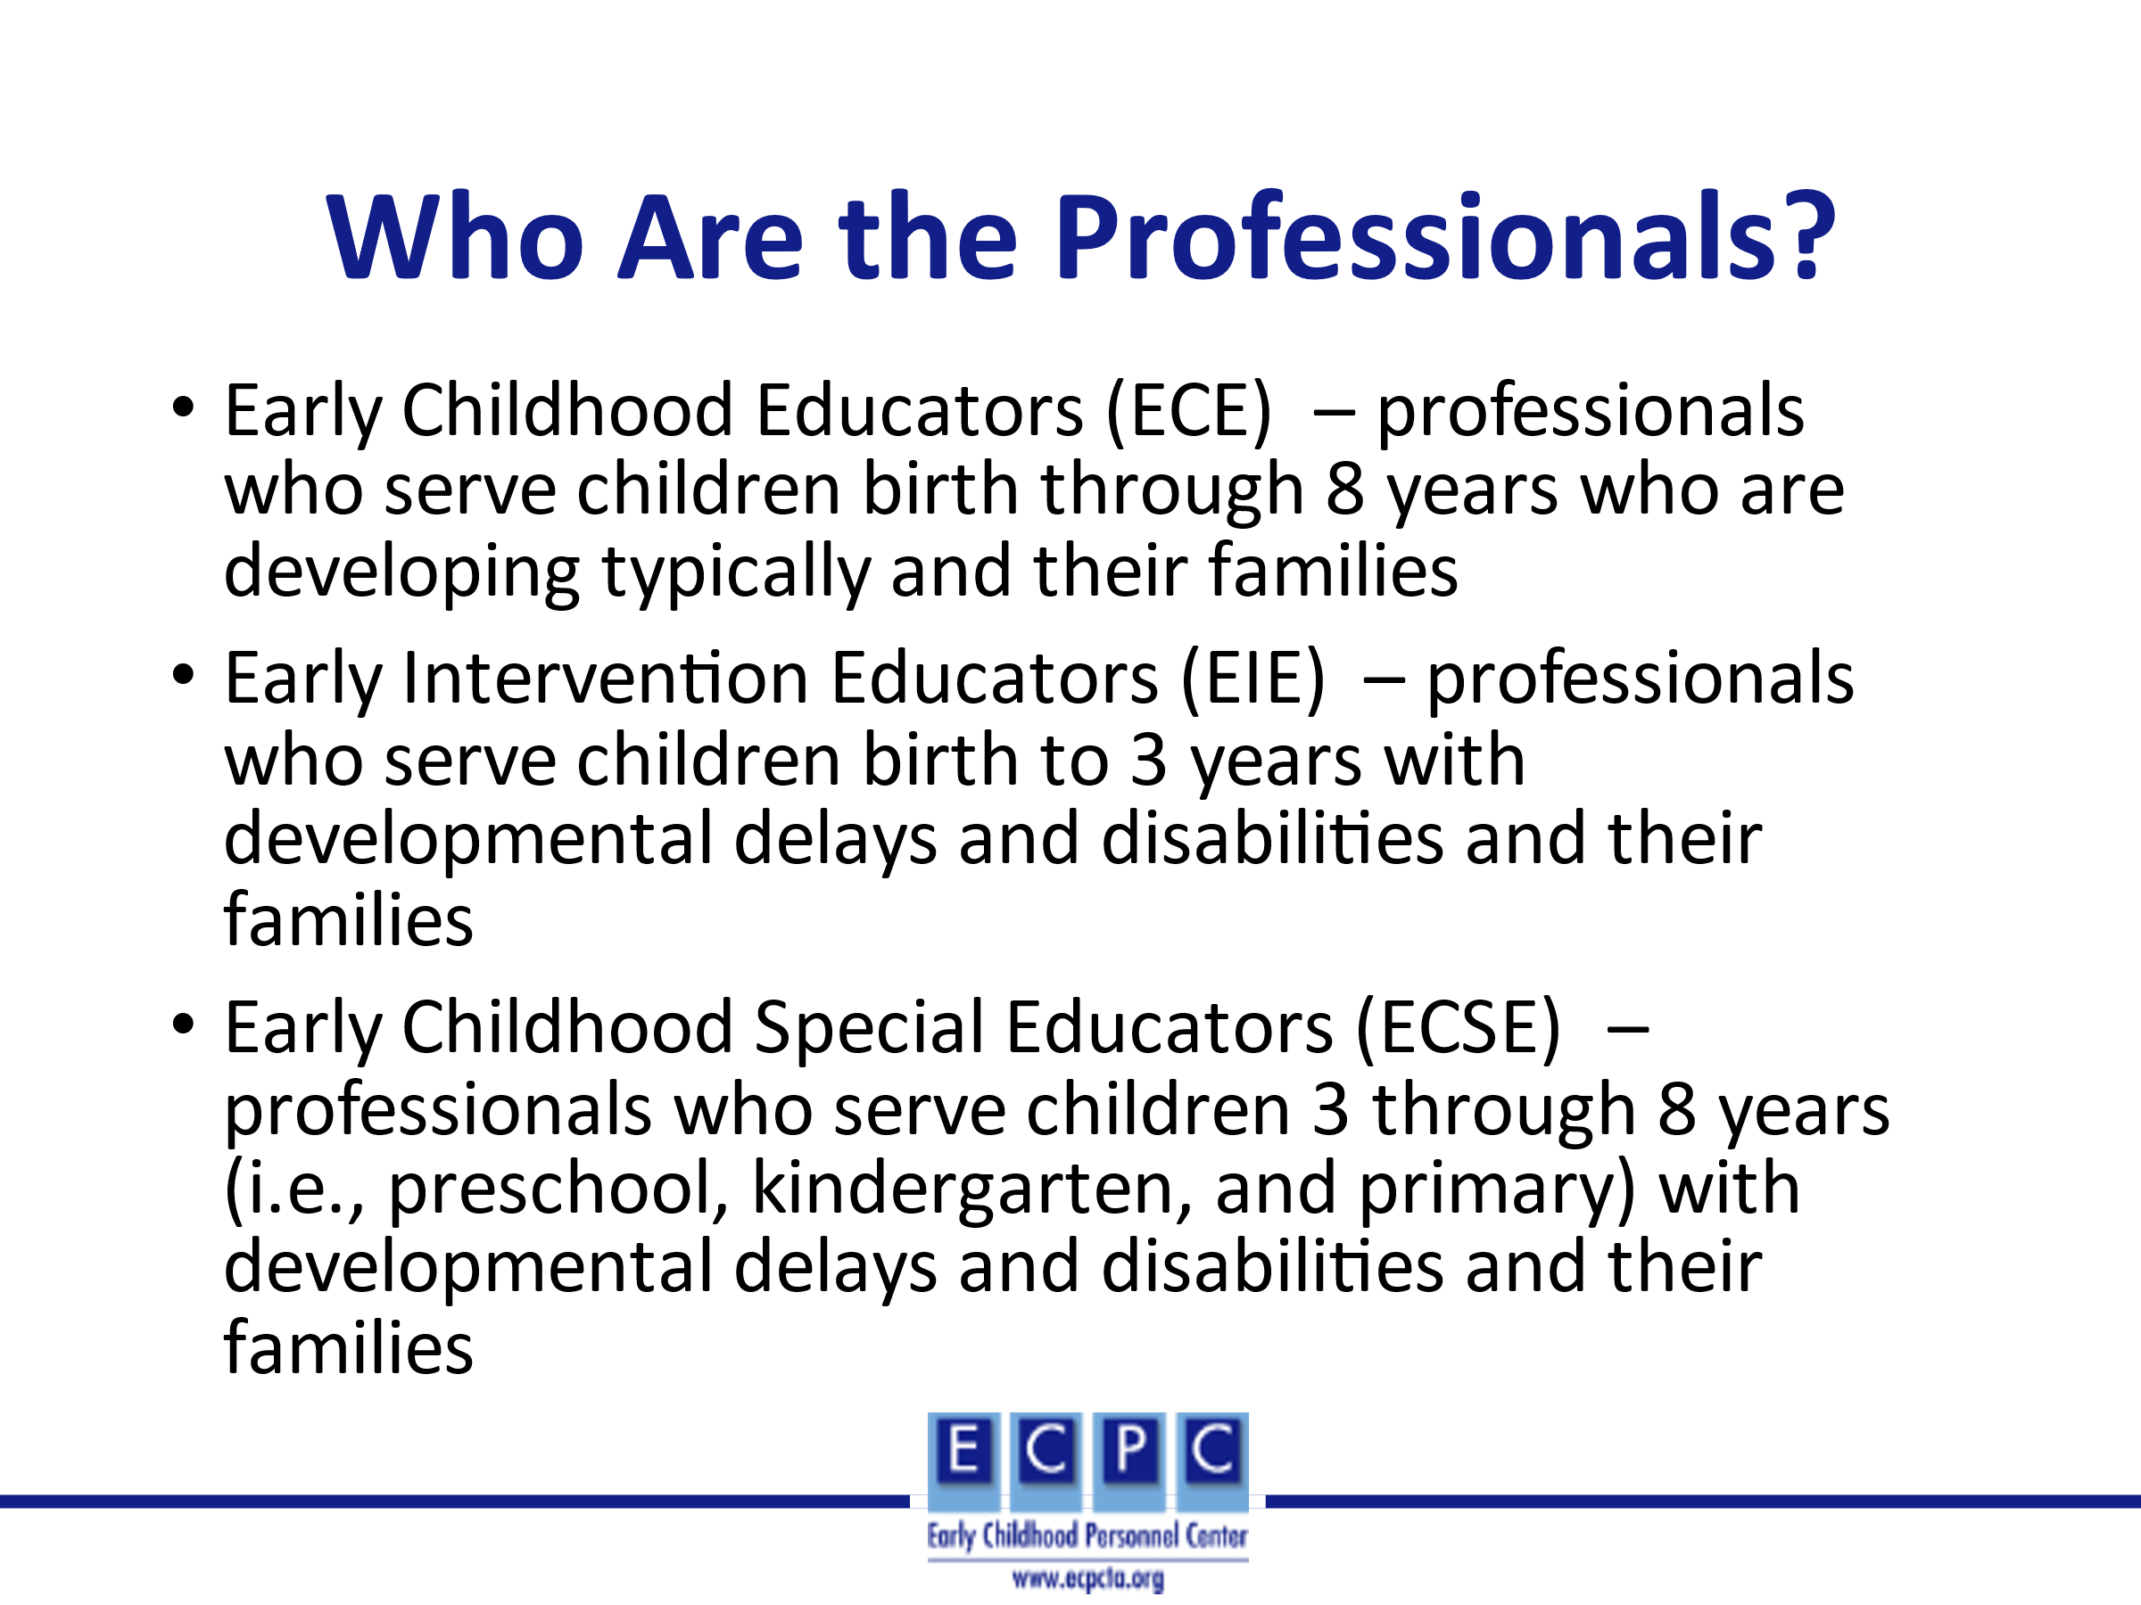 | The definitions provided here focus on professionals who are working directly with young children and families and who have demonstrated performance in the professional standards for the discipline (i.e., what professionals in the discipline should know and be able to do). The Power to the Profession Unifying Framework (p. 11) also includes others in the early childhood field such as administrators, higher education faculty, professional development providers, and childcare providers.  https://powertotheprofession.org/wp-content/uploads/2020/03/Power-to-Profession-Framework-03312020-web.pdf  The following slides will identify roles for the EIE and the ECSE.
Slide 8 | 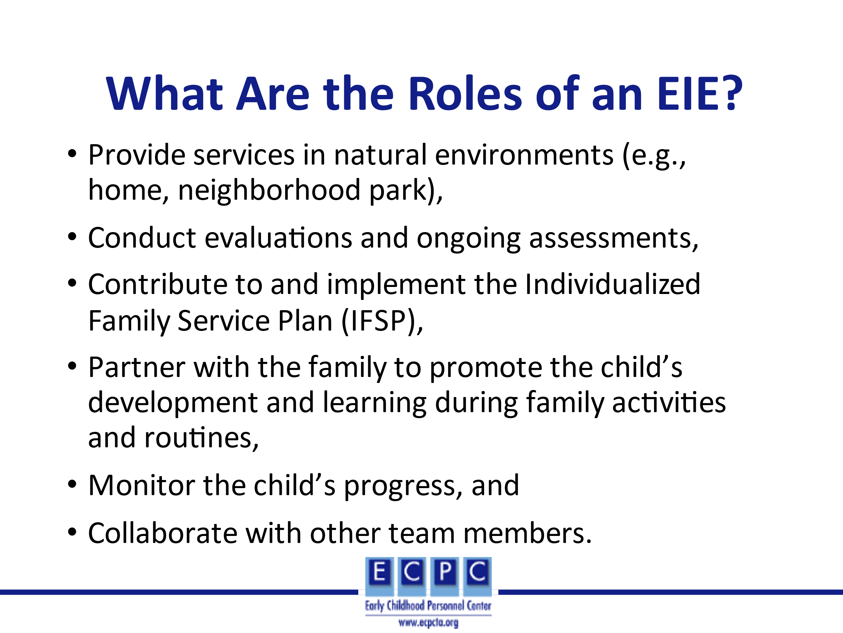 | Early intervention services are provided by professionals from a variety of disciplines (e.g., physical therapy, occupational therapy, speech language pathology). Early intervention educators (EIEs) are the special educator on the team and provide what is referred to as special instruction in Part C of IDEA regulations. EIEs work with children birth to 3 years with developmental delays and disabilities and their families in the families’ natural environment (e.g., home, neighborhood park, grocery store). The EIE works in partnership with the family to support the parent/caregiver in using evidence-based intervention strategies to address IFSP outcomes in the family’s daily activities and routines. For example, if a child is working on pincer grasp, strategies to assist the child in acquiring that grasp might be incorporated into a mealtime in which the child is picking up a small food item (e.g., cereal). The EIE also conducts ongoing informal assessments and monitors progress on the IFSP. In a Primary Service Provider model, the EIE may serve as the primary service provider. The EIE also communicates with other team members on a regular basis and is a member of the team when IFSP meetings and transition meetings are conducted. Depending on the regulations and procedures in the state, some EIEs may conduct evaluations.
Slide 9 | 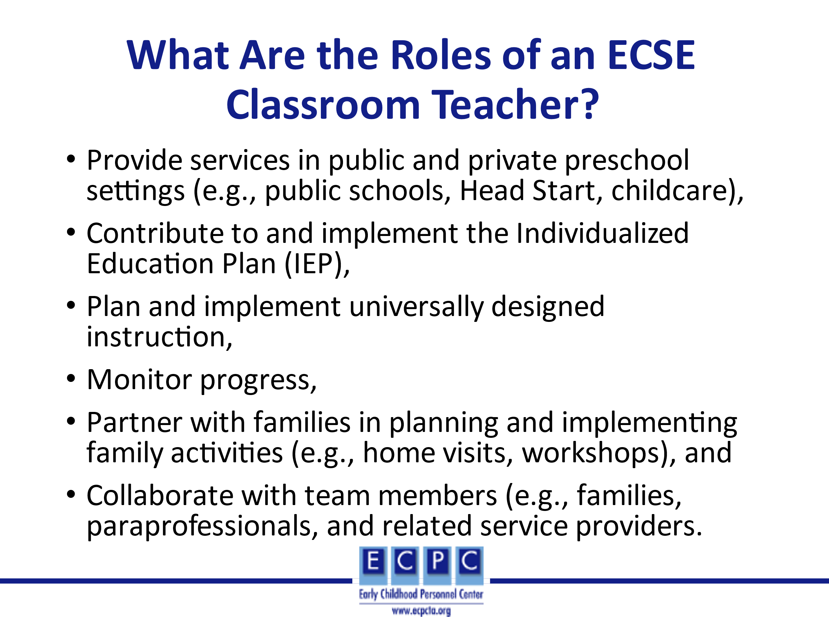 | Early Childhood Special Educators (ECSE) may work as a classroom teacher in a preschool or kindergarten setting that includes children 3 through 5 years with developmental delays and disabilities. Based on the least restrictive environment (LRE) provision of IDEA, these should be inclusive classrooms. As a member of the team, the ECSE participates in IEP meetings to develop and/or revise the IEP. In partnership with the family and other team members, the ECSE plans universally designed instructional activities, implements instruction, and monitors progress through informal assessment. The ECSE communicates with the family on a regular basis (e.g., email, newsletters, home visits, parent-teacher conferences) and partners with families to plan special activities for families (e.g., open house, literacy night). The ECSE also serves as a team leader with the paraprofessional(s) and related service providers who may be coming into the classroom to work with children who have IEPs and meets with them regularly to plan instruction and discuss progress. The ECSE serves in a mentor role for the paraprofessional(s) in the classroom.
Slide 10 | 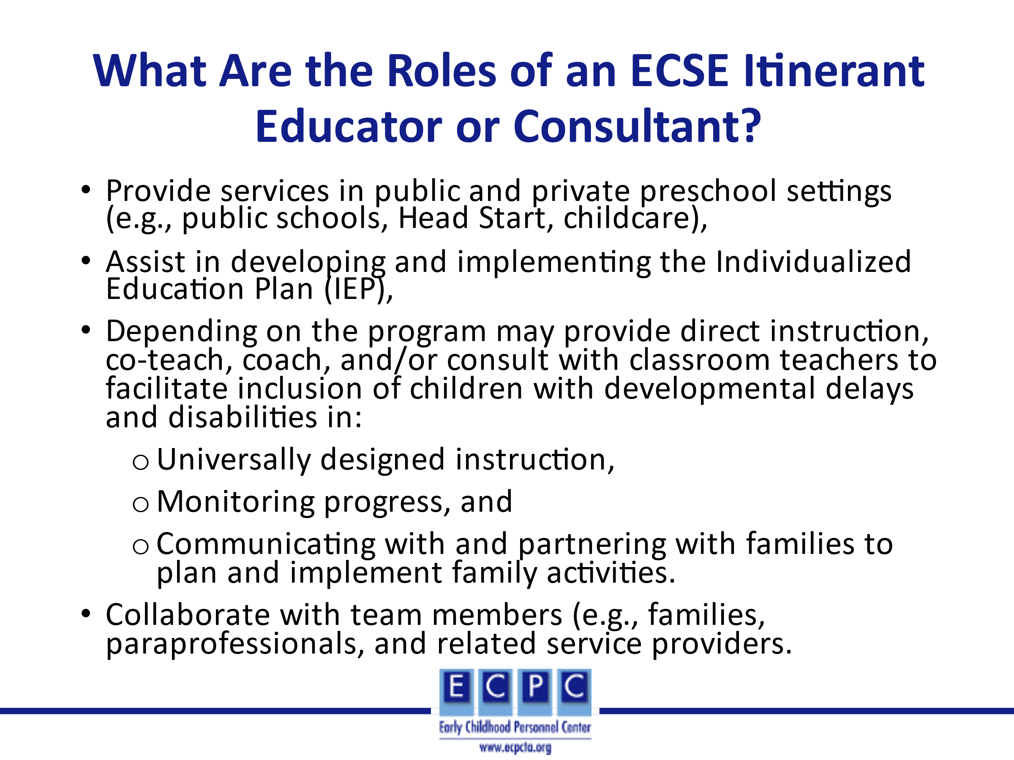 | Some programs may employ ECSEs who serve in an itinerant or consultant role working with several ECEs in public and private settings (e.g., public school, Head Start, childcare) to support the classroom staff in including children’s IEP goals into the daily activities and routines. The ECSE may model the use of specific evidence-based instructional strategies through direct instruction or co-teaching. Or the ECSE may serve as a coach or consultant to the classroom staff to support them in planning and implementing universally designed instruction, monitoring progress, and communication with families. As a member of the team, the ECSE communicates with other team members on a regular basis and participates in IEP meetings and other meetings.
Slide 11 | 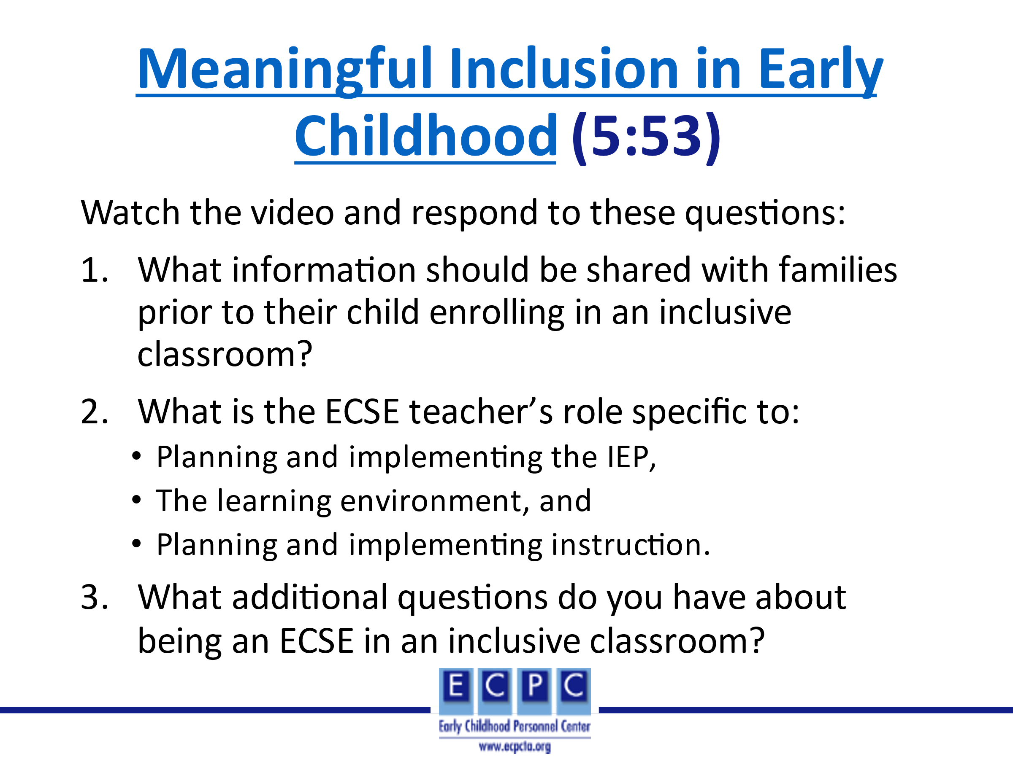 | Provide a brief introduction to the video such as, this video takes place in an inclusive preschool classroom in the Sun Prairie (Wisconsin) Area School District. Parents of children in the classroom discuss some of their fears when their child entered the classroom as well as benefits over time. ECSE teachers discuss important aspects of the classroom and curriculum and their roles in including young children with developmental delays and disabilities.  Review the questions on the slide for the learners to think about as they watch the video. Show the video. Using the questions on the slide as a guide, discuss the video.
Slide 12 | 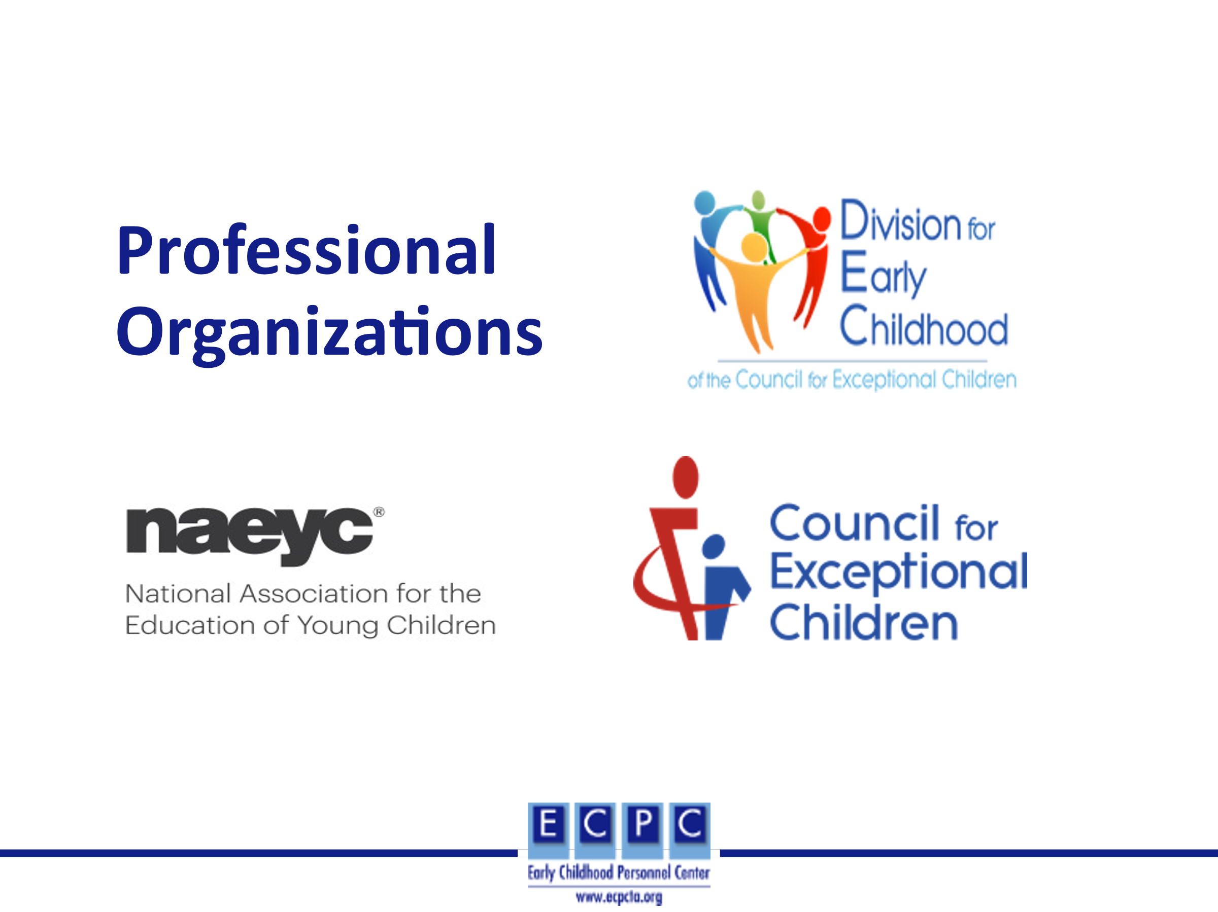 | Professional organizations or professional associations advance a specific profession and support the interests of those in that profession or connected to the profession in some way. Professional organizations typically require membership dues, have an elected leadership body, have an executive office with staff, and include committees that assist with the work of the organization. They may be national or international in scope. Professional organizations engage in a variety of professional development, communication, research, and advocacy activities to support their members and advance the profession. They also provide a vehicle to network with others with similar interests.  We will briefly discuss three professional organizations that relate directly to the ECE and EI/ECSE professions. These are the Council for Exceptional Children (CEC) and its Division for Early Childhood (DEC), both of which are international organizations. A national ECE professional organization with which CEC and DEC work closely is the National Association for the Education of Young Children (NAEYC).
Slide 13 | 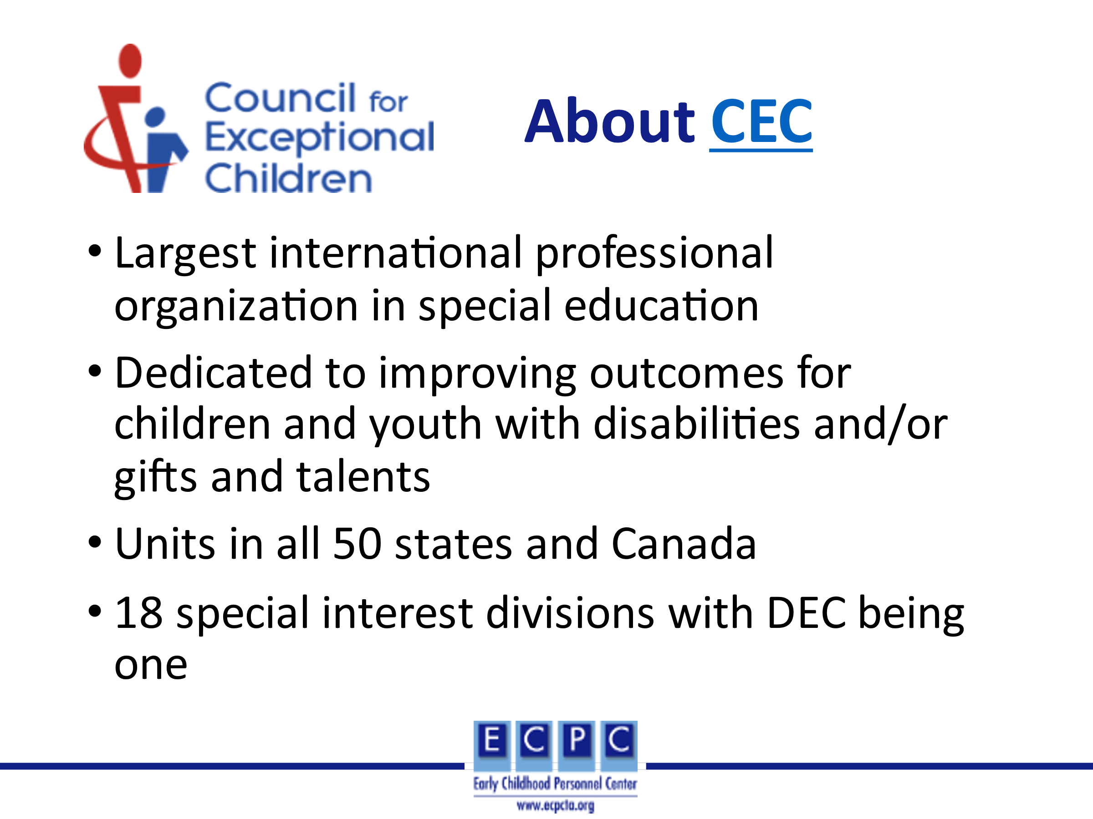 | As a special education professional association, CEC focuses on services and supports for professionals (e.g., teachers, administrators, university faculty, professional development providers) who work with or on behalf of children and youth birth through 21 years who receive services under the Individuals with Disabilities Education Act (IDEA).
Slide 14 | 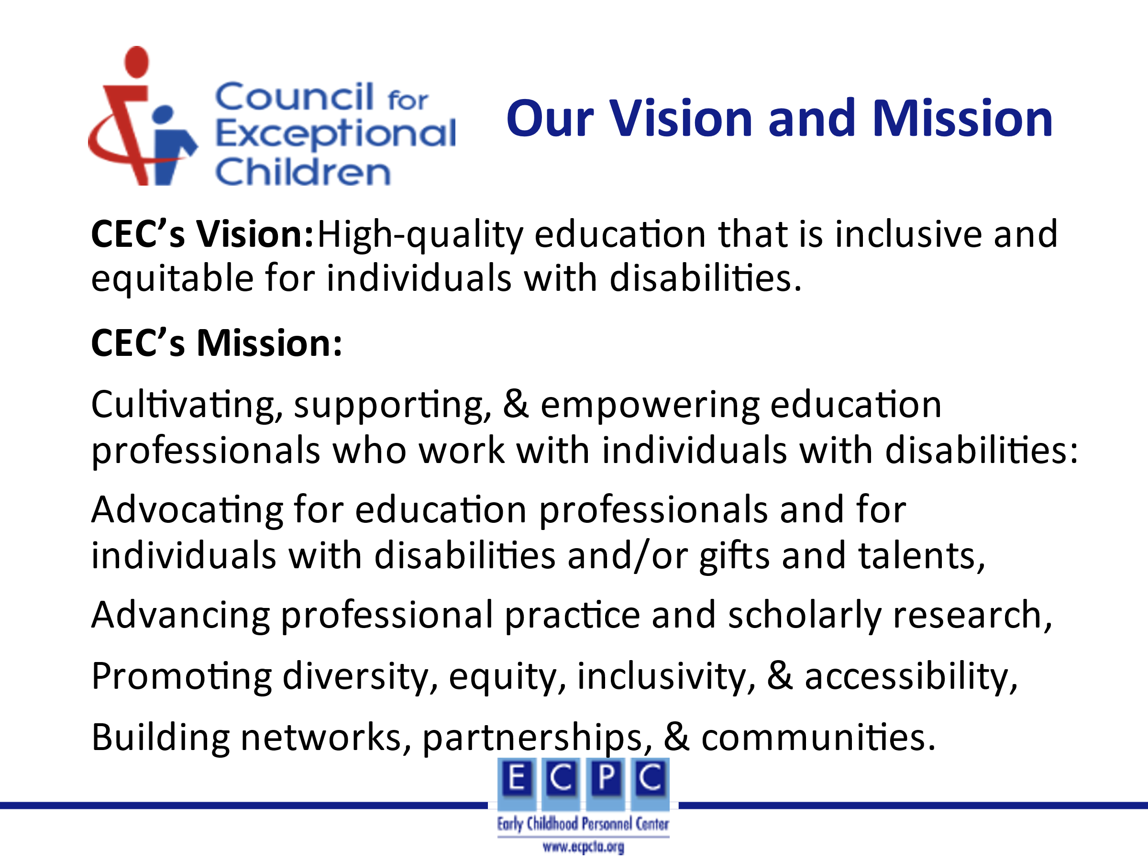 | Ask learners to read CEC’s Vision and Mission. Then, ask them what supports and resources based on the vision and mission statements that CEC might provide its members.
Slide 15 | 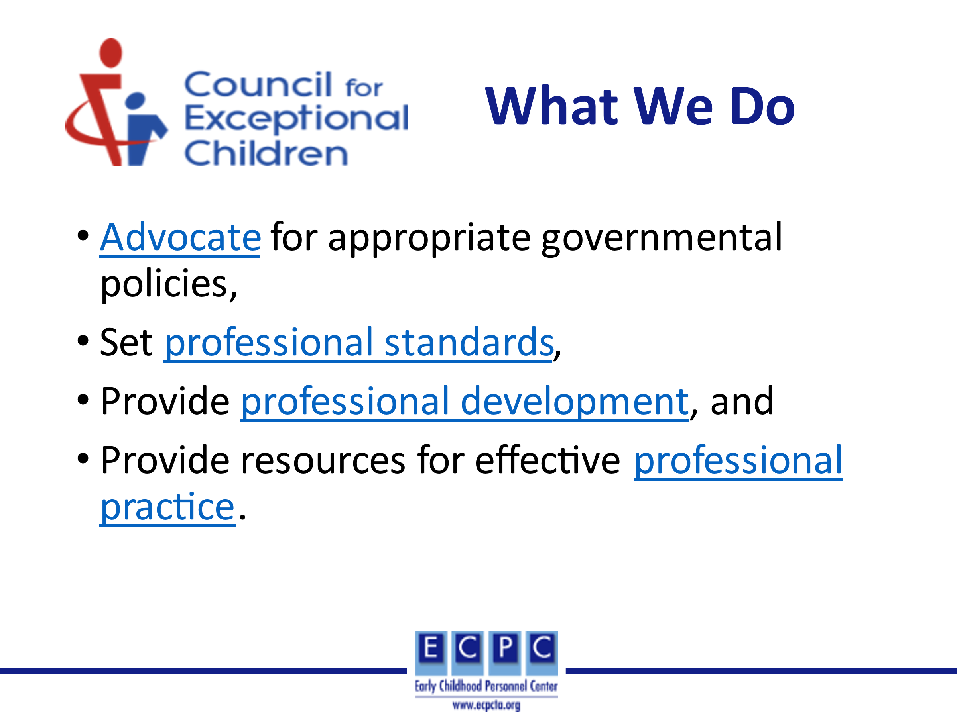 | Using the hyperlinks in the slide, talk about where to find more information on CEC’s website. Mention that some examples of resources for PD and professional practice are on the next slide. As you scroll through the website, point out some of the key resources as identified below.  - Advocacy – Advocacy is one of the major activities in which CEC engages. On the website, you will find CEC’s policy agenda, learn about issues being addressed at the federal level, and be able to send letters to your members of Congress about specific issues.  Professional Standards – As the parent organization for DEC and CEC’s other subdivisions, it is the “holder” of the different sets of professional standards. These standards identify what beginning professionals for that specialization area should know and be able to do to practice effectively. CEC has initial standards for EI/ECSE which we will discuss in more depth below, K-12 special educators, gifted educators. It also has advanced standards including those for special education administrators. The link on the slide will take you to each of those sets of standards as well as resources to support the use of the standards.  Professional development and practice – CEC hosts an annual conference and individually designed training on the high leverage practices for local, district, or state teams. It also hosts a variety of online learning events such as webinars and Jump Start for new special educators.
Slide 16 | 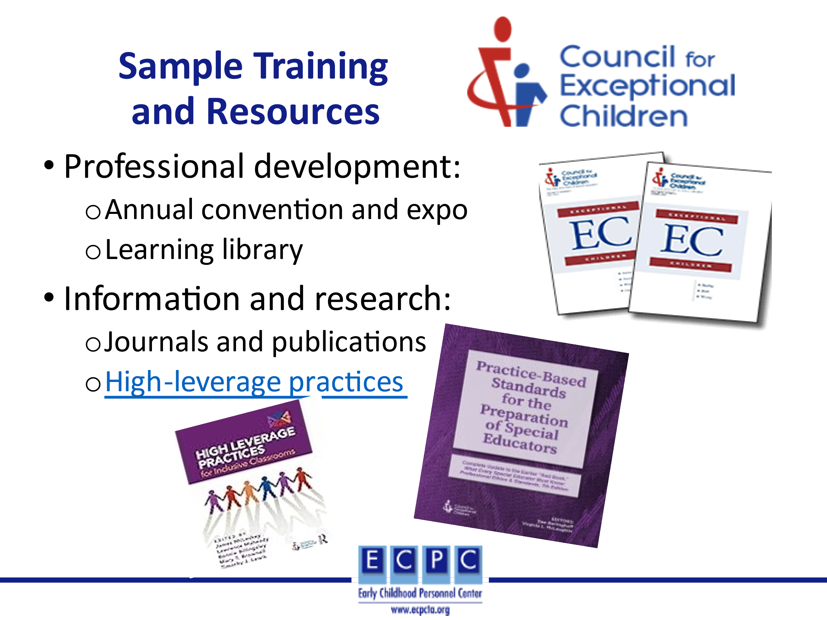 | CEC’s members receive two journals: Exceptional Children which reports results of research studies, and Teaching Exceptional Children which includes articles that discuss applying research in your practice.  High-leverage practices are practices in four areas; instruction, assessment, collaboration, and social-emotional; that beginning K-12 professionals should be able to implement. A variety of resources have been developed to support the use of the HLPs.
Slide 17 | 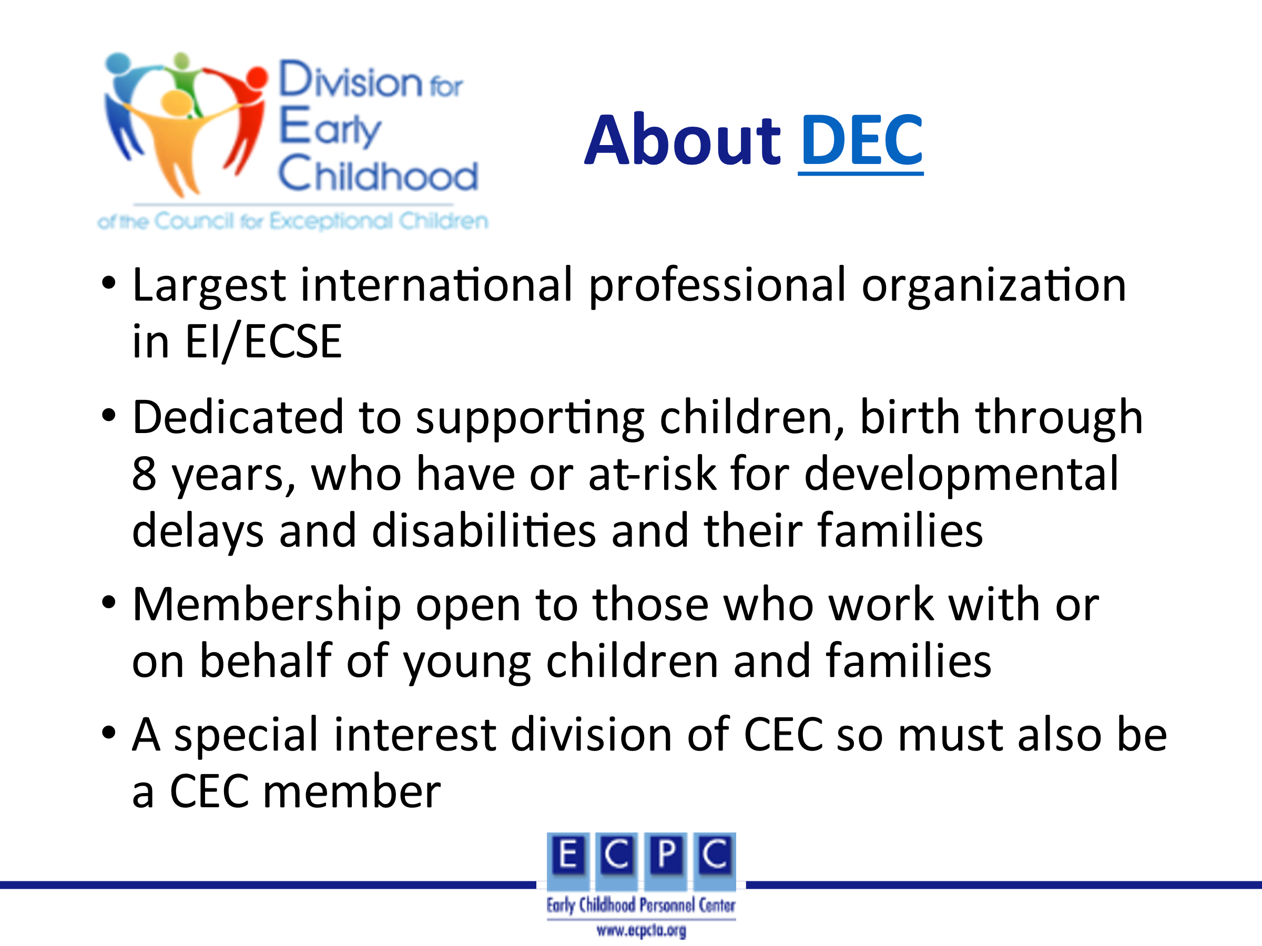 | DEC is a special interest division within the Council for Exceptional Children (CEC). You have to be a member of CEC to join DEC or any of their special interest divisions.
Slide 18 | 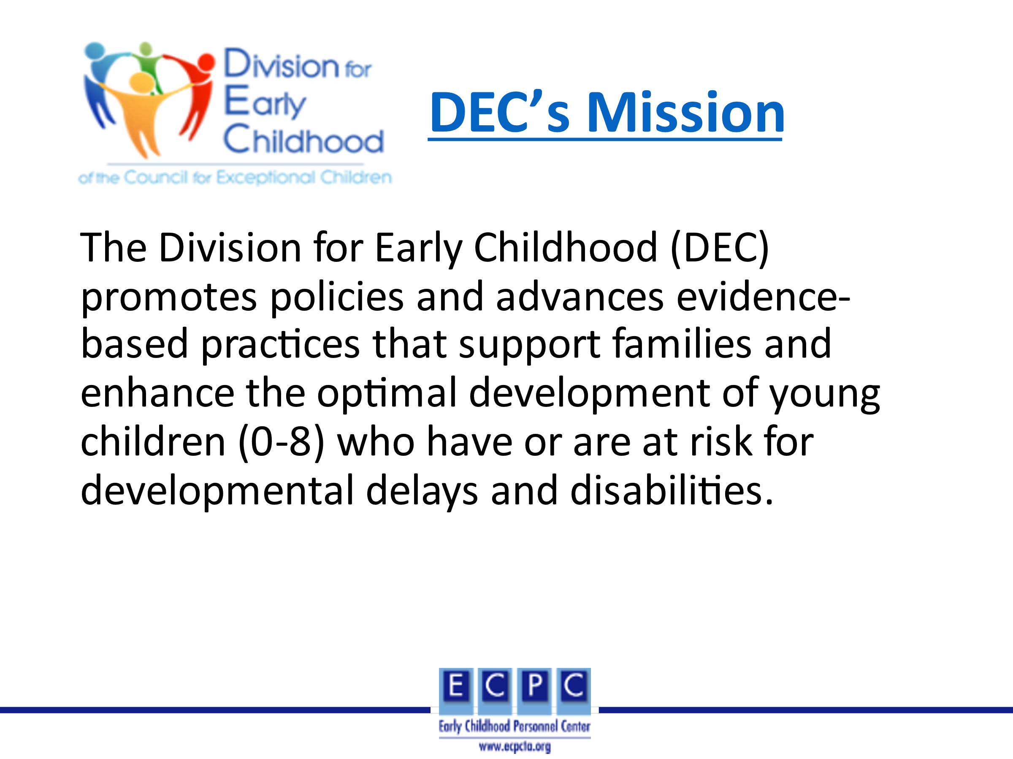
Slide 19 | 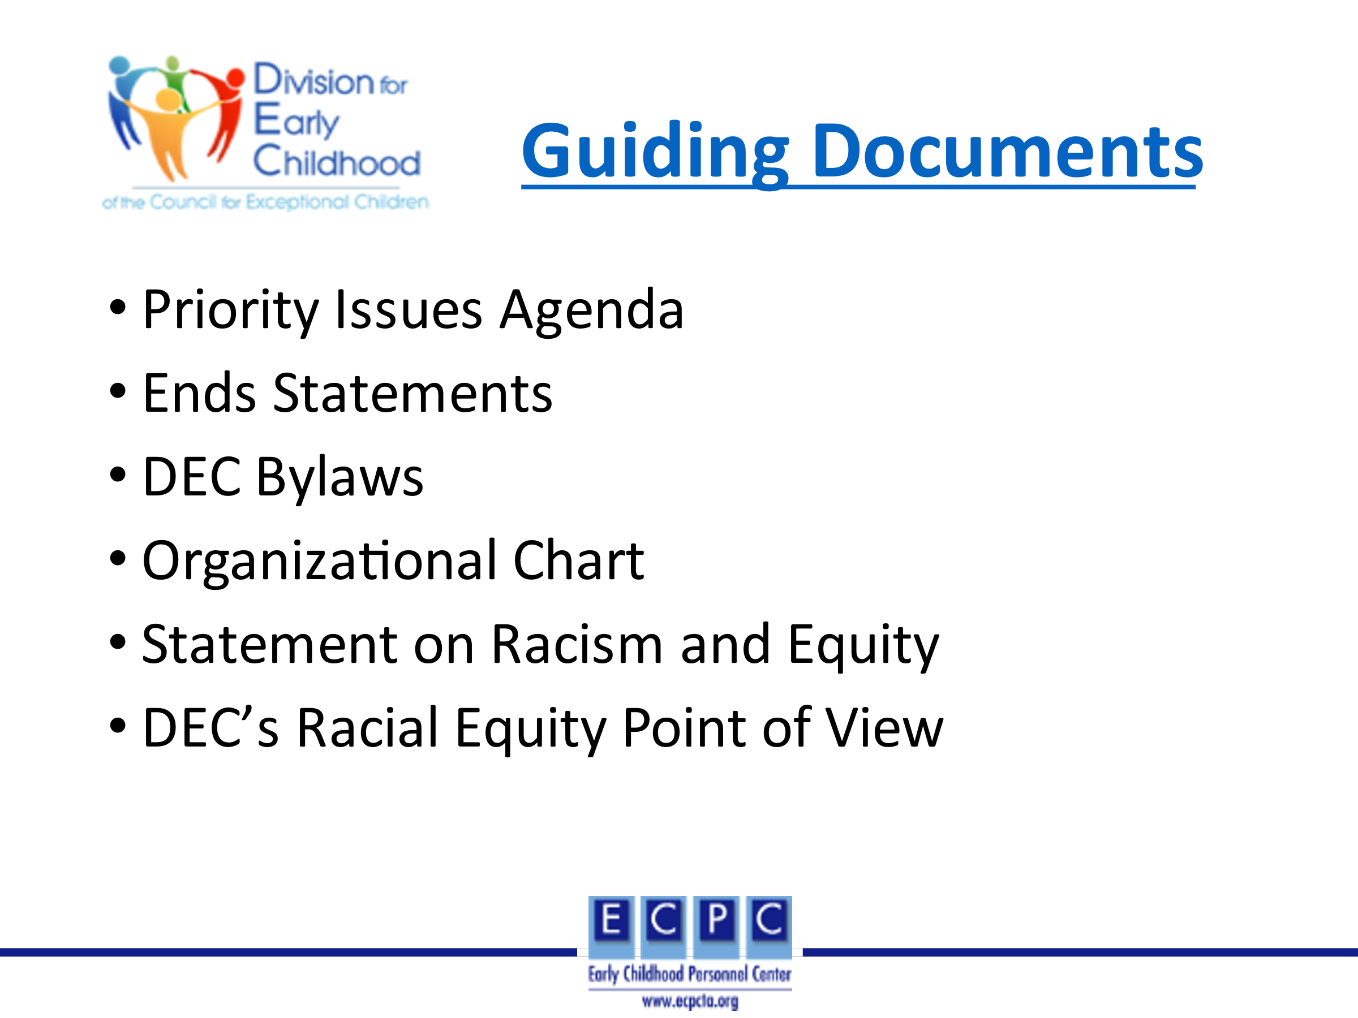 | DEC has several documents that guide the work of the organization: priority issues agenda, ends statements, bylaws, and organizational chart. Each of these can be found at the Guiding Documents link on the website. DEC is committed to equity, inclusion, and social justice. As a result of a recent racial equity assessment, DEC has developed the racial equity point of view that identifies DEC’s commitment to overcoming institutional racism in all of its work.
Slide 20 | 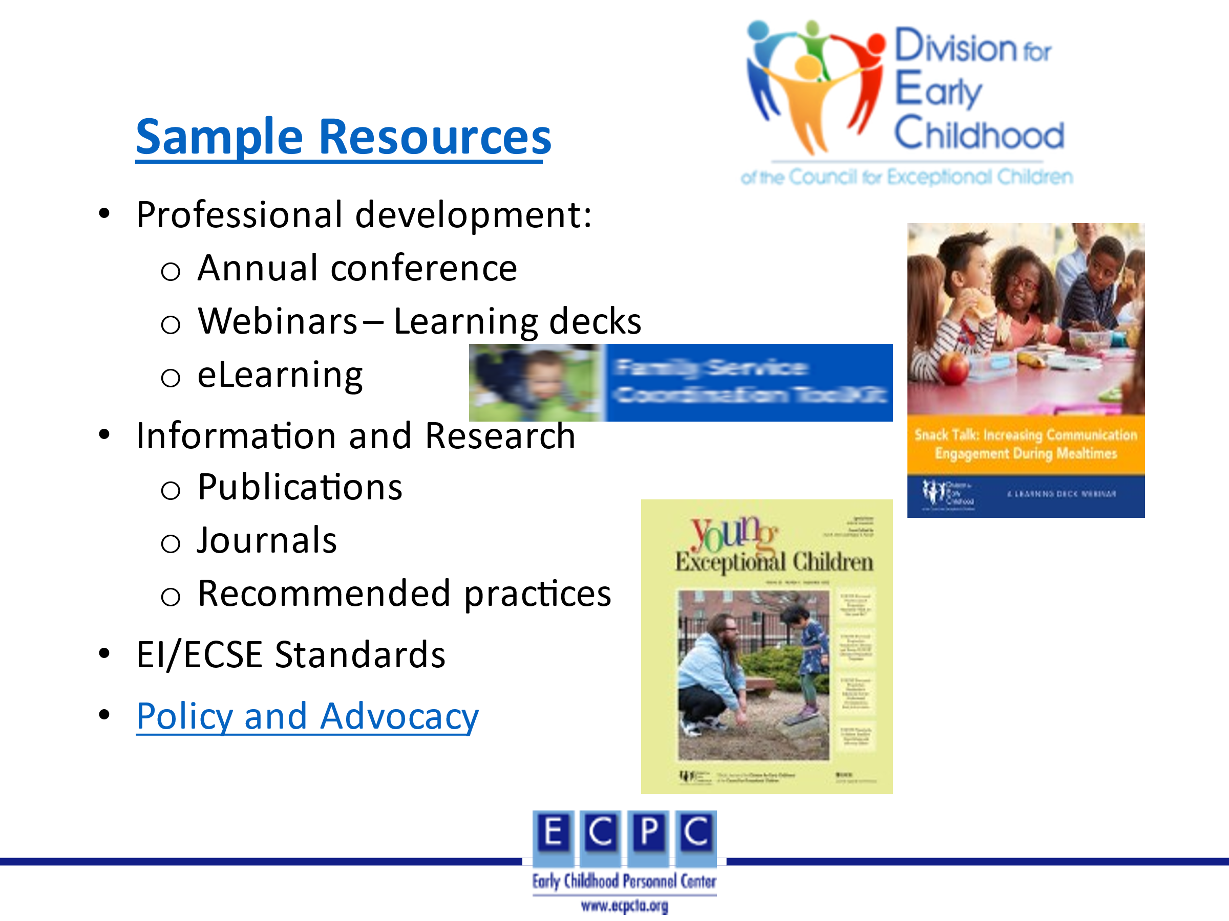 | Using the hyperlinks in the slide, talk about where to find more information on DEC’s website. As you scroll through the website, point out some of the key resources as identified below.  DEC sponsors a variety of activities and resources to support ongoing professional development. These include:  - An annual conference  - Learning decks (webinars) based on topics of interest to members in various roles (e.g., Snack Talk…., Who is Missing at the Table? Leadership Fundamentals…>).  - eLearning Library with modules, toolkits, and webinars again with varied topics for individuals in distinct roles.  Recommended practices – DEC has developed recommended practices based on research and the best wisdom of the field. A variety of resources (e.g., videos, monographs) have been developed to support the use of the practices. The recommended practices and resources will be discussed in more detail in the PD Guide for Standard 7, component 7.2.  EI/ECSE Standards – DEC in collaboration with CEC has developed professional standards for individuals who work as early interventionists and early childhood special educators. These standards and resources will be discussed in more detail below.  As a DEC member, you receive two journals, Journal of Early Intervention (JEI) and Young Exceptional Children (YEC). The primary focus of JEI is to include articles that report research studies. While YEC includes articles that discuss how research can be applied to early childhood practice.  DEC offers several ways to engage in policy and advocacy activities.  - The Children’s Action Network (CAN) is a communication network that works toward changes in policy and legislation at the local, state and federal level. Through DEC state subdivisions, the CAN network engages members to act on issues important to the field.  - Joining a listserv will alert you to current policy and advocacy issues and provide opportunities to contribute or get involved.  - DEC provides templates that are issue specific to facilitate writing letters to your legislators.  - For individuals interested in policy and advocacy, DEC sponsors a community of practice focused on policy and advocacy committee for which DEC members and non-members can participate.  - The DEC website identifies other resources specific to policy and advocacy.
Slide 21 | 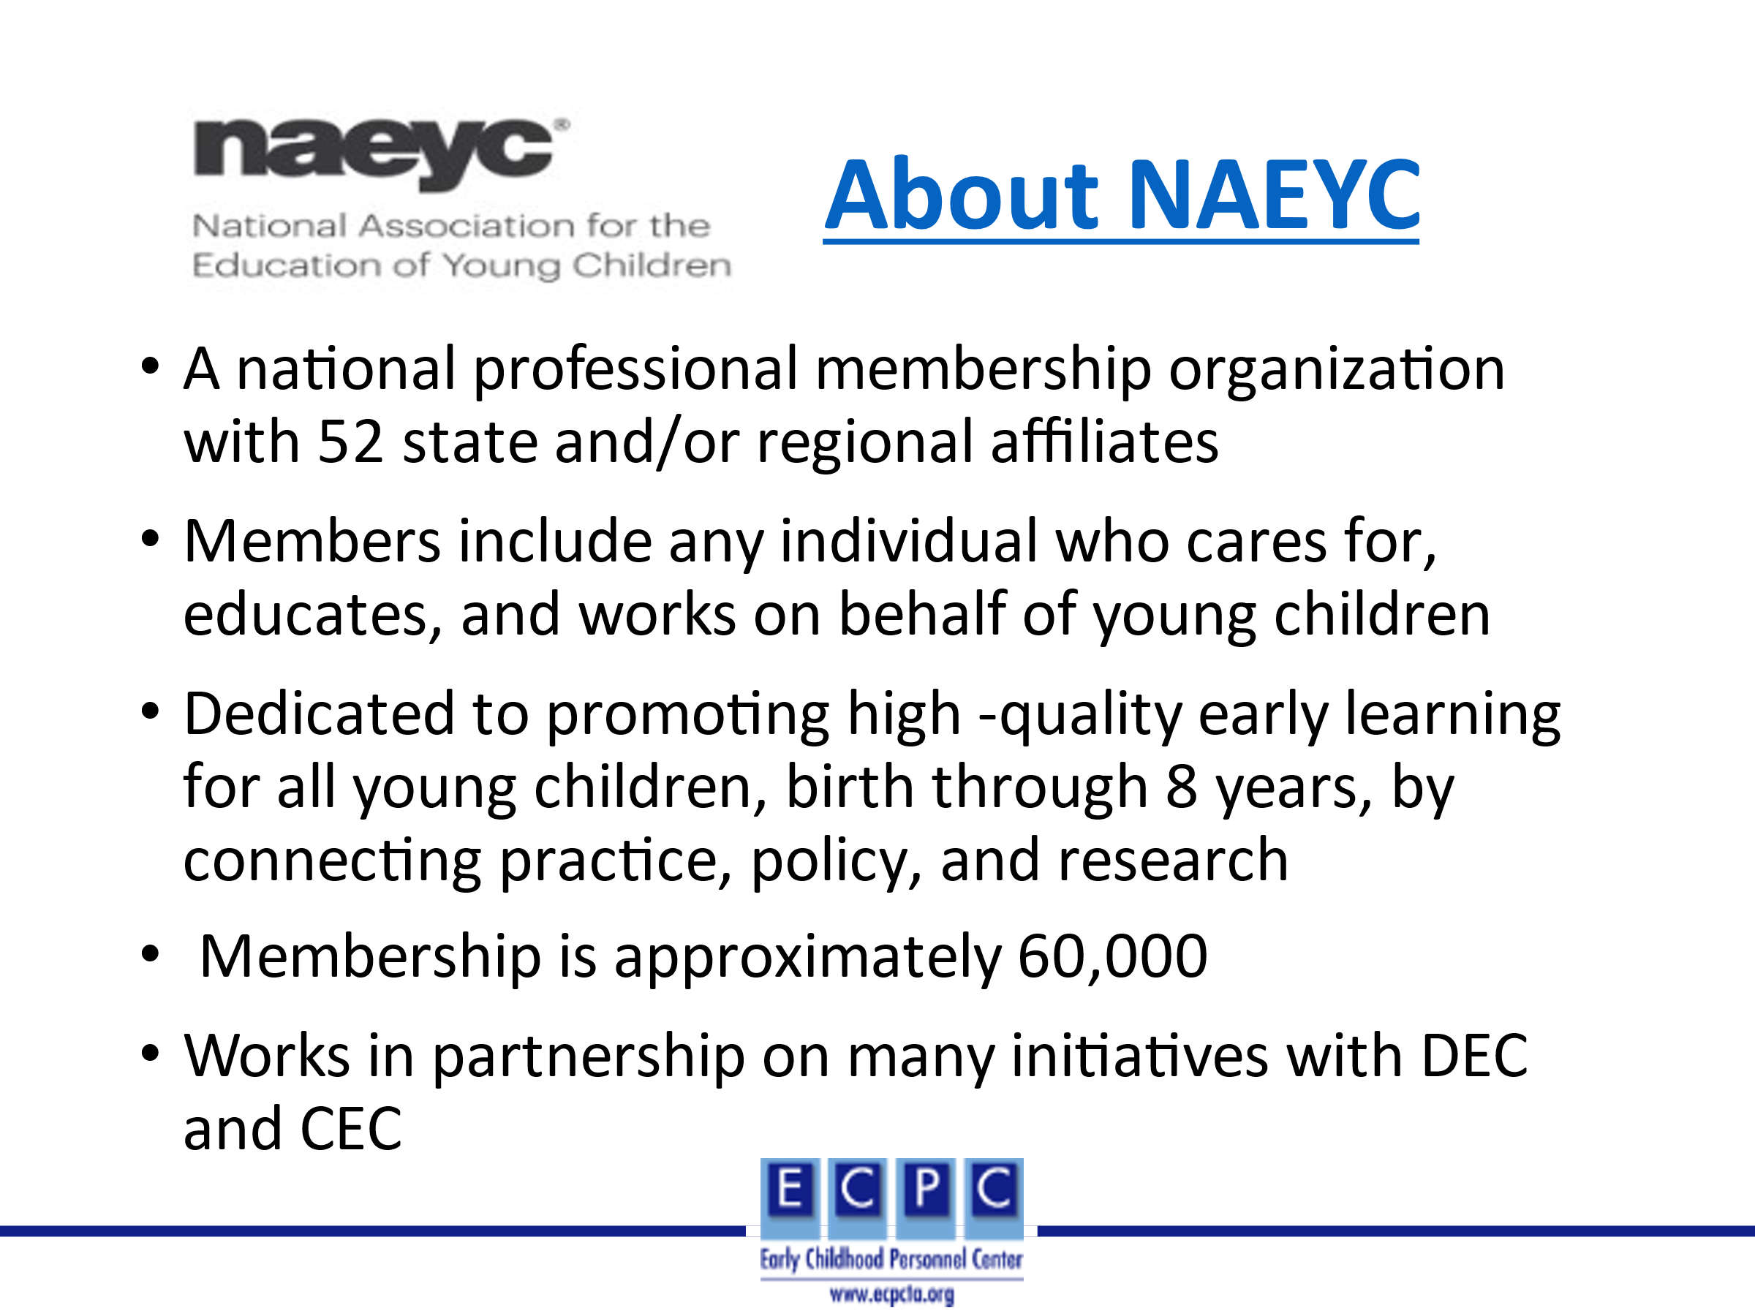
Slide 22 | 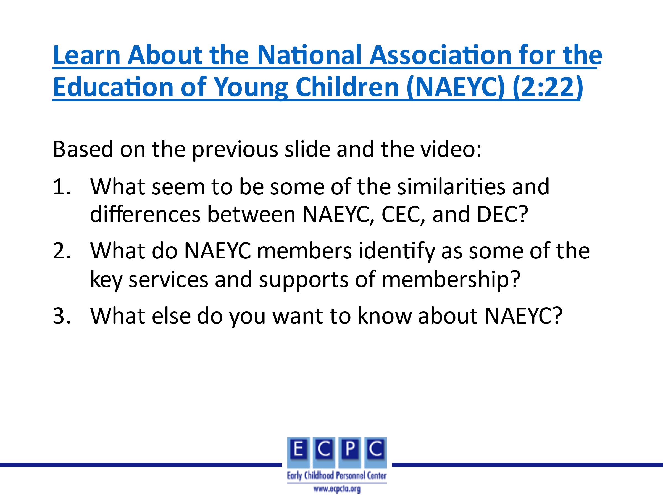 | This video discusses through its members’ voices who NAEYC is, what it does, and how NAEYC is working to provide brighter futures for all young children. After watching the video, discuss learner’s responses to the questions on the slide.
Slide 23 | 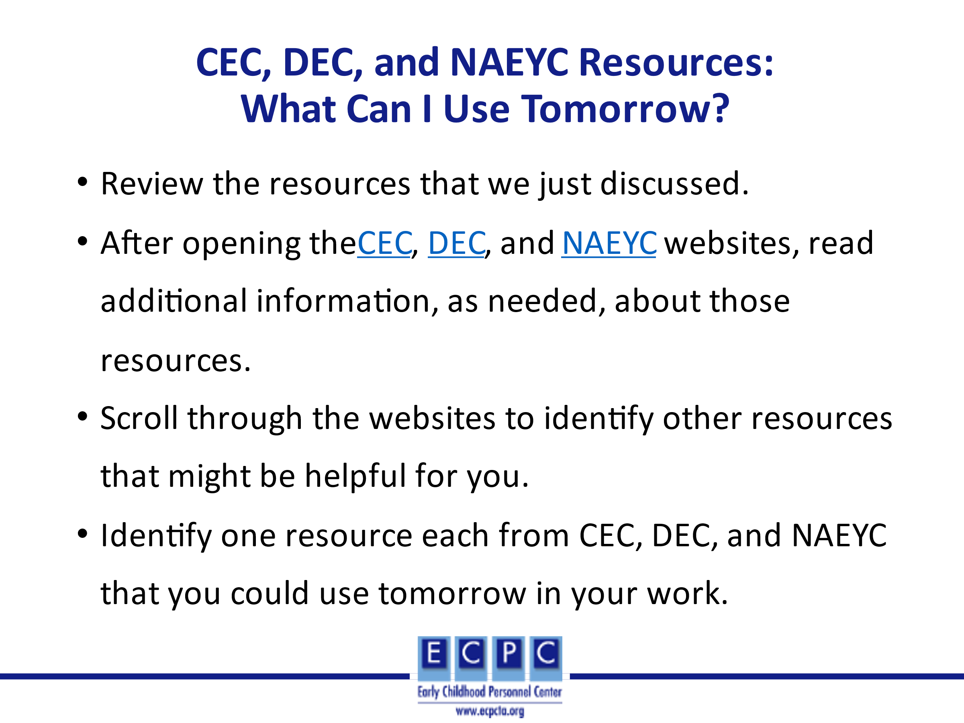 | Review the directions for this activity on the slide. After learners individually have had time to look at resources on each of the websites, ask some of the group to share the resources that they identified and why they think that will be helpful to them in their work. You might also, with a show of hands, ask if others in the group identified one or more of those resources.
Slide 24 | 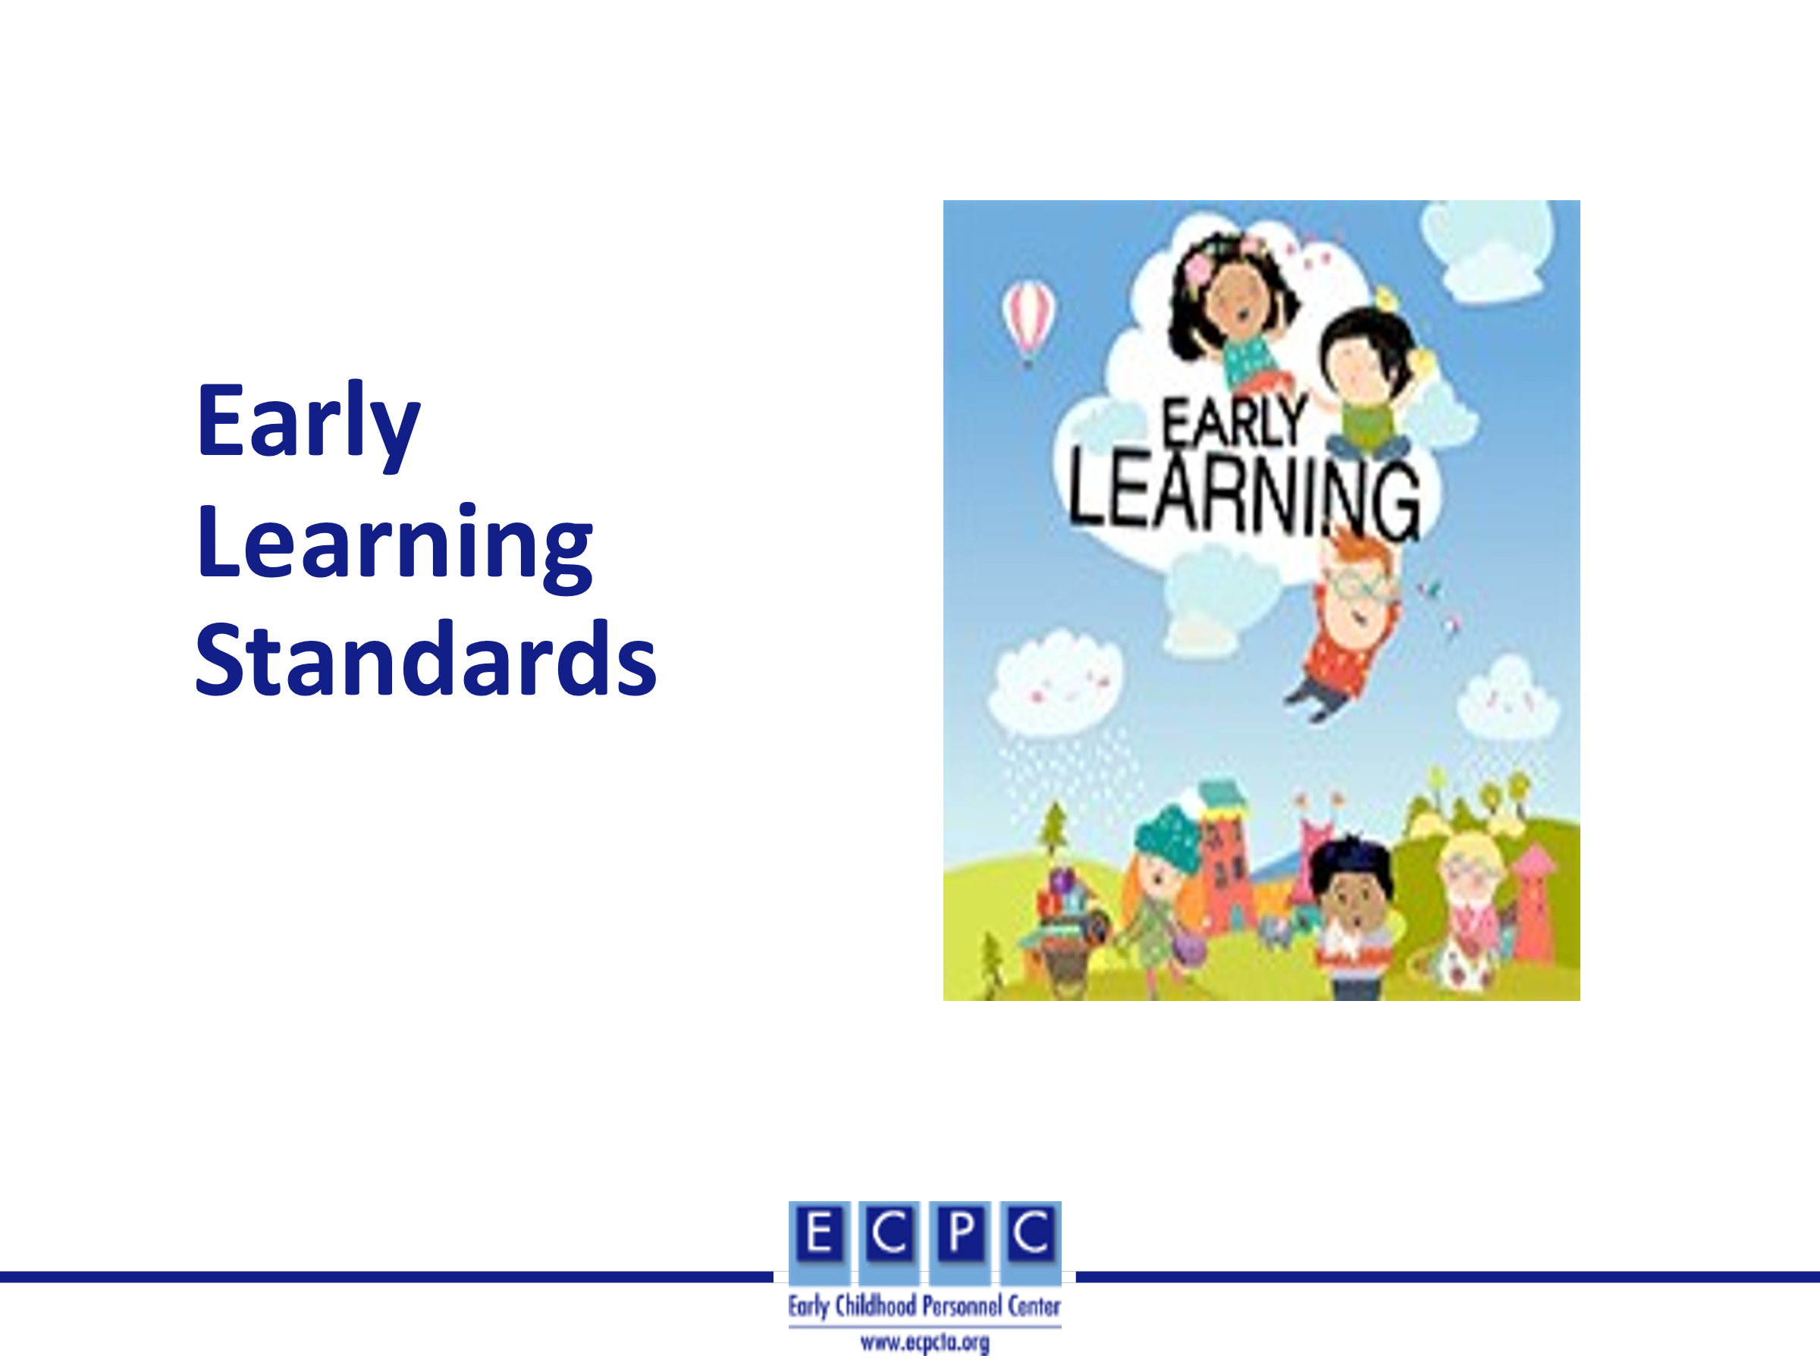
Slide 25 | 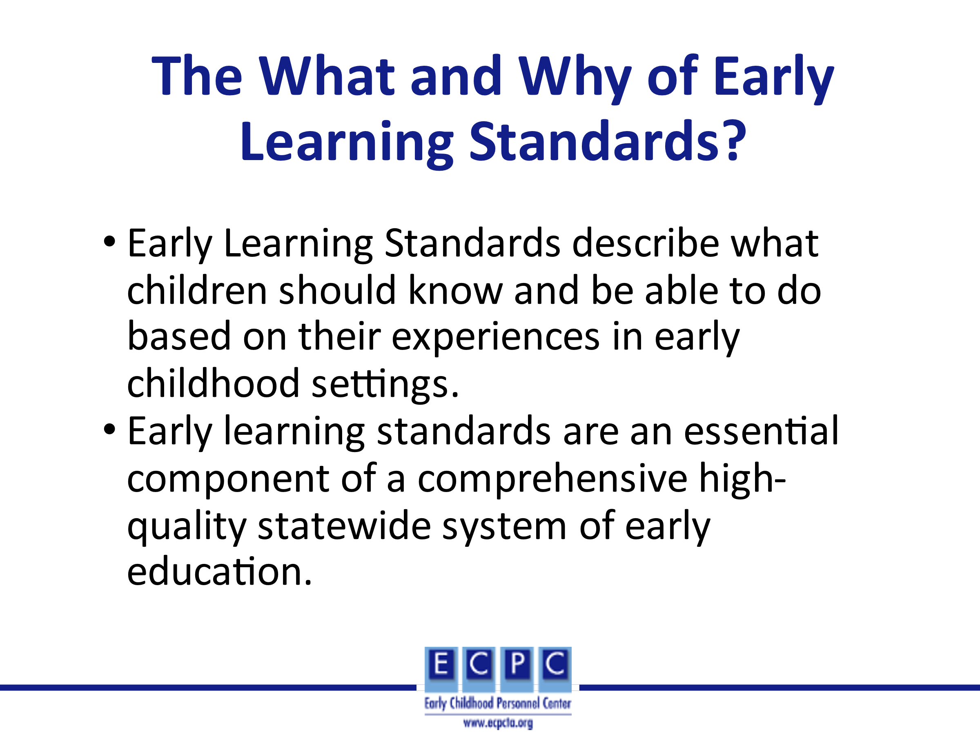 | They are one of the types of standards that form the basis of a state-wide early education system. They are the first link in an aligned Birth through grade 12 educational system.
Slide 26 | 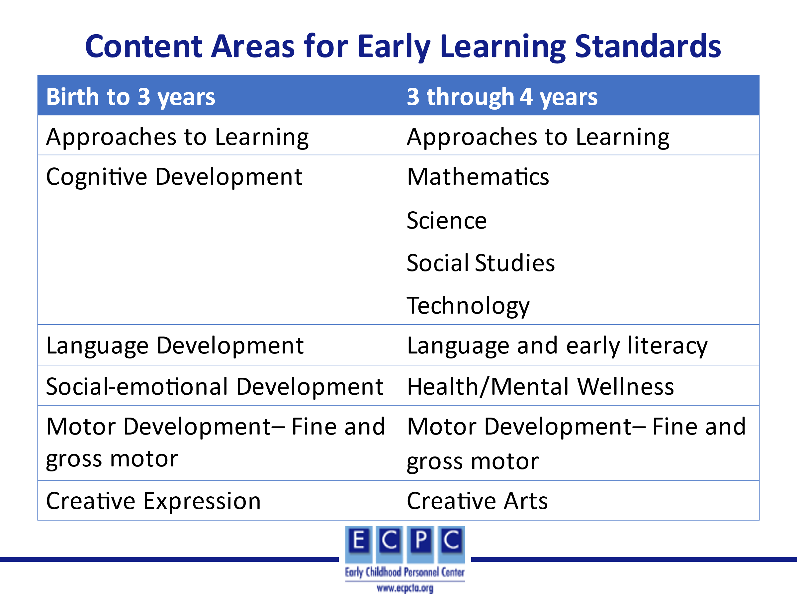 | Early learning standards typically include the birth through 4-year age range. Age 5 or kindergarten would then be included in the state’s standards for grades K-12. Early learning standards vary across states; however, they typically include skills based on developmental domains for birth to 3-years. The standards for 3 and 4-year-olds are more commonly based on pre-academic areas. For both age ranges, approaches to learning and creative arts/expression are included as content areas.
Slide 27 | 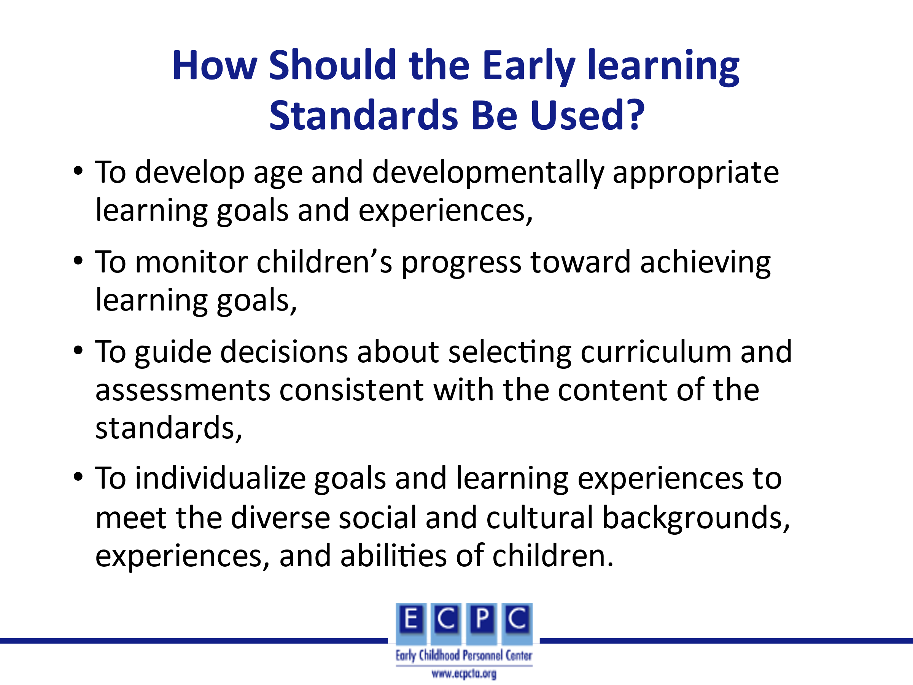
Slide 28 | 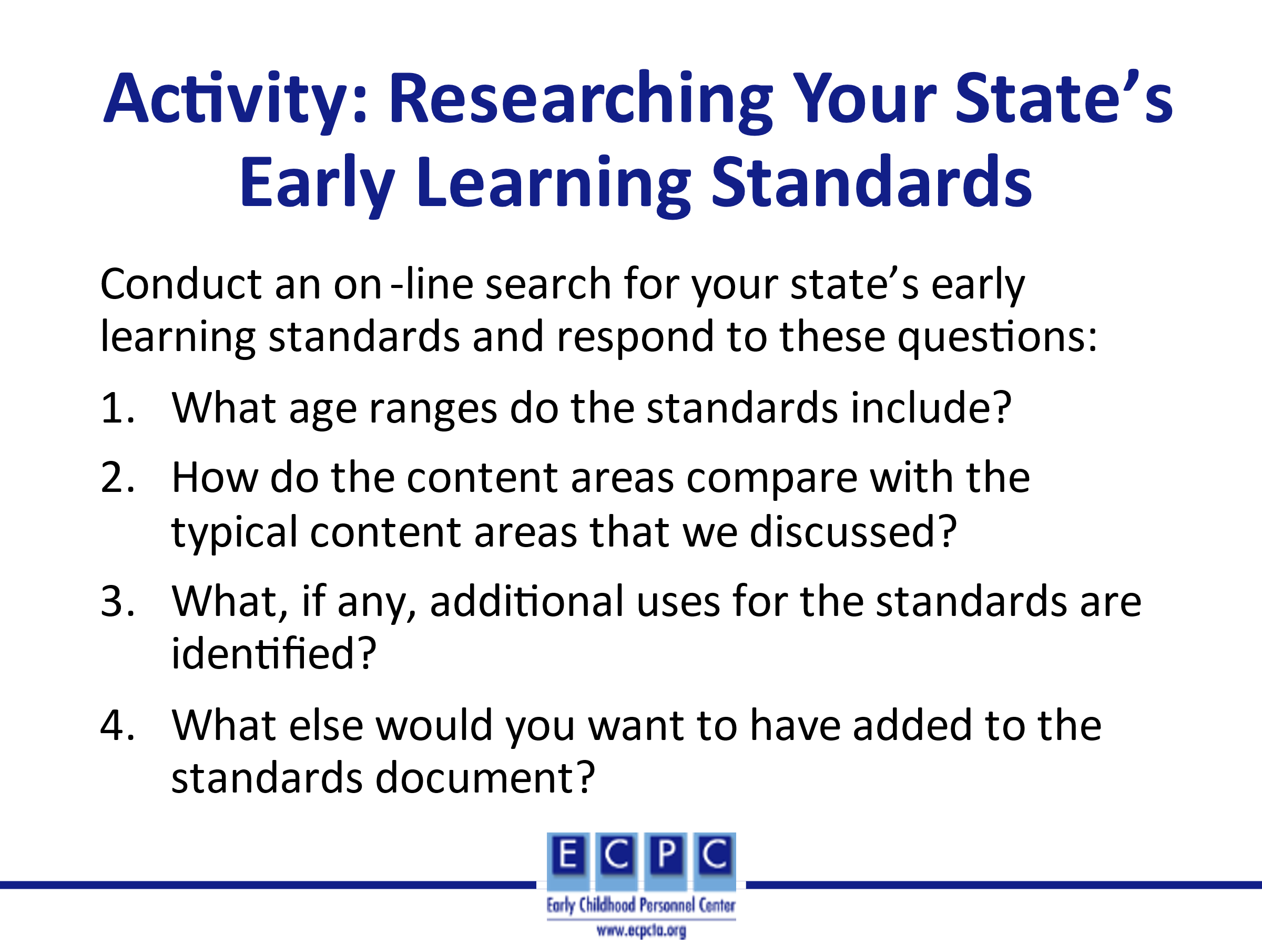 | Provide learners with approximately 15 minutes to research their state’s early learning standards using the questions in the slide. Discussion within the group might address questions such as, what did you like about the organization and format of the standards? Were you surprised by anything in your state’s standards? If yes, what?
Slide 29 | 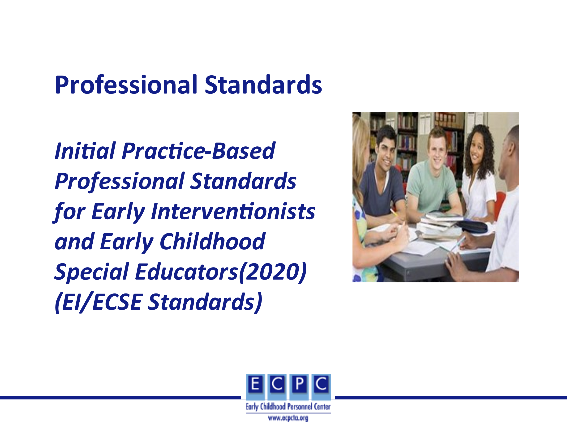 | Another essential component of a comprehensive high-quality statewide system of early education is professional standards. DEC in collaboration developed the first ever EI/ECSE Standards for beginning professionals in EI/ECSE. These Standards identify what EI/ECSE professionals upon completion of a higher education initial or preservice program should know and be able to do. They were developed by a 12-member Standards Development Task Force with input from the field. Multiple resources were used to develop the Standards, including research, the DEC Recommended Practices, and the CEC High Leverage Practices. Knowledge bases for each component identify the resources for that component.
Slide 30 | 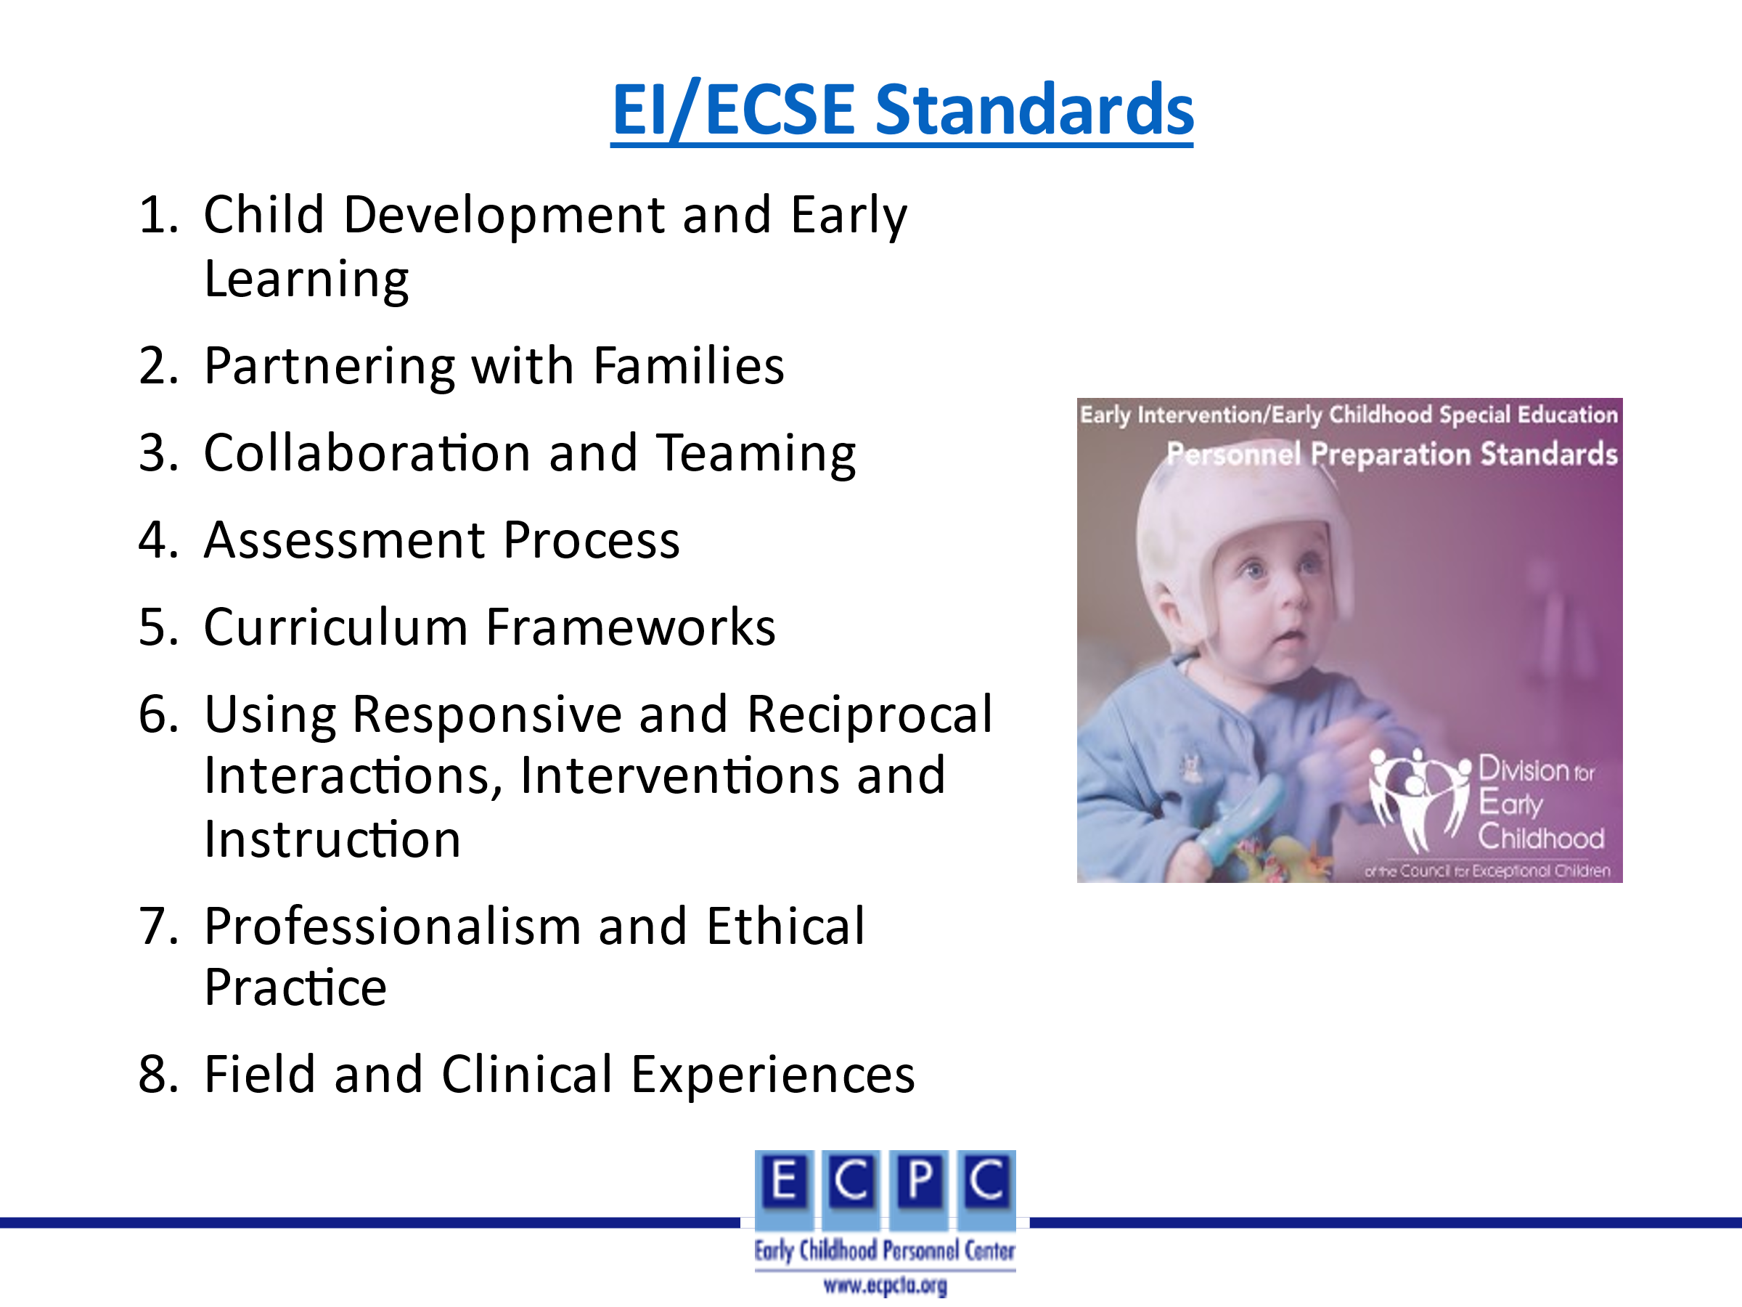 | The EI/ECSE Standards include Standards for 7 content areas and an additional 8th Standard focused on field and clinical experiences. Each of the 7 content Standards has components which further describe what professionals should know and be able to do based on that Standard. Each component has a supporting explanation which includes examples of what that Standards and component would look like in practice. The Standards and components can be found at the link on the slide along with a link to a document that includes the supporting explanations.
Slide 31 | 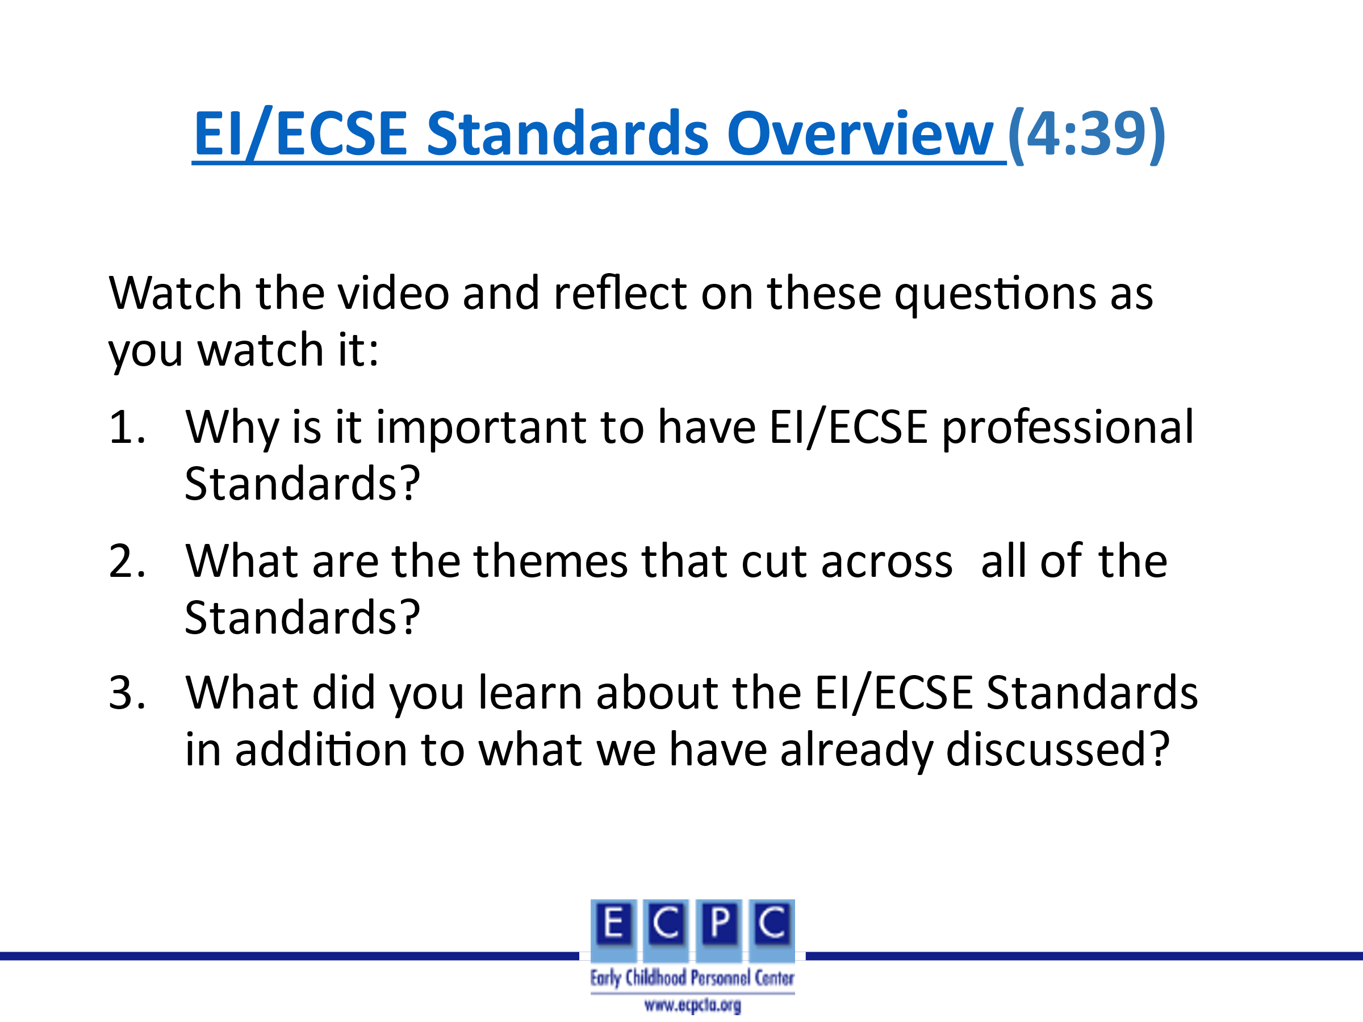 | This video provides an overview of the EI/ECSE Standards, why they are important, how they were developed, and the content of the Standards. Introduce the video and the questions for reflection on the slide. After watching the video, divide the group into small groups to discuss the 3 questions. After about 10 minutes, use a round robin method for each group to share one main point per question.
Slide 32 | 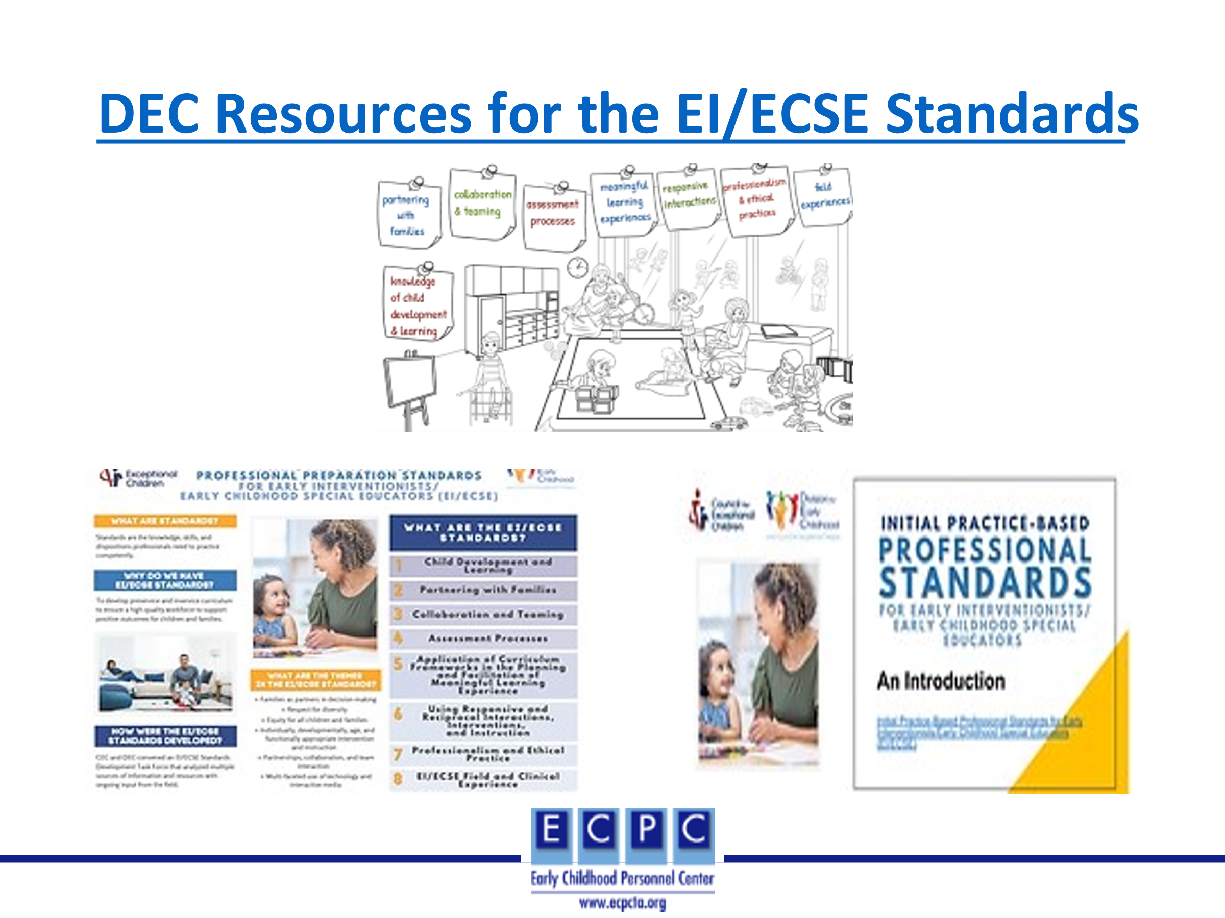 | In addition to the overview video, there are many other resources for the Standards on the DEC website. Two additional overview resources are an infographic and power point slides.
Slide 33 | 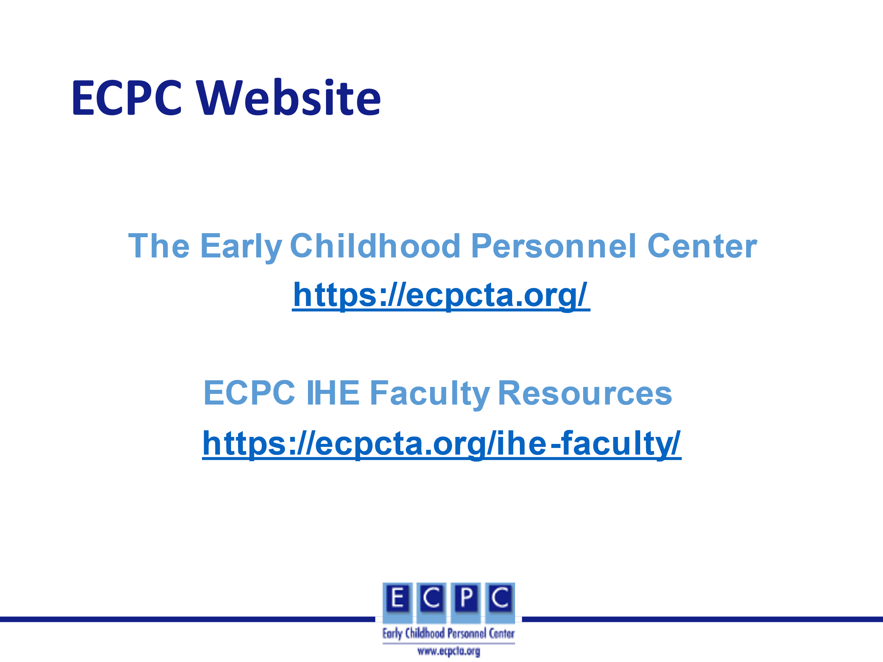 | The Early Childhood Personnel Center (ECPC) also has multiple resources for use in higher education and professional development.
Slide 34 | 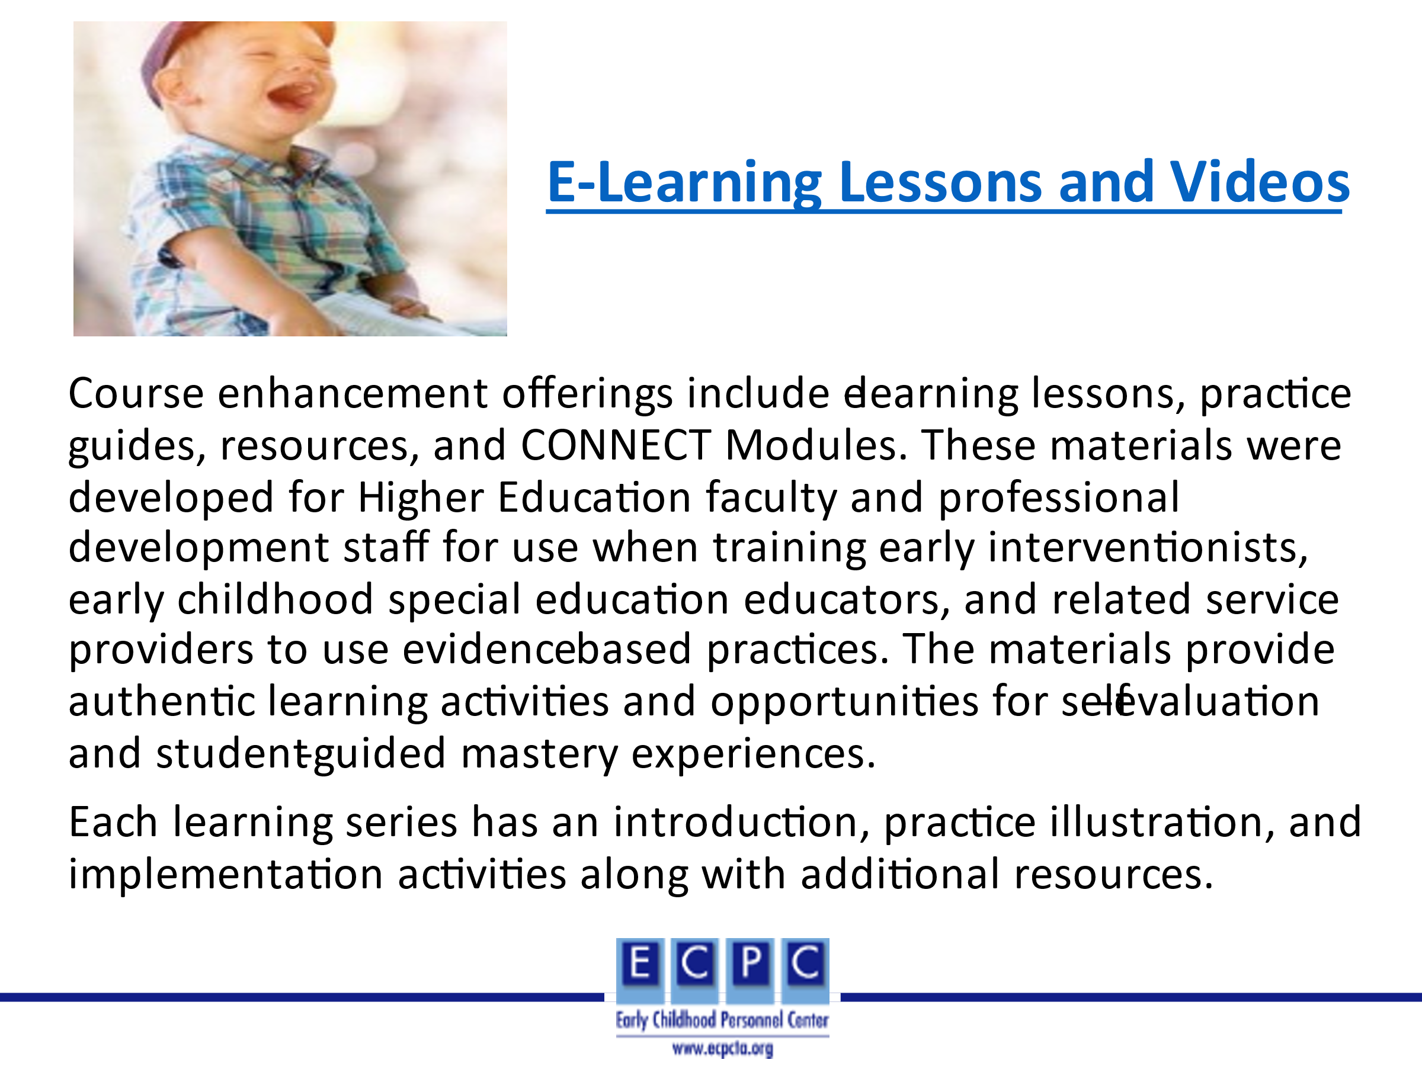 | An ECPC resource that may be especially helpful to practitioners in applying the EI/ECSE Standards are the E-learning lessons and videos.
Slide 35 | 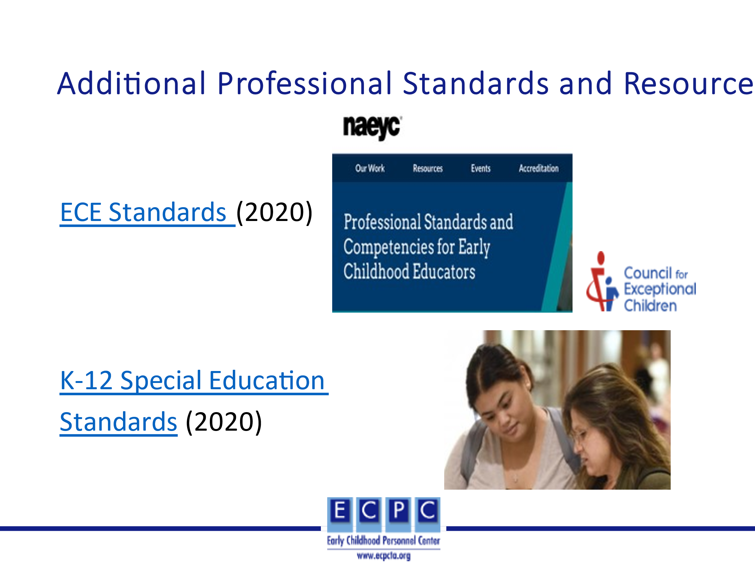 | Both the ECE Standards and the K-12 Special Education Standards may be ones that will be used at times by EI/ECSE professionals. It is important for both higher education faculty and professional development providers to know about them. For example, if it is a blended ECE and EI/ECSE program, both the ECE and EI/ECSE Standards would be used to develop the curriculum. EI/ECSE professionals working in an inclusive early childhood birth through 8-year setting will want to know what knowledge and skills that their ECE colleagues were prepared to demonstrate in practice.
Slide 36 | 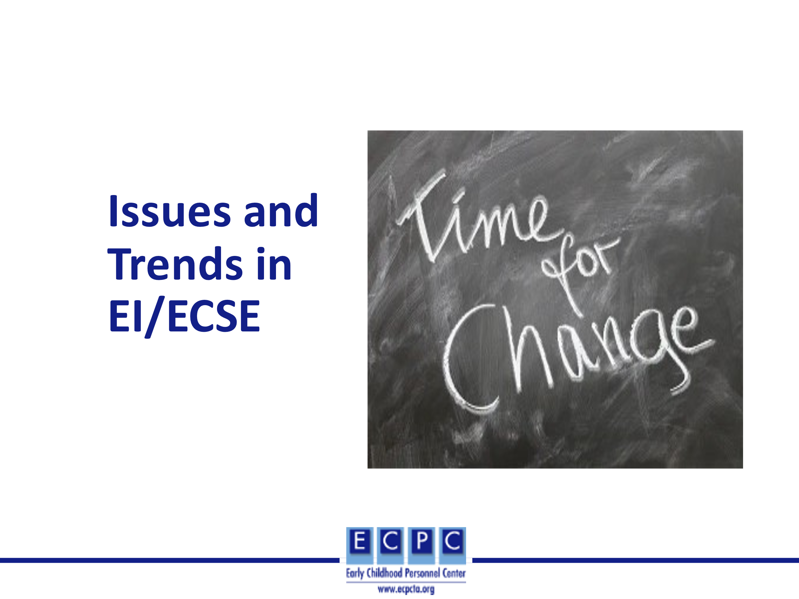 | As an EI/ECSE professional, it is important to know what the current issues and trends are in the field, especially as they influence your advocacy focus and your practice. Although some issues seem to remain constant over time (e.g., adequate funding for EI/ECSE services), other issues and trends change based on societal influences, research, and legislation. Therefore, it is important that we know what sources will be informative in identifying what the current issues and trends are and their implications for us as professionals.
Slide 37 | 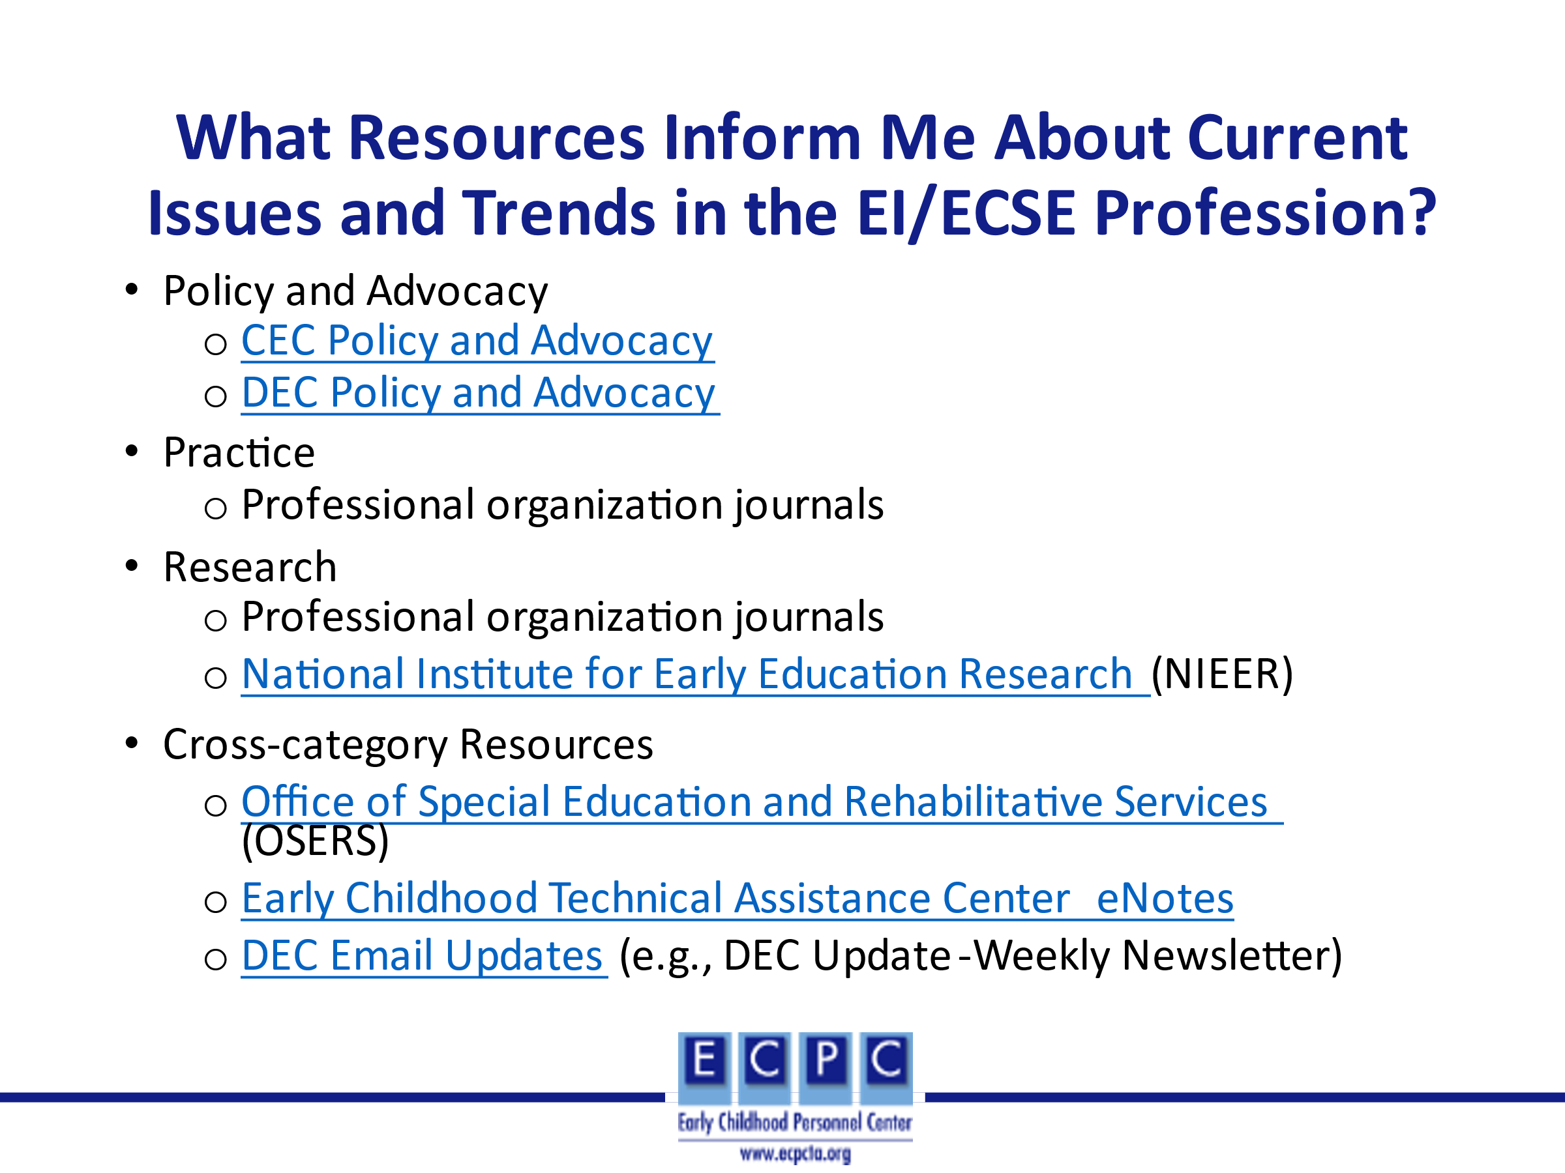 | Both CEC and DEC provide information about current policy related issues for which advocacy is needed at the Policy and Advocacy sections of their websites as well as ways for you to be involved.  Professional journals tend to be of two types: those that report research (e.g., Journal of Early Intervention) and those that include articles about how that research informs practice (e.g., Young Exceptional Children).  NIEER conducts research into diverse topics/issues related to ECE and EI/ECSE. Its website includes reports of those research studies, as well as resources to inform how that research might be applied, current news in the field and other products.  OSERS offers multiple ways in which a professional can stay abreast of current issues and trends (e.g., newsletters, blogs, listservs), and its website includes how one can sign up for these.  Similarly, ECTA and DEC provide email updates that include information about policy, practice, and research. The links provided in the slide include information about how to sign up for these updates.
Slide 38 | 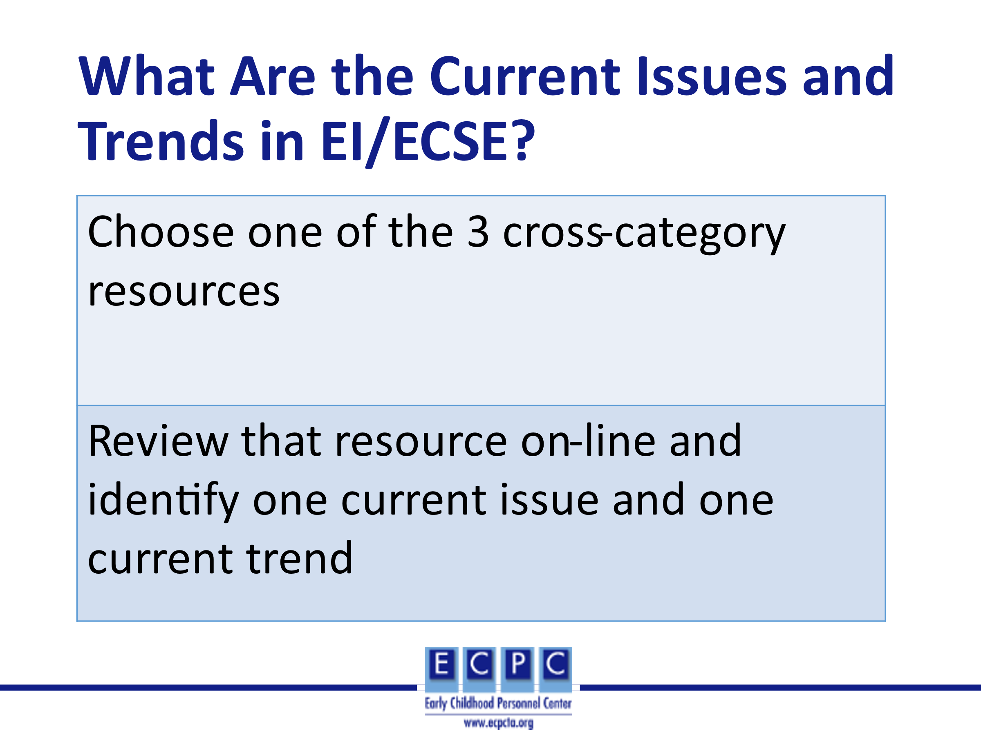 | Introduce the activity. It could be done individually or in a small group. Then, in the large group ask individuals or small groups to share their source and what they identified as an issue and a trend.  Note: The link for the DEC email updates is actually the page to sign-up for all updates or select ones. If this link is chosen, they should google DEC Update – Weekly Newsletter or DEC Spotlight.
Slide 39 | 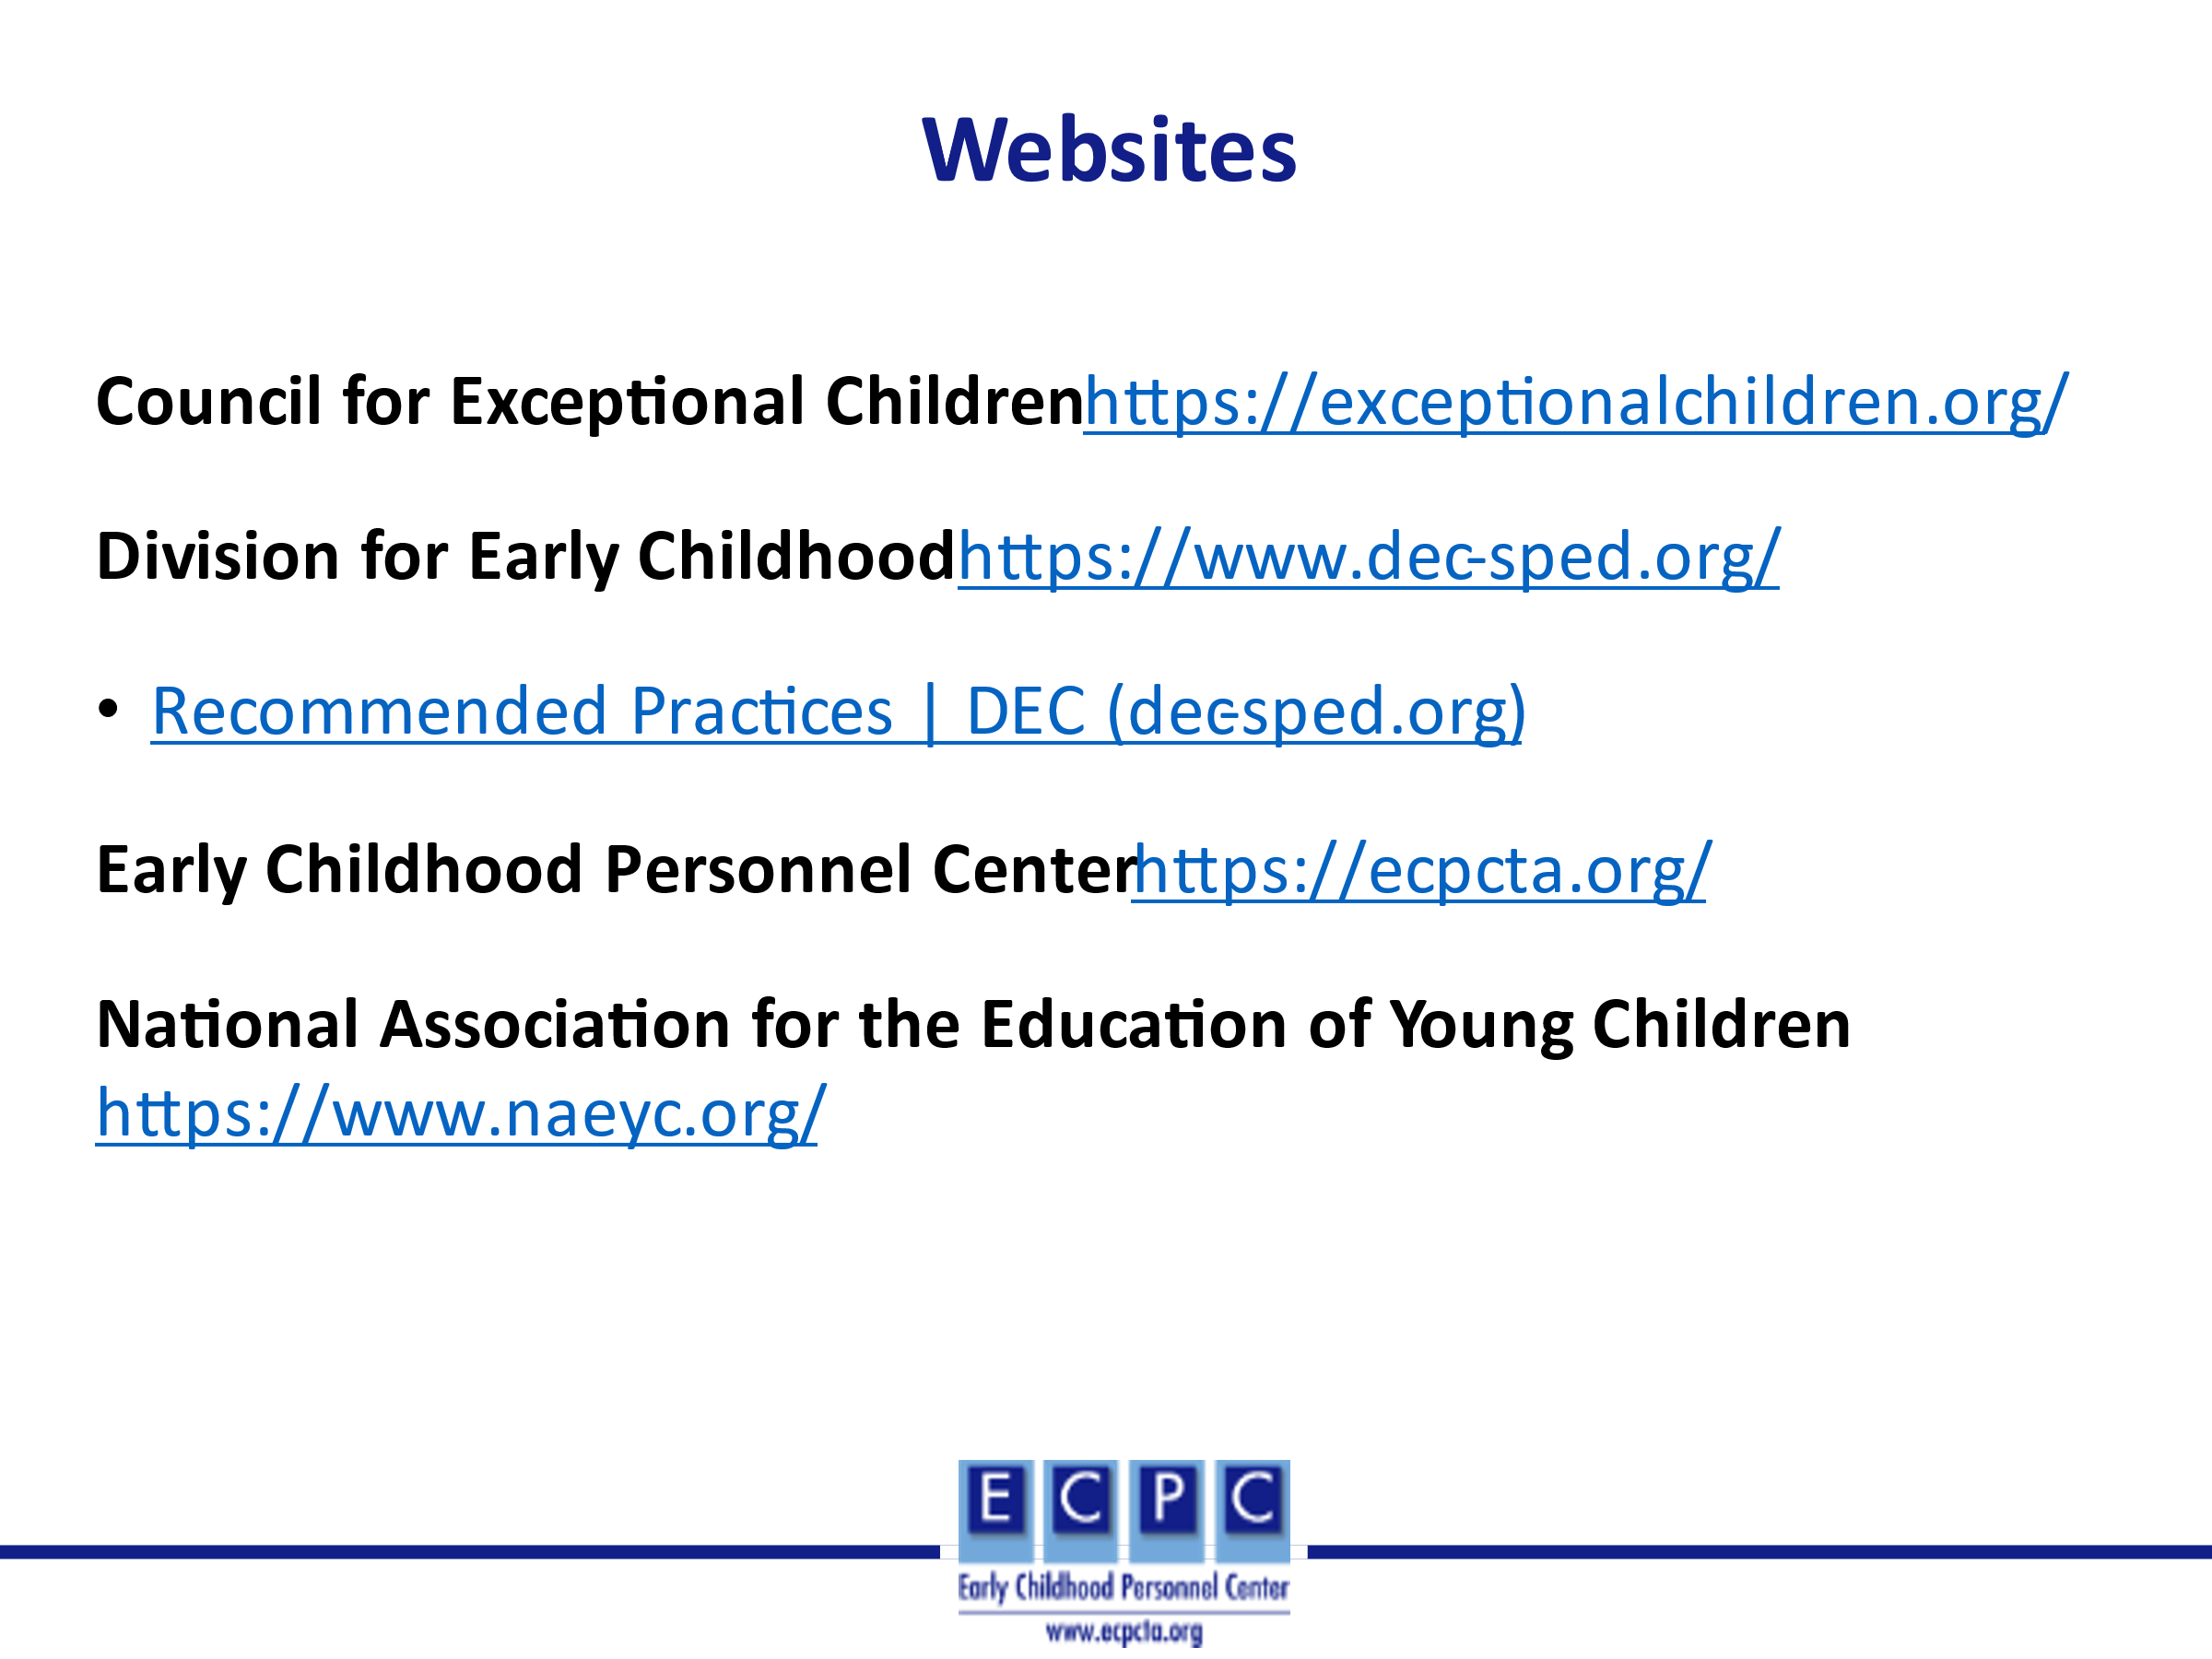
Slide 40 | 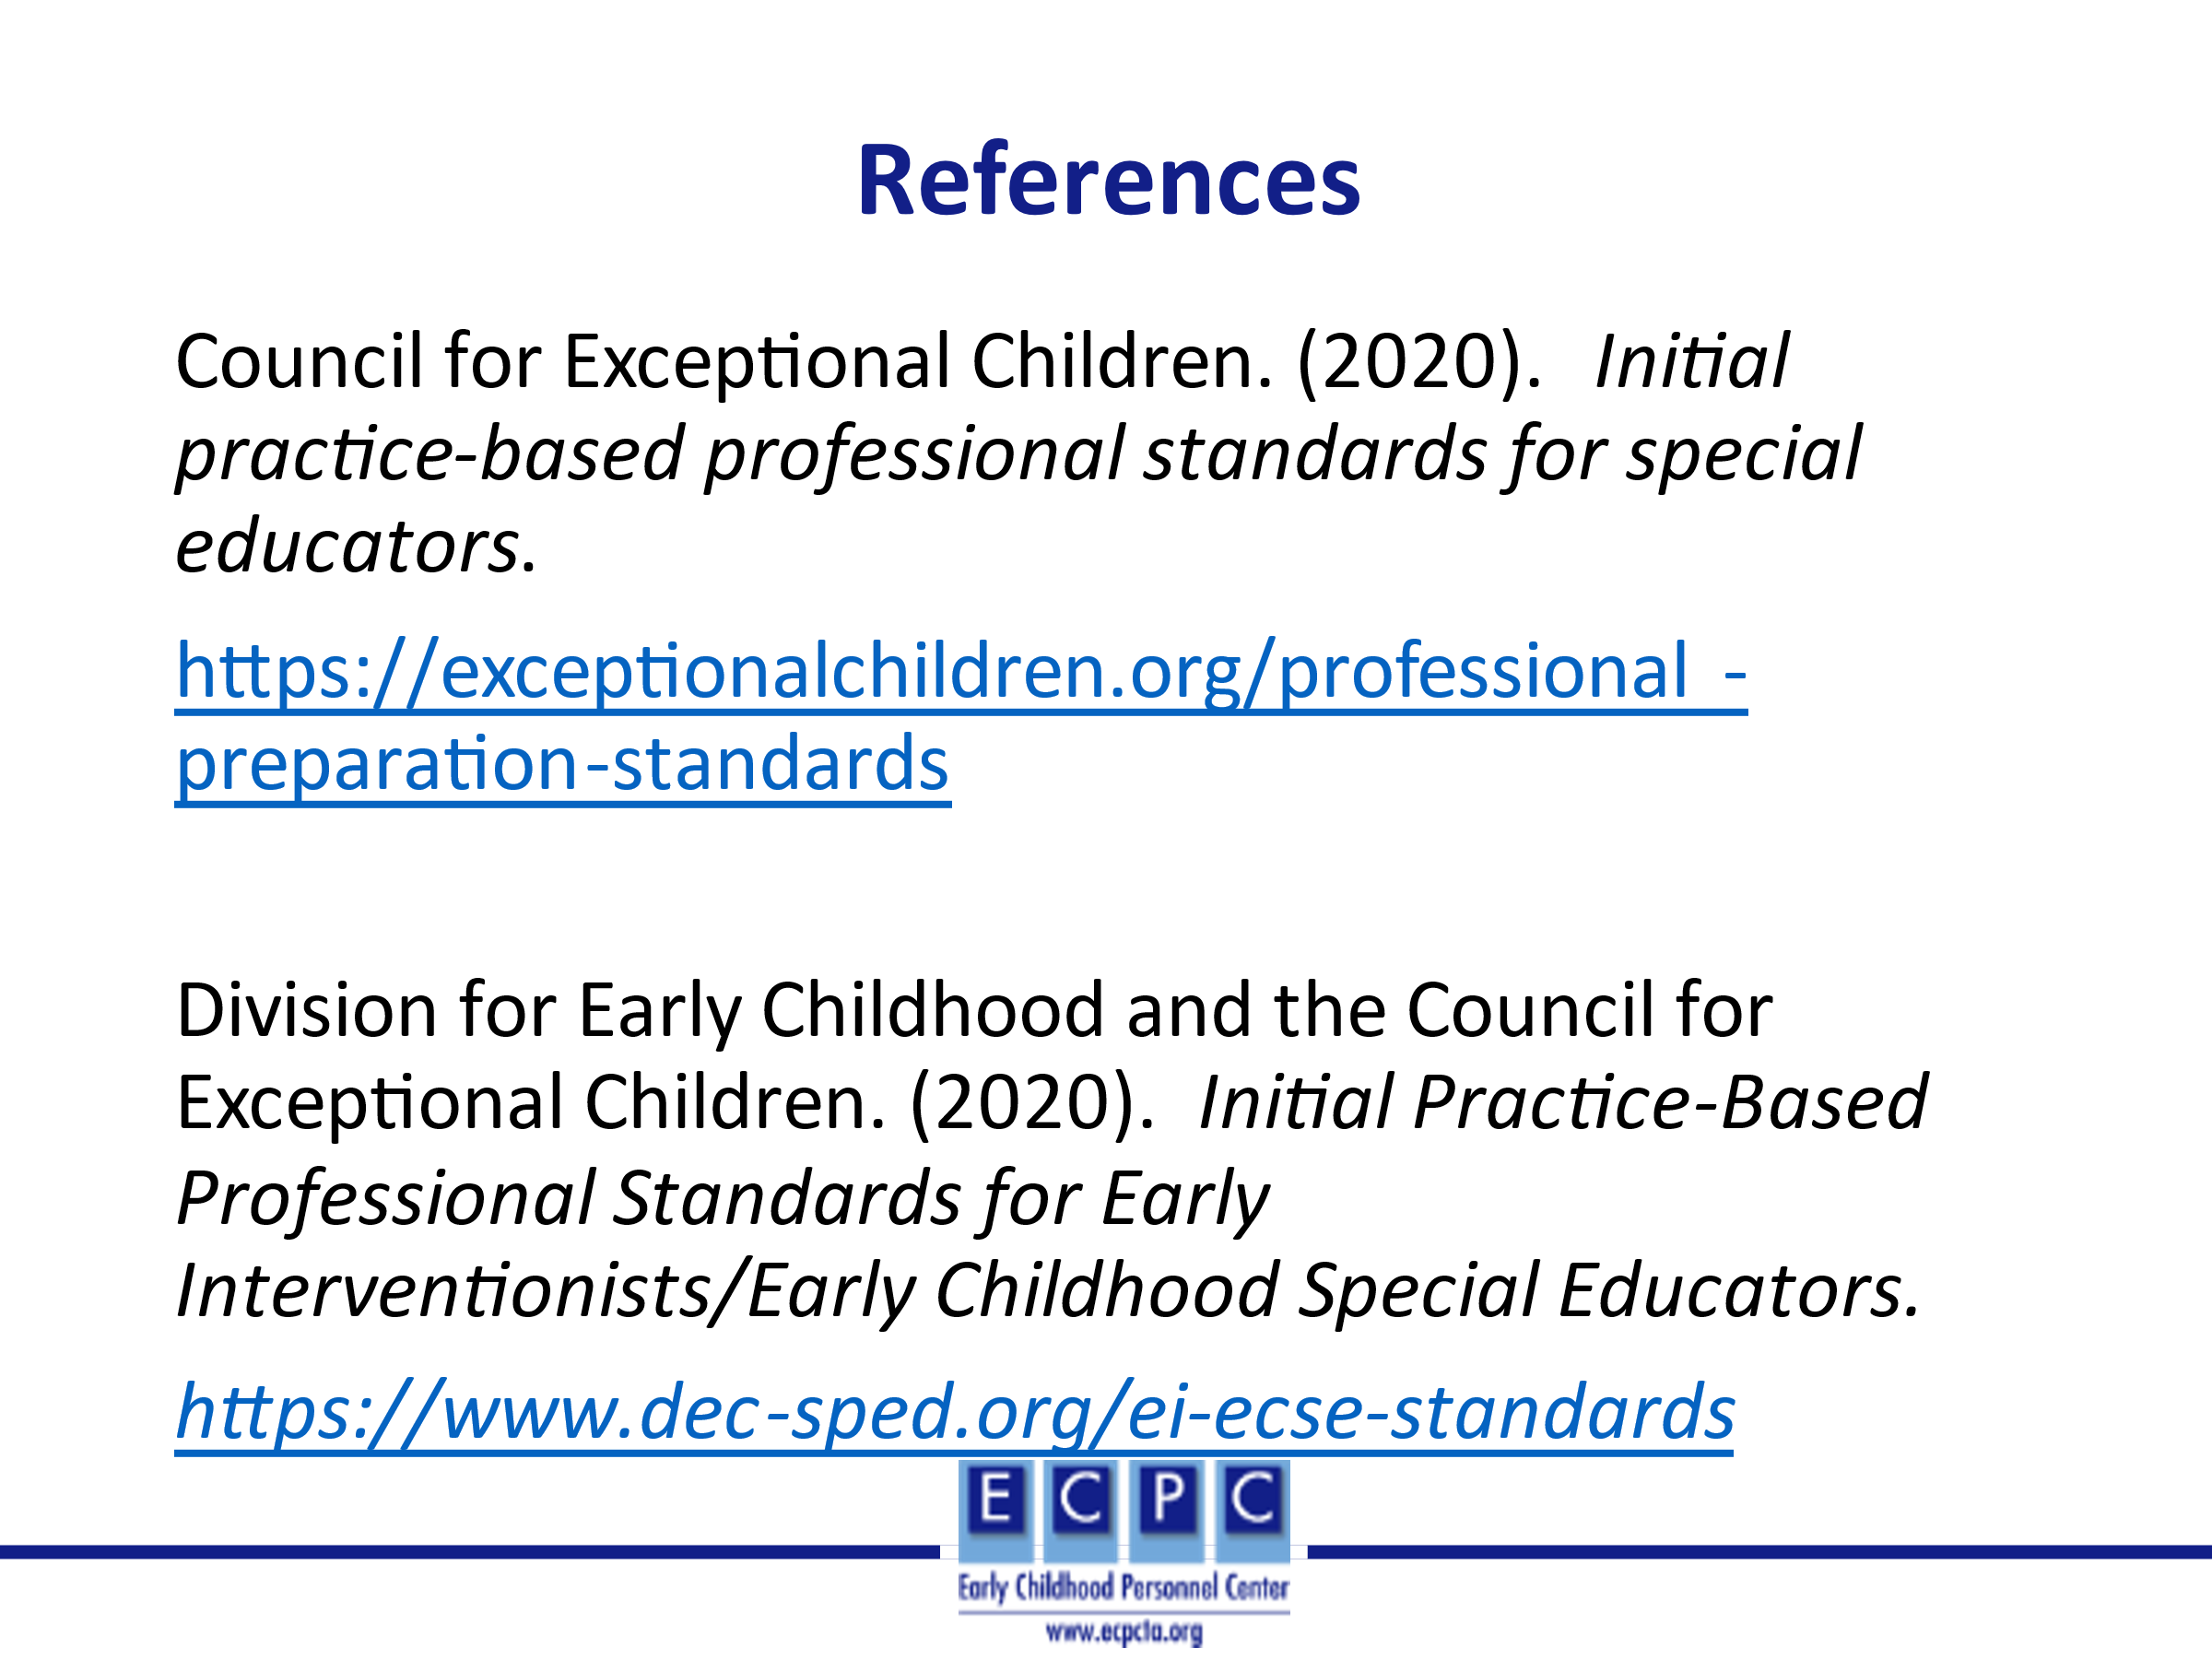
Slide 41 | 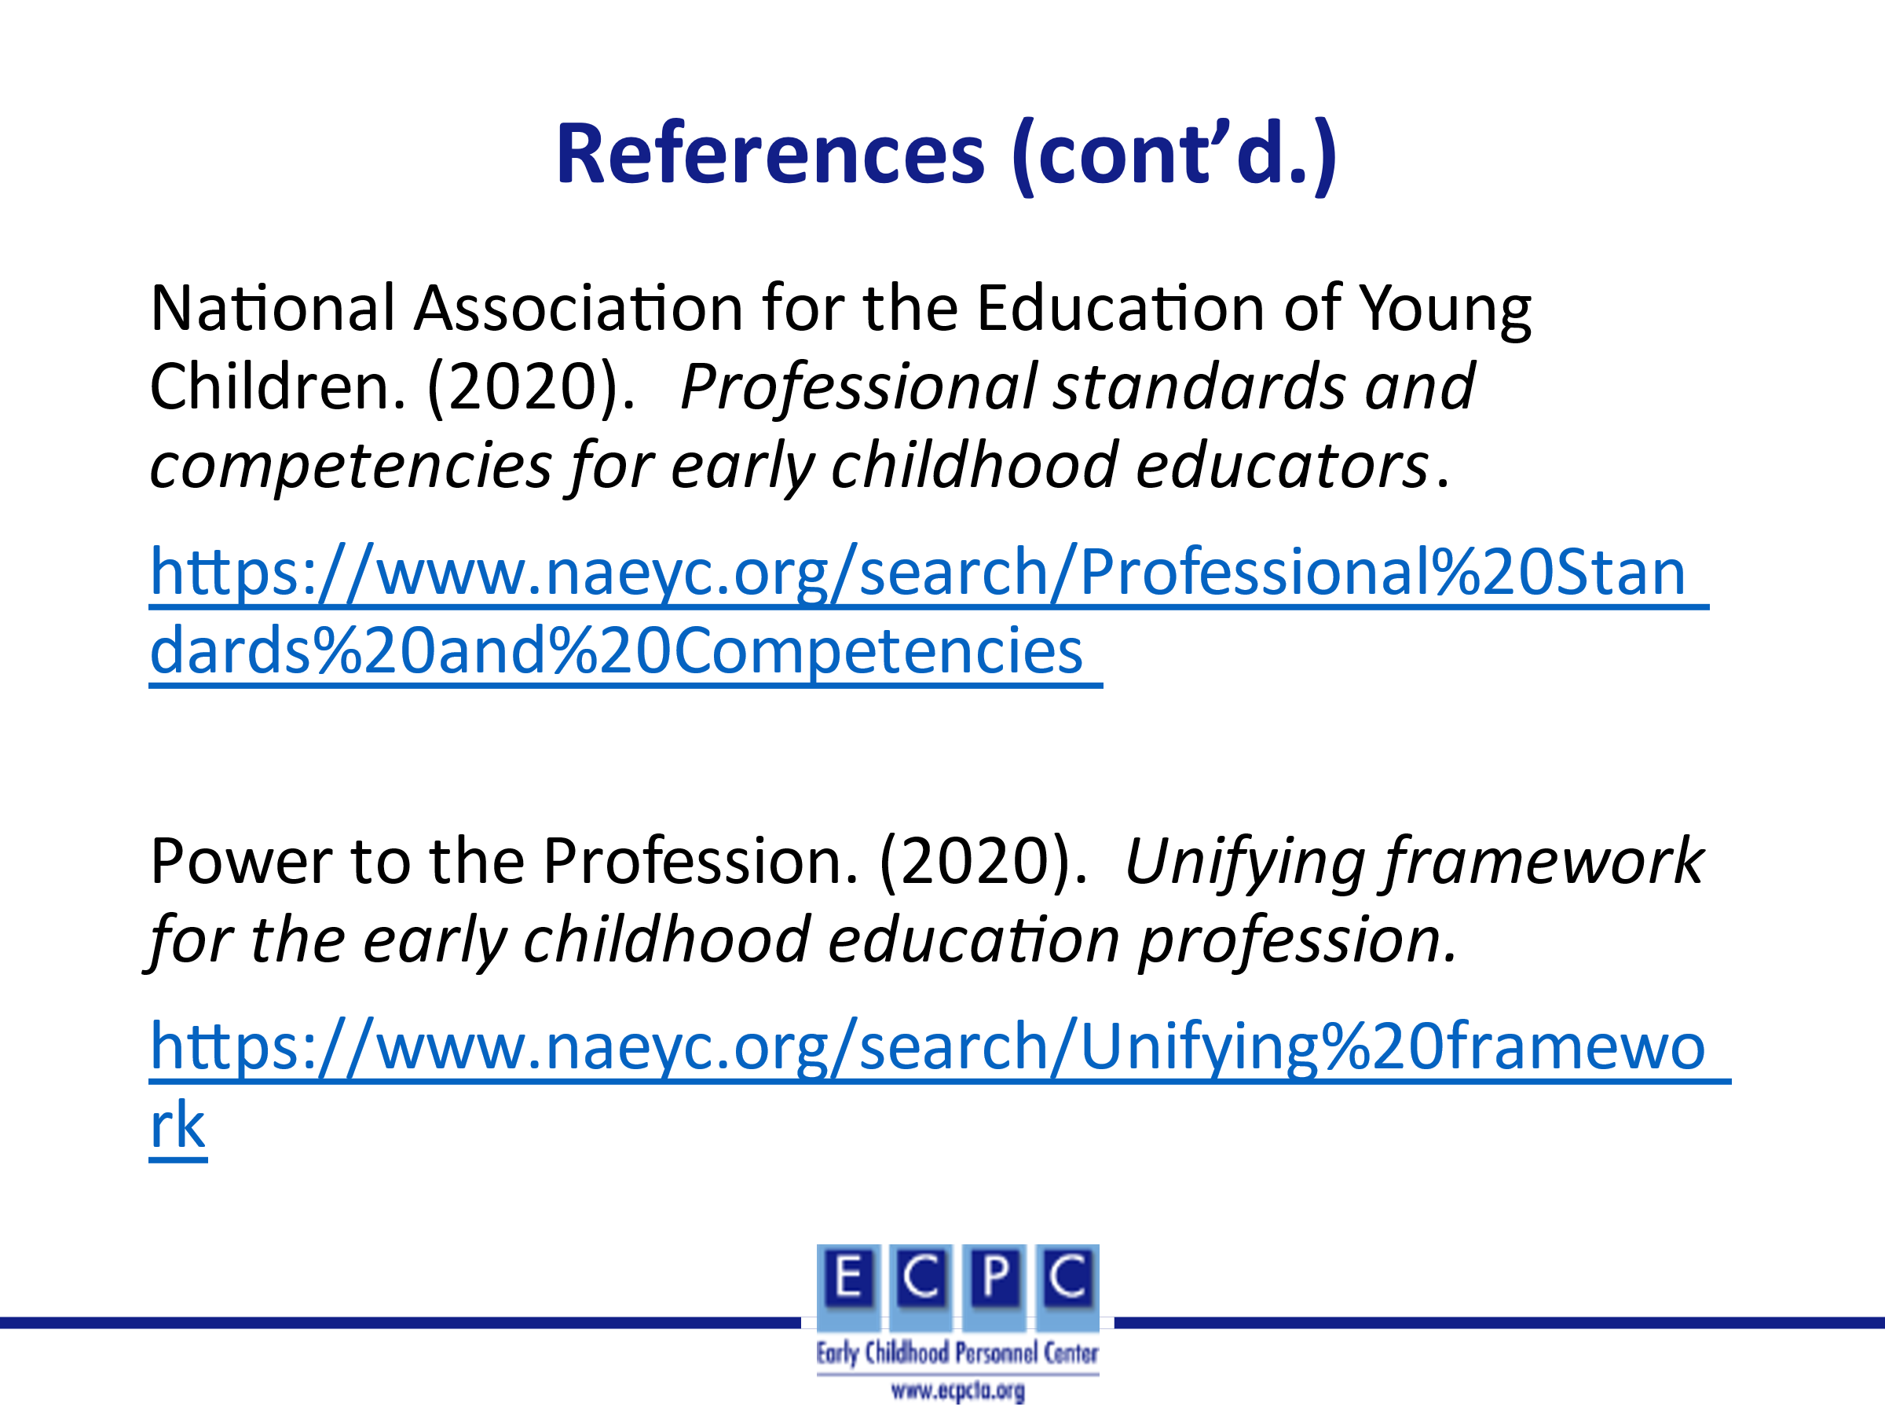
Slide 42 | 