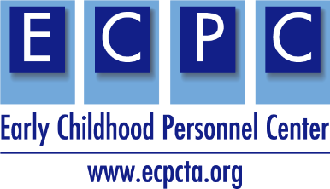
Name:
ECPC Materials Checklist for Higher Education Faculty |  | - All you use
ECPC Curriculum Planning Tool (EI/ECSE standards, DEC RPs, ECE standards, Cross-Disciplinary Competencies)
ECPC Curriculum Planning Tool (EI/ECSE standards, DEC RPs, ECE standards, Cross-Disciplinary Competencies), Zero to Three, and Infant Mental Health competencies)
ECPC Adult Learning Planning Tool or ECPC Adult Learning Planning Tool with Examples
ECPC Program of Study Self-Assessment Checklist
ECPC Syllabi Checklist
Cross-Disciplinary Competencies
Cross-Disciplinary User Guide
Case Study Maria - Professionalism
Case Study Aiden - Coordination Collaboration
Case Study Antonia - Family-Centered Practice
Case Study Robert - Evidence-Based Intervention
Crosswalk of the EI/ECSE Standards (2020) with DEC RPs (2014)
Crosswalk of the EI/ECSE (2020) and ECE Standards (2020)
EI/ECSE Standards Curriculum Modules – Please share Module/tools used – select all that apply
Topics
Sample Syllabi
Learning Activities
Practicum Application (*new)
Case Study (*new)
PD Guides
Multimedia Illustrations
Resources
- Websites
- Learning Modules
- Glossary
- References
E-Learning Lessons and Videos
Video Library (*new)
Briefs | Checklists
Leadership Brief | Leadership Practices Checklist
Recruitment and Retention Brief | Core Elements of Technical Assistance Checklist
In-Service Brief Overview | Faculty Checklist Partnering with Families
Pre-Service Brief Overview
ECPC TA Brief Overview

